
Please find below a brief snapshot of the huge range of work being undertaken across the area by Roads and Infrastructure staff this week.
Roads and Infrastructure
Weekly member briefing
Edition 146: 26th April 2024
The updates are designed as a resource for you to be able to answer constituent queries.
You can view all previous weekly member briefings on the website
Oban, Lorn and the Isles | Helensburgh and Lomond | Mid-Argyll, Kintyre and the Islands | Bute and Cowal | All areas
Roads updates  The team have been continuing this week on the Loch Avich capital job on the C29, which will complete by close of play today.  Next week we’ll be progressing with pre surface dressing works in the North Shian area.  On Coll we’ve completed our reprofiled surfacing works. Unfortunately we lost three days due to ferries not sailing which means we will be revisiting the island in September to complete this job. We’ve included some images of the new surfaces below.  We’ve had 80tonne of material delivered to Tiree and are progressing work there this week and next.  On Mull our main focus has been on cattle grid installations this week before moving to preparatory works ahead of capital schemes beginning on the island 7th May.  Oban sea wall  Our bridge squad completed the rebuild of the masonry wall on Monday this week. We poured the concrete to permanently fill the void under the footway on Thursday, ahead of the footway being reinstated.  BEAR Scotland have confirmed that they will be carrying out repair works, sea wall, steps and slips adjacent to the Esplanade between Corran roundabout and North Pier  Craignure  Ground investigation works started at Craignure Pier on Monday and should last around four weeks.  The works will involve drilling boreholes to gain ground conditions information, rock height etc to aid in the foundation design of the proposed jetty, ferry terminal, marshalling yard, terminal building and vehicle access road.  The work will mainly be in the sea using a Jack-up, self-elevating platform. The marine work will be operational 24 hours-a-day, for seven days a week for the duration of the project.  We expect that ferry services will operate as normal.  Photos of the rig are below  New permit, Glengorm  We have a new Pollution Prevention and Control (PPC) permit issued by SEPA for the landfill element of the Glengorm site on Mull.  The old permits have been updated to reflect changes in environmental regulatory legislation.  What this means in practice is that the permit is simplified, although it puts an additional duty on the Council to ensure that each site doesn’t pose any environmental threat to the wider environment, and the clauses around this are more specific than they were in the past.  Monitoring requirements have changed, with more of certain types and less of others. Overall the new permits are well balanced and reflect the current landscape.  Staff on site are fully aware of the permit and the permit conditions. We need to have management plans and controls in place to protect site staff and site users as well as the wider environment.  The team at Glengorm have been trained this week on the new permits and the site management plans have been updated to reflect the new permits.  This is a heavily regulated industry and the Council has a very good record of demonstrating compliance with the requirements. It is likely as a result of this good track record that we are in the first tranche of the new permits being rolled out.  These permits will be rolled out across all of our sites eventually. | Roads updates  Work continues with patching work around Arrochar, which is part of the preparatory phase for the upcoming surface dressing scheme. This is expected to complete at the start of next week.  Crews are also carrying out patching work Whistlefield roundabout to repair safety defects that have been identified through inspection.  Tigh Dearg Road  We are liaising with property owners regarding any damage to properties which have been a result of work carried out by the previous contractor.  Our new contractor GeoRope are developing a programme to complete the works and any repairs to properties will be included in this programme.  The next public drop-in meeting will be held in the Commissioners Room, in Cove Burgh Hall, on Wednesday 1 May, from 10:00AM – 12:00PM | Roads updates  The works at Woodside in Carradale are ongoing as is the large capital job at Electric Cottage on the A819.  The jetpatcher is continuing to work through defects on Islay – this has been week two of three before a week on Jura.  Campbeltown Flood Protection Scheme (CFPS)  The planters will shortly be being placed out in Burnside Square. Community groups had previously expressed an interest in possibly using these for community food growing. We’re reaching out again to these groups to confirm their intentions going forward.  EV charging at Council offices  Taking advantage of funding from the government’s Switched on Fleets initiative we’ve purchased two new fast chargers, one of which will be installed at the Kintyre Hub Office at Kintyre House. The way the timeline around the funding has worked means we purchased the hardware from last financial year’s funding and will be installing the chargers with this coming year’s funding. We are just in the process of finalising our submission on this basis.  Inveraray public convenience  We are currently pricing up, via our property maintenance term contractor, different options for potential upgrades to this facility, which we could put forward for Crown Estates funding.  Islay – Jura ferry  The Eilean Dhiura is expected to be back in service on Monday as planned following its drydocking. | Roads updates  This week our teams have been working to repair the culvert which was damaged at Colintraive last week, as well as another culvert which had issues on the Couston Road south of the ferry slip  The gully emptier finished works ahead of pre surface dressing works in Innellan and has now been returned to doing normal cyclic maintenance.  The jetpatcher has been used to assist with pre surface dressing works in West Cowal as well as works on the Ardlamont Loop  Lochgoilhead Bridge project  We are moving our plans for these strengthening works forward. This week we have been considering options for diversions during the works. There are a couple of options for this – we’ll be outlining these and reaching out to key stakeholders in the next few weeks.  EV charging at Council offices  Taking advantage of funding from the government’s Switched on Fleets initiative we’ve purchased two new fast chargers, one of which will be installed at the Rothesay Hub Office at Union Street. The way the timeline around the funding has worked means we purchased the hardware from last financial year’s funding and will be installing the chargers with this coming year’s funding. We are just in the process of finalising our submission on this basis.  Glenmorag public convenience  As well as progressing the door access control project for this public convenience, we are working with colleagues in Economic Development to look at options to upgrade the facility through allocated Crown Estates funding. There may be an opportunity to look holistically at this whole area including the playpark and the car park across the road to see what can be done to make it into more of an attraction with facilities which could encourage people to take a walk along the front from Dunoon. The site may lend itself to a coffee kiosk/café franchise and this is a design option we have asked our architects to draw up for us.  Bus shelters  Our contracts officer has a number of site meetings arranged with the bus shelter contractor on the 9th May where they will be discussing a number of repairs that are required to bus shelters across Bute and Cowal. | Public transport team recruitment  Members will be aware of some delays recently to bus shelter works because of a lack of available resource within our public transport team. This week we have advertised a recently vacated post of Public Transport Technician. Hopefully once we are able to recruit to this post we’ll be able to move a few outstanding jobs forward.  Community transport support  This week we renewed grants of nearly £60,000 in total to five community transport providers across Argyll and Bute. Community transport provides bus services for those who have barriers to accessing regular bus services and/or provides these services in areas where there is no public provision.  The groups provide business cases and our team review them to ensure the grants are continuing to provide best value.  The groups supported cover the following areas:  - Luing  - Lorn  - Mid Argyll and Kintyre  - Cowal  - Lochgoilhead

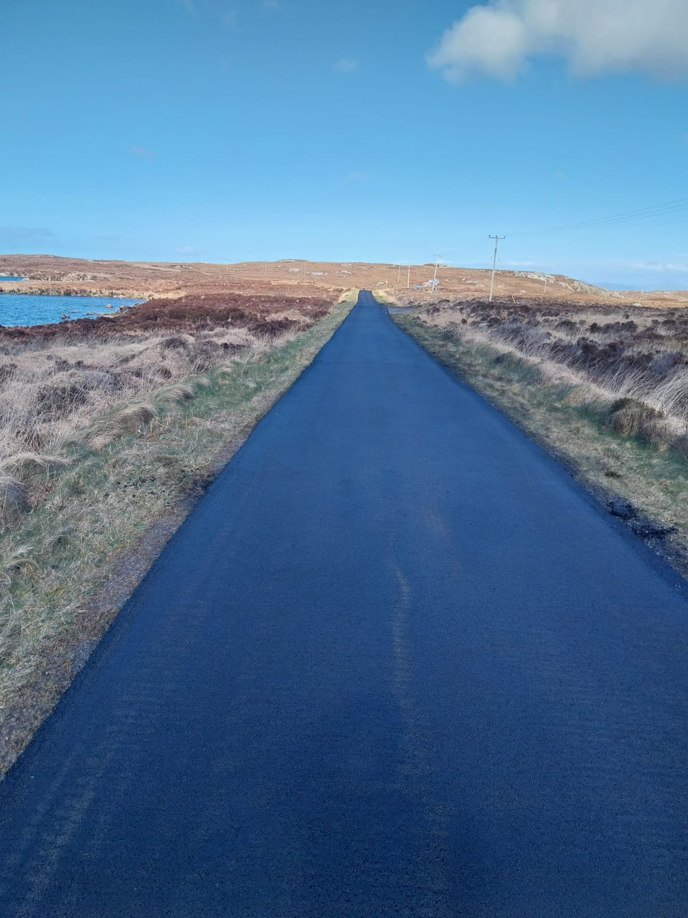
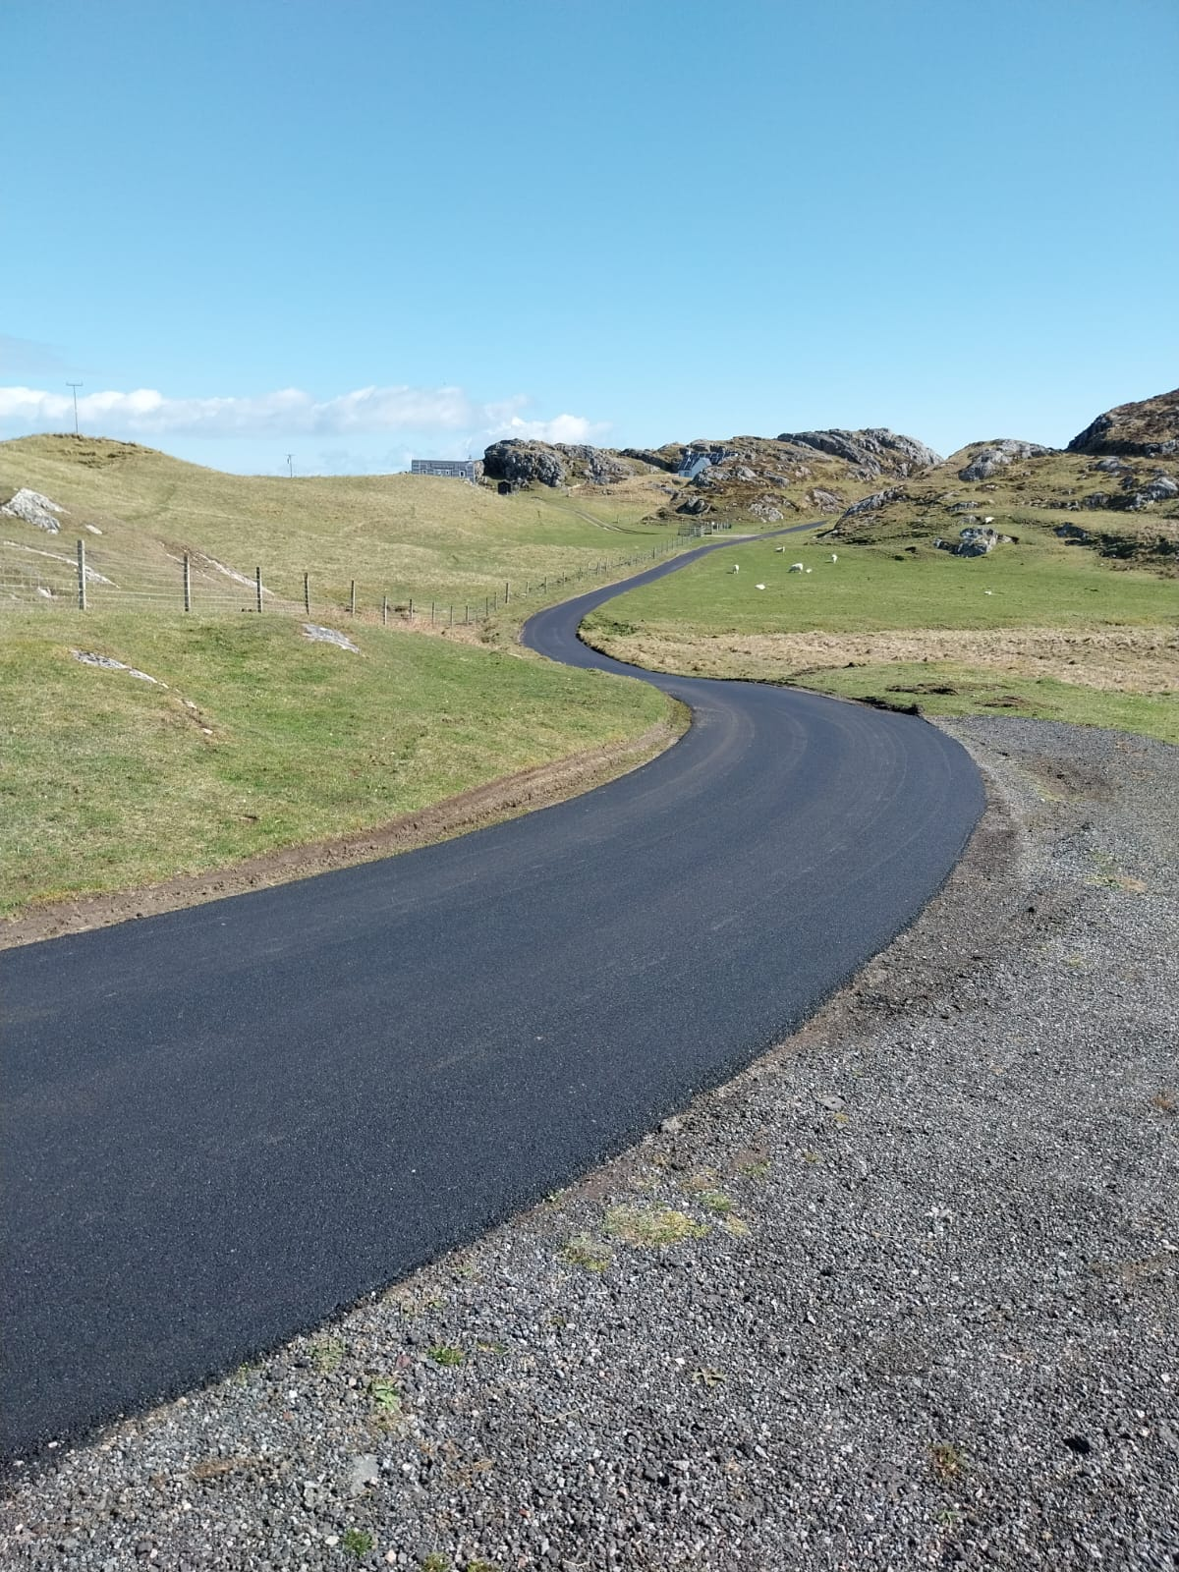
Coll surfacing images
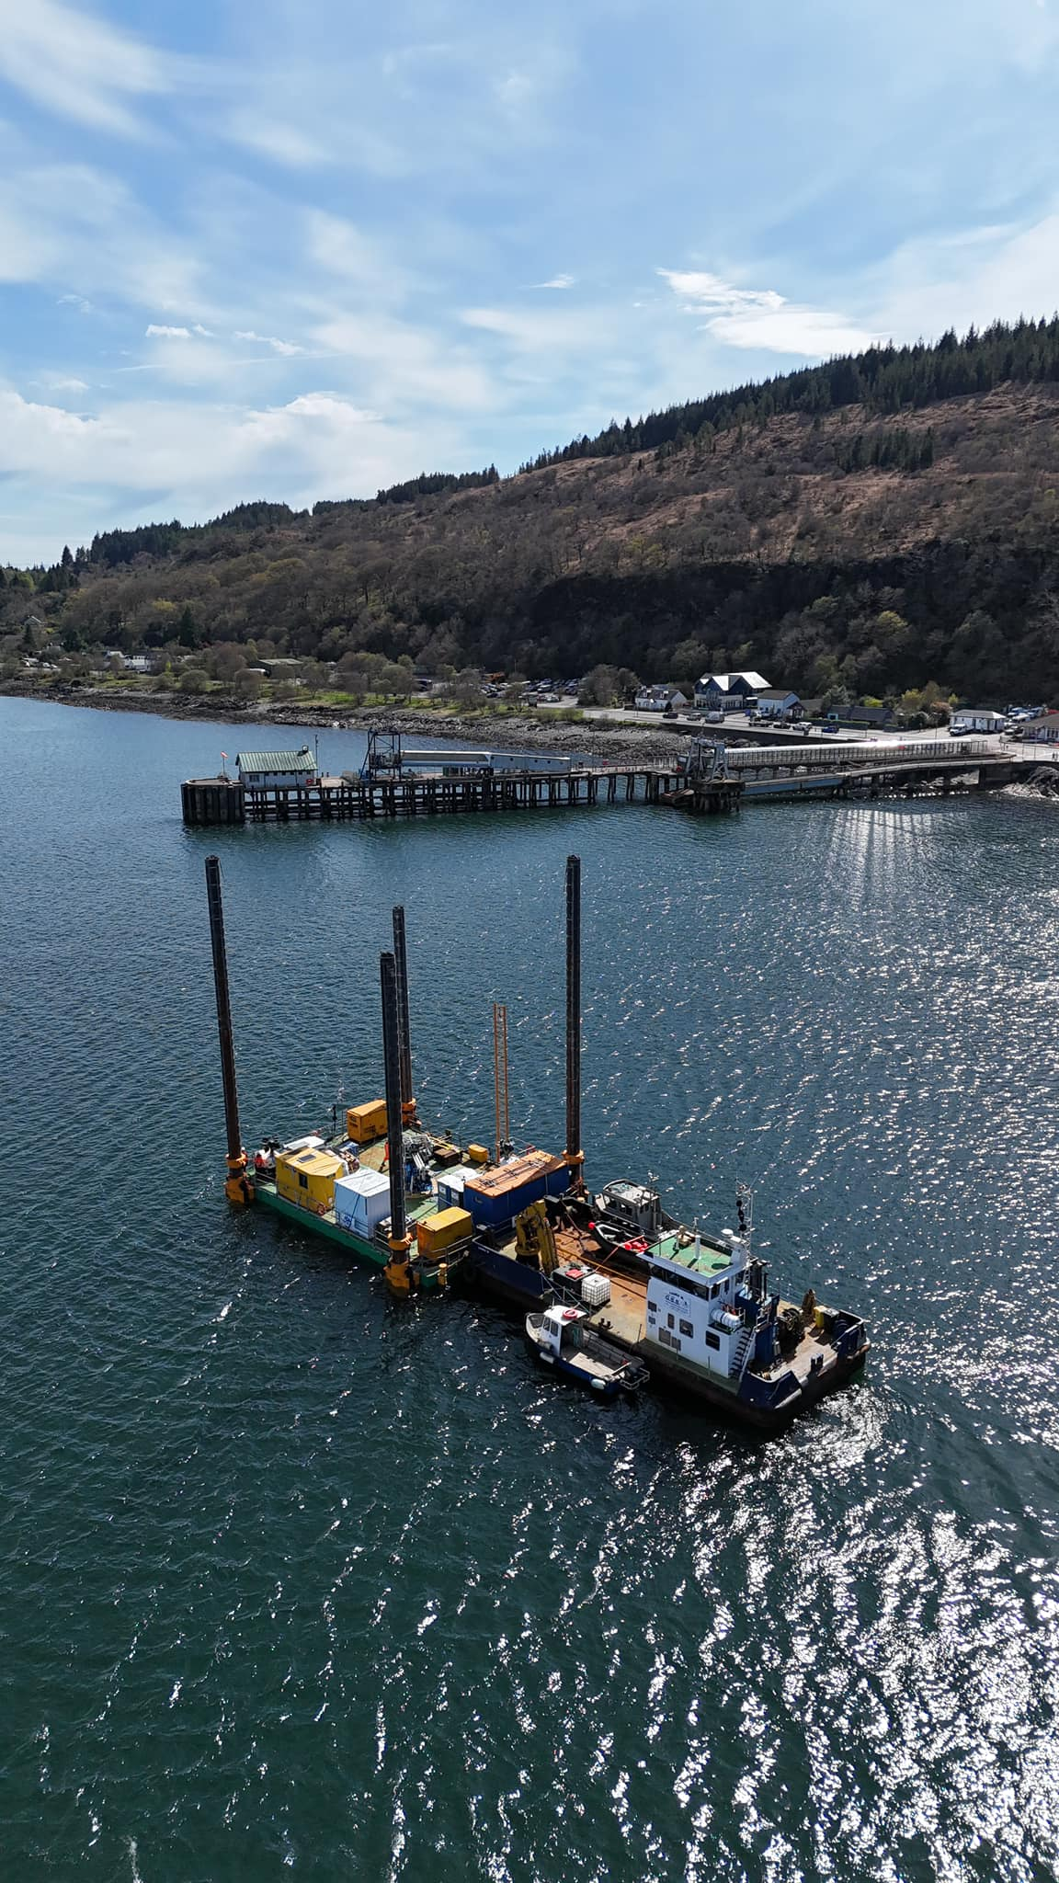

Ground investigation rig, Craignure

