
Please find below a brief snapshot of the huge range of work being undertaken across the area by Roads and Infrastructure staff this week.
Roads and Infrastructure
Weekly member briefing
Edition 145: 19th April 2024
The updates are designed as a resource for you to be able to answer constituent queries.
You can view all previous weekly member briefings on the website
Oban, Lorn and the Isles | Helensburgh and Lomond | Mid-Argyll, Kintyre and the Islands | Bute and Cowal | All areas
Roads updates  The Loch Avich capital job got underway on Monday as advised. Good progress has been made this week and the job is expected to complete next week.  A crew also attended Easdale with the mobile hotbox to attend to actionable potholes in that area.  On Mull the team have been installing new cattle grids at various locations. The team has also been working on Coll all this week and will work into the weekend to complete road upgrades.  Oban sea wall  The sea wall has been damaged at the Esplanade in Oban, which has undermined the footway. Our teams attended Thursday evening to place barriers and make the area safe. We made emergency repairs this morning which involved  a concrete bag repair to the masonry face, and backfill with 20mm clean stone for support and safety.  We have programmed in permanent repairs to get underway on Monday.  Photos of the damage are included below.  New bin lorry, Mull  We will shortly be taking delivering of a new bin lorry for Mull which will replace an older, less reliable vehicle. This will increase the resilience of the waste and recycling collections on the island.  Belnahua  The Belnahua is expected to be back in the water around mid-May – currently there is a relief vessel called Spanish John in operation  Craignure  The important ground investigation works for the pier project are set to begin on Monday, with the contractor mobilising this weekend.  These works are key to informing the business case for the project | Roads updates  We are undertaking patching work around Arrochar, which is part of the preparatory phase for the upcoming surface dressing scheme.  New traffic order, Luss  The uptake rate for the new permits has increased and is now around 60% of residents and businesses, based on those who applied previously for free permits under the temporary order. The figure might be slightly misleading as some people are likely to have driveways, and some will have blue badges.  Feedback from the community would suggest that the new arrangements are working well.  We have issued a few penalty charge notices (PCNs) but not a high number, so this would suggest the scheme is being generally understood and complied with.  Lomond school transport contract  There is a new school transport contract now in place with Garelochhead Coaches, the same supplier as under the previous contract. This new contract is for five years.  New small bin lorry  A new small bin lorry has arrived for Helensburgh – this replaces the older small lorry. This type of lorry (18tonnes) is used for streets which are narrow and which would be difficult for a standard sized bin lorry to safely access. See photo below  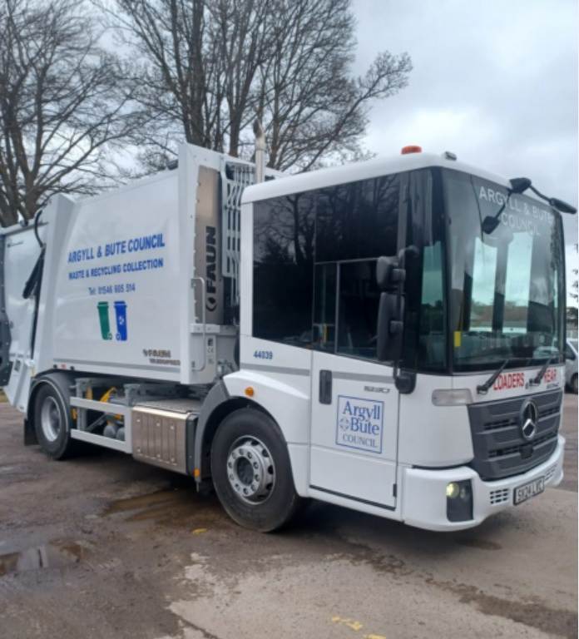 | Roads updates  The works at Woodside in Carradale are ongoing. Works have been a little slower than expected because there has been more rock than originally estimated.  The team are also continuing to work on the significant capital scheme on the A819 at Electric Cottage.  The jetpatcher has been deployed to Islay this week to work through reported defects – this is week one of three on Islay followed by a week on Jura.  The team are gearing up to start pre surface dressing at the start of May – this will be a week in Mid Argyll and a week in Kintyre.  Islay Jura ferry  The usual ferry is expected to be back in service towards the end of next weekend following its drydocking.  Islay school and public transport contract  We have a new contract in place on Islay for both school and public transport. This is again to the same supplier as under the previous contract, in this case Mundells. The contract is for the same package of routes/services as before, which ensures continuity of bus services.  Campbeltown Flood Protection Scheme (CFPS)  The CFPS scheme is nearing completion, with the final elements of the work being progressed. All indications are that works will complete in advance of the target completion date of 10th May.  Whitestone Bridge, B842  The strengthening works on the Whitestone Bridge south of Carradale have been successfully completed.  Claonaig  Due to the increase in traffic using the Claonaig to Arran ferry causing road edge damage, the Council has put in place, as a temporary measure, traffic cones to deter vehicles from overrunning the verge on the B8001.  These temporary measures have been put in place to preserve the road and limit any further damage or deterioration. Whist we accept this isn’t an ideal solution, it has unfortunately been necessary. We are considering other possible measures including promoting a temporary traffic regulation order with either a clearway or more likely, double yellow lines along either side of the carriageway.  We are working closely with Calmac and CMAL who are considering other measures within their remit to manage the traffic associated with the port facility. | Roads updates  We have been emptying gullies in Sandbank and Innellan this week. Some of this work is within areas planned for surface dressing (SD) and ensuring the gullies are emptied is part of the preparatory works ahead of the SD schemes.  The jetpatcher has been out on the C9 which is the road from Ardentinny to Whistlefield, as well as working in Dunoon.  We’ve progressed a fairly substantial footway surfacing job in Toward which involved the laying of 45 tonnes of material.  A culvert blew in Colintraive earlier in the week damaging the road surface, so the team undertook some hand patching repairs.  We are also progressing with footway works on West Princes Street in Rothesay.  Signage  We have been installing safety signage along the A880 Kilmun/Blairmore road. These include sharp bend chevron signs.  Sandbank and Glenmorag public conveniences (PCs) now charging  We had previously advised that we were targeting the Port Bannatyne and Glenmorag PCs for activation of the new charging system on Tuesday of this week. Unfortunately the contractor was delayed which meant a change of plan and instead we activated the Glenmorag and Sandbank sites.  They seem to be operating well so far  Streetlighting  We managed to remove the last obsolete column from the St Brides Road capital improvement scheme last Friday as advised.  New bin lorry, Cowal  In addition to the new vehicle for Mull we will also be bringing a new vehicle into the fleet in Cowal, which will replace an older vehicle. | Certificate of Professional Competence (CPC)  We are continuing to put drivers through their CPC training which is a week long course – this limits our resources while the training is being delivered but it is a key qualification for our HGV drivers. Drivers must do 35 hours of periodic training every 5 years to keep their Driver Certificate of Professional Competence (CPC) to drive a lorry, bus or coach.  Public convenience (PC) door access control project  Following the issues with the new doors over the weekend of 17th February we have been engaging with the contractor to resolve these faults. It appears the overarching issue was down to a software upgrade which had the effect of disconnecting the door systems from the internet/back office computer system.  The contractor has engaged positively with us and we have slowly reactivated some of the sites and tested and retested the systems.  As of today we have four sites operating consistently:  - Ardrishaig  - Lochgilphead  - Sandbank  - Glenmorag  We are therefore going to look to reactivate all other sites which have had the new systems installed. Due to the availability of the contractor this is likely to be over two days w/b 29 April.  The sites to be activated that week are:  - Inveraray  - Helensburgh  - Tighnabruaich  - Colintraive  - Port Bannatyne  Once all sites in this phase are reactivated and assuming they work consistently, we’ll then take a view on the next phase of the project (the contract for that phase has not yet been awarded). The sites in the following phase are:  - Chapel Hill (Rothesay)  - Port Ellen  - Bowmore  - Bridgend (Islay)  - Ganavan  - Fionnphort  - Oban North Pier (retrofit of existing to include contactless)  We are also looking at future options for Rothesay Victoriana and Riverside (Dunoon) since these assets came back over to the Council from third parties after the original list was developed.  New pool cars and vans  We have placed an order for 15 new vans which will replace hired vehicles, ultimately reducing our operating costs. This is in addition to three new Renault Clio hybrid pool cars, which will replace older petrol/diesel vehicles.

