
Please find below a brief snapshot of the huge range of work being undertaken across the area by Roads and Infrastructure staff this week.
Roads and Infrastructure
Weekly member briefing
Edition 144: 12th April 2024
The updates are designed as a resource for you to be able to answer constituent queries.
You can view all previous weekly member briefings on the website
Oban, Lorn and the Isles | Helensburgh and Lomond | Mid-Argyll, Kintyre and the Islands | Bute and Cowal | All areas
Roads updates  Starting on Monday the team will begin surfacing works on the C29 Loch Avich. This is the first capital job of this financial year, and will run for two weeks. We’ve also been continuing with the Glen Lonan overlay job.  The surfacing works on Mull for the Tobermory sea wall project are now complete.  Pennyfuir  Cemetery improvement works are ongoing at Pennyfuir.  Street Lighting  Works started this week on the capital streetlighting works in Oban to replace 70 columns, 2 electrical distribution units (HDU) and cable replacement over the following streets:  Nant Drive, Etive Gardens, Coe Gardens, Ure Gardens, Crecan Gardens, Lonan Drive, Orchy Gardens.  Pennyghael Bridge replacement consultation  This event was well attended. We are currently collating the feedback as well as that from the online consultation which runs until Friday 3rd May. You can view it here. | Roads updates  The culvert collapse at the top of the hill near Blairvadach House has been made safe for the time being while we explore a longer term solution to the flooding problems in this area.  The footway surfacing works at Jeanie Deans Road, Guy Manning Road, Red Gauntlet Road and Tallisman Crescent in Colgrain were completed last week.  The roads team have also completed a capital footway surfacing scheme on Grant Street this week. We have attached photos below of these works.  We’ve also attended to a collapsed verge at Glen Douglas as well as attending to windblown signage.  Next week the roads team are undertaking works on the A814 in Arrochar to prepare the carriageway for surface dressing works. This will start on Monday 15th and will last for about a week.  Luss TRO  The installation of the signage planned for this week has been delayed due to other competing demands and is now planned for next week, along with the necessary road markings in relation to the Luss TRO. As always this will be weather permitting. | Roads updates  Regarding the planned works at Lossit Road, we’ve done the culvert extension but had to delay the plans to construct the new passing place until next week.  We are also continuing the Electric Cottage capital job on the A819. The team are also continuing to work through the Woodside footway scheme which is expected to last another couple of weeks. The carriageway element is being surfaced this week  Our resources on the ground have been depleted this week because we’ve had a lot of people away on Certificate of Professional Competence (CPC) training, which is a requirement for HGV drivers.  Streetlighting  Works have started at Sound of Kintyre on installing replacement columns. We have completed the footpath lights and we are waiting on a delivery of brackets to complete the job.  Following this we will be arranging an external contractor to paint the columns to match the original colour.  Claonaig meeting with CMAL/CalMac  Earlier this week we met with CMAL and CalMac representatives to discuss the increased traffic and associated issues arising from the revised ferry arrangements.  It was a positive discussion and we’ve agreed a few actions around additional marshalling and messaging for CalMac to provide to their customers. | Roads updates  In Cowal we have been installing dropped kerbs on Park Road and dealing with carriageway debris from flooding in Tighnabruaich.  We have also been undertaking gully emptying in and around Dunoon and on the B839, as well as machine ditching/scrub cutting on the A886 at Dunans. We have also been installing signs and poles in Dunoon and on the A815 Stratheck, as well as passing place poles and signs on the C6 Lochgoilhead.  The jetpatcher has been out in West Cowal and we’ve been doing various patching jobs in Dunoon and Sandbank as well as potholes Lochgoilhead B839/C6/B828 and A815 North.  On Bute culvert checks and debris clearing following the stormy weekend weather in Rothesay itself, and along the A844. Potholing various locations including Annex Road.  We had hoped to do disabled bay lining but will need to wait for better weather.  Streetlighting  We’ve managed to remove one of the two obsolete columns at St Bride’s Road but unfortunately high winds prevented the removal of the other. We are trying to get this today weather permitting.  Bute bedding plants  The second batch of plugs has arrived for Bute and will be brought on at Ardencraig before being planted out. | Safe disposal of used vapes  To provide a safer option for the disposal of used vapes we are providing new containers at our civic amenity sites, and we are looking at a publicity campaign about the dangers of not disposing of vapes safely.

Grant Street
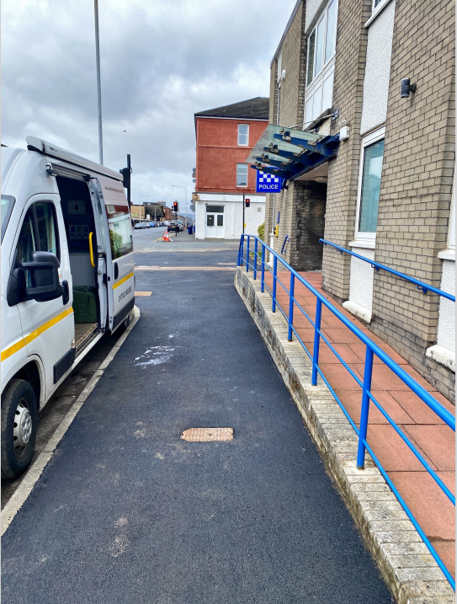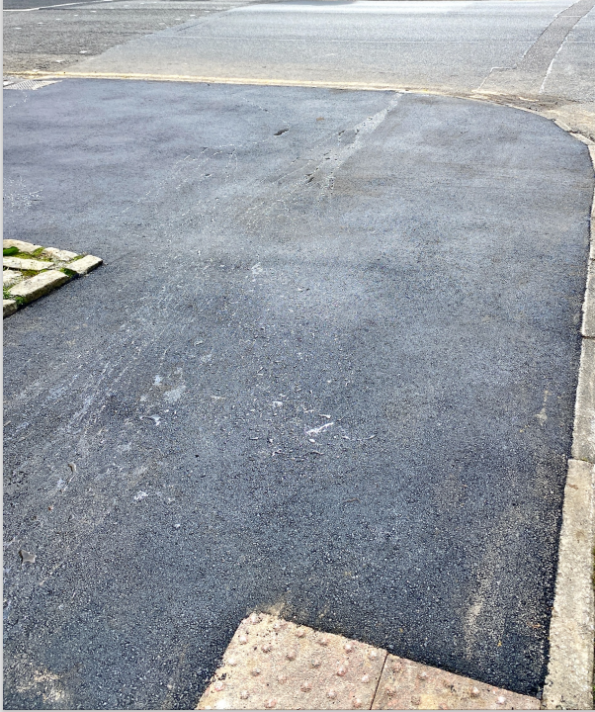

Glen Lonan

