
Please find below a brief snapshot of the huge range of work being undertaken across the area by Roads and Infrastructure staff this week.
Roads and Infrastructure
Weekly member briefing
Edition 143: 5th April 2024
The updates are designed as a resource for you to be able to answer constituent queries.
You can view all previous weekly member briefings on the website
Oban, Lorn and the Isles | Helensburgh and Lomond | Mid-Argyll, Kintyre and the Islands | Bute and Cowal
Roads updates  Surfacing work on the C32 Glen Lonan Road has now been completed.  The surfacing works on Mull for the Tobermory sea wall project are expected to be completed next week.  Street Lighting  Capital streetlighting works will be commencing next week in Oban to replace 70 columns, 2 electrical distribution units (HDU) and cable replacement over the following streets:  Nant Drive, Etive Gardens, Coe Gardens, Ure Gardens, Crecan Gardens, Lonan Drive, Orchy Gardens.  Pennyghael Bridge public consultation  The consultation will take place at Pennyghael Community Hall next week on Tuesday 9th April.  The online public consultation will run from Monday 8th April until 3rd May.  https://www.argyll-bute.gov.uk/my-community/community-planning/consultations/consultation/a849-280-pennyghael-bridge-replacement  Belnahua  The Belnahua ferry which operates the Luing and Seil Island service is due to go into dry dock for a major overhaul including engine replacement. This boat is currently 53 years old and whilst the boat will be required to have an annual dry dock and inspection to comply with MCA requirements, this major overhaul is potentially the last this vessel will see before it is replaced. The ferry is pictured below.  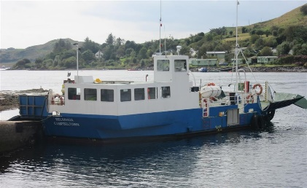 | Roads updates  A culvert collapse has been identified at the top of the hill near Blairvadach House.  Both our operations staff and flood prevention team are working together to carry out necessary works to rectify the flooding issues in the area.  Capital footway work  Surfacing work has recommenced on the capital footway schemes at Jeanie Deans Road, Guy Manning Road, Red Gauntlet Road and Tallisman Crescent.  These works were delayed due to the crews attending to emergency machine patching on the A814.  Luss TRO  The remaining signage for the Luss TRO is programmed to be installed next week.  External lining contractors have been programmed to attend w/c 15th April to carry out the necessary road markings in relation to the Luss TRO. As always this will be weather permitting. | Roads updates  Work is progressing well to construct a new large passing place on the Lossit to Ballygroggan Road in Kintyre.  A culvert running under the road has had to be re-routed and lengthened to accommodate the construction.  Carradale footway programme  Improvement work to increase the width of the footway and carriageway at Woodside is progressing well.  Alterations are being made to the existing carpark to accommodate the improvements however we are maintaining the same car parking capacity (see photos below).  Ardrishaig public toilet – door access control project  The trial at Ardrishaig seems to have been successful and the system was operated consistently for a full week.  On that basis we reactivated the toilets in Lochgilphead. If this goes well for another week we will look to turn on a few more.  Streetlighting  Works have started at Sound of Kintyre to finish installing replacement columns. This is scheduled to finish today.  Following this we will be arranging an external contractor to paint the columns to match the original colour. | Roads updates  In Cowal crews have been attending to general maintenance such as gully cleaning, machine offlets to alleviate flooding in areas, pothole repairs and the erection of car park signs.  Next week we are hoping to start pre surface dressing work  On Bute the team have been carrying out pothole repairs that have been identified through inspection.  We are aiming to start capital footway works on the B881 High Street (this work has been carried over from the last financial year).  Streetlighting  The St Brides capital scheme is now complete. All electrical connections have been made and lights operational. There are 2 x obsolete columns to be removed which we will be arranging within the next fortnight.

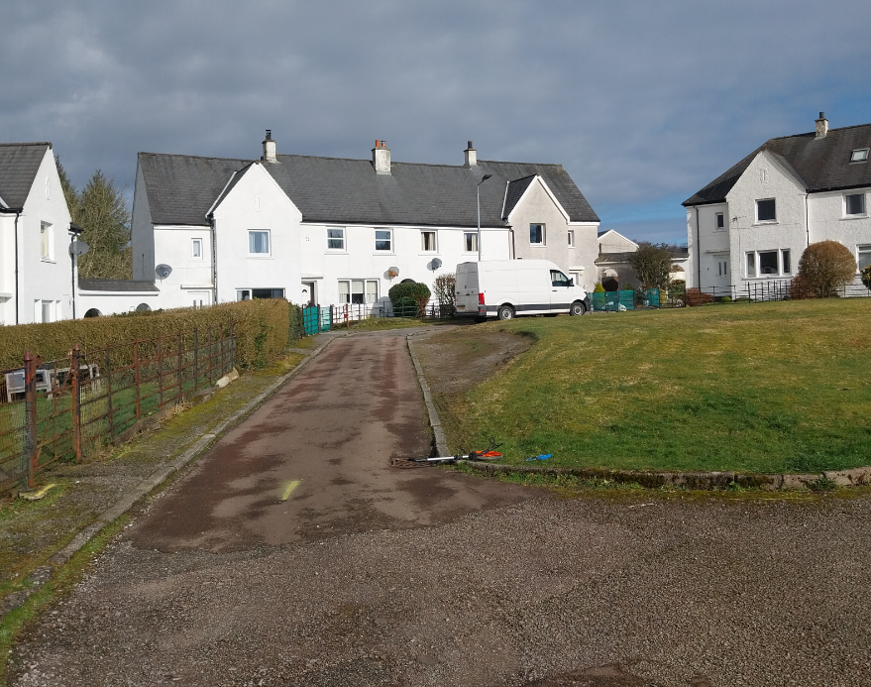

Ongoing footway and carriage way improvements at Woodside, Carradale

