
Please find below a brief snapshot of both the huge range of work being undertaken across the area by Roads and Infrastructure staff this week.
Roads and Infrastructure
Weekly member briefing
Edition 142: 28th March
The updates are designed as a resource for you to be able to answer constituent queries.
You can view all previous weekly member briefings on the website
Oban, Lorn and the Isles | Helensburgh and Lomond | Mid-Argyll, Kintyre and the Islands | Bute and Cowal | All areas
Roads updates  Surfacing work continues on the Glen Lonan Road and will continue into next week.  The surfacing works on Mull to complete the Tobermory sea wall project was delayed last week due to supply chain problems – these will now commence next week.  Street Lighting  Capital works will be commencing on 8th April in Oban to replace 70 columns, 2 electrical distribution units (HDU) and cable replacement over the following streets:  Nant Drive, Etive Gardens, Coe Gardens, Ure Gardens, Crecan Gardens, Lonan Drive, Orchy Gardens.  This a large capital scheme which will see the streetlighting in the area benefit from approximately £238,000 investment.  Oban Harbour Revision Order  We have now began issuing responses to representations made for the Harbour Revision Order.  We aim to have all responses issued in the next two weeks. | Roads updates  This week the team have been carrying out surfacing works at the access road to Cardross crematorium (see photos below).  The team have also been carrying out general maintenance duties such as repairing safety defects, gully cleaning etc ahead of the capital programme commencing in the new financial year.  Street Lighting  This week the team are working with our sub-contractor in Helensburgh to carry out column replacements which have been caused by vehicle and weather damage.  Waste disposal arrangements  Barr Environmental based in Alexandria are ceasing operations from 1st April. We use that site for general waste tipping. We have made an arrangement with another provider in Paisley for the moment while we explore other options closer to Helensburgh. This will ensure continuity of the service.  Kilcreggan flood alleviation scheme  A temporary road surface has now been put in place and our contractor will monitor this over the public holiday weekend. They are currently aiming to mobilise to site towards the end of the week to commence works. These works have been initiated following the original contractor having left site and a replacement contractor now mobilising to complete the works. | Roads updates  Work continues on the A819 at Electric Cottage along with other general maintenance duties across the area.  A new passing place is currently being installed on the Lossit to Ballygroggan road in Kintyre this week.  Port Ellen distillery road  The developer funded works in Port Ellen where the road to the Oa joins the A846 have been substantially completed and look great as can be seen from the photos below.  Street Lighting  The streetlighting team will be installing the remaining lantern heads at Sound of Kintyre next week.  Contractor assistance has been arranged for the erection of portable scaffolding at each column to assist with the heavier lantern heads. Work will commence on Tuesday 2nd April.  Ardrishaig public toilet – door access control project  The door payment system was activated at this location on Tuesday and appears to be running smoothly. We will closely monitor how the system is and if it operates consistently will look to progress with the other sites.  Claonaig ferry works  We are aware of issues arising from the CMAL works at Clonaig and the CalMac ferry timetable changes which appear to be causing increased traffic volumes despite previous assurances that this would not be the case. This appears to be causing damage to roadside verges and traffic congestion.  We are engaging with them on this issue.  Port Askaig  Contractors are mobilising at Port Askiag for the vessel enabling works for the new ferry vessels currently undergoing sea trials near to the ship yard in Turkey.  These works include changes to the mooring facilities, additional shore side power and changes to the car park and marshalling area. The car park and marshalling works are necessary to facilitate the increased number of vehicles being carried by the new vessels. | Roads updates  On Bute we have been carrying out culvert checks and road repairs that were identified during safety inspections.  In Cowal the lining contractors were in the area carrying out markings following some capital works in various locations.  Street Lighting  St Brides streetlighting civil works have been completed which involved excavation, cable tracking and the installation of two lighting columns.  The streetlighting team will now make arrangements for these to be connected  Bus timetables  CalMac are due to change to their Summer ferry timetable on the 29th March 2024.  To ensure we still meet connections at Rhubodach and Colintriave, along with providing suitable journeys to Dunoon and Portavadie, there will be some tweaks to the Service 490 and Service 478 timetables. | Financial year end  A lot of our teams are working hard at the minute to complete financial returns and measures for the year end process to ensure we balance the books for 2023/24.  Roads capital programme  The capital programme for 2024/25 was agreed at the Environment, Development and Infrastructure committee last week and has been emailed out to members in each administrative area.  Easter arrangements  Waste collections will continue to schedule over the Friday – Monday public holiday and operations of the Civic Amenity sites (opening times on ABC Website) will be as per normal.

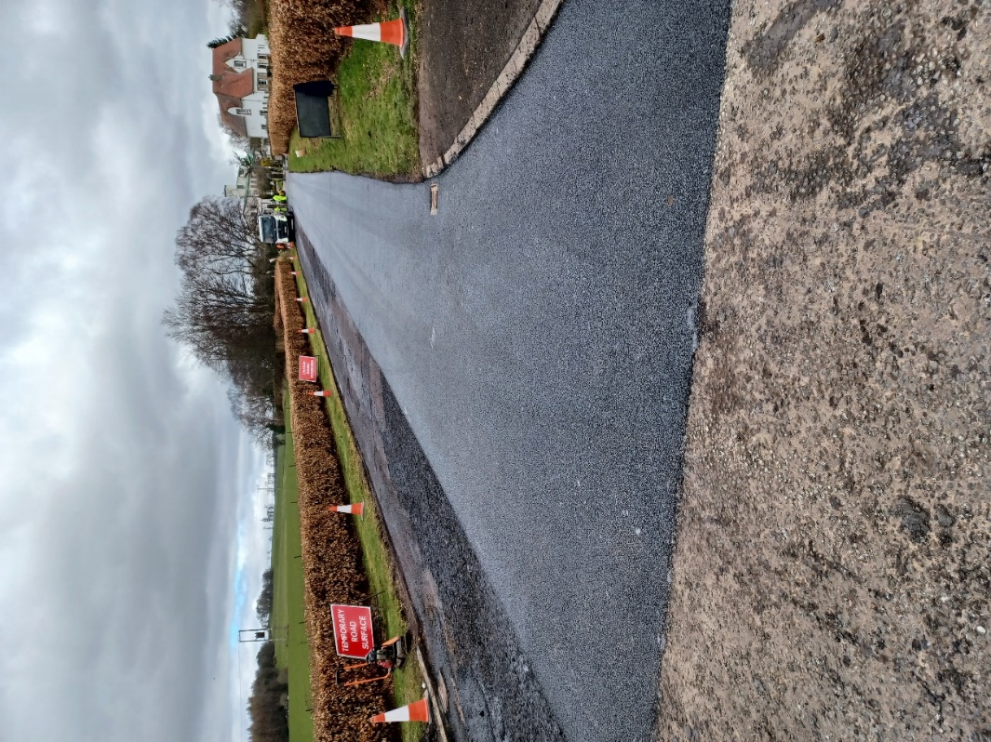
Surfacing work on the access road to Cardross Crematorium
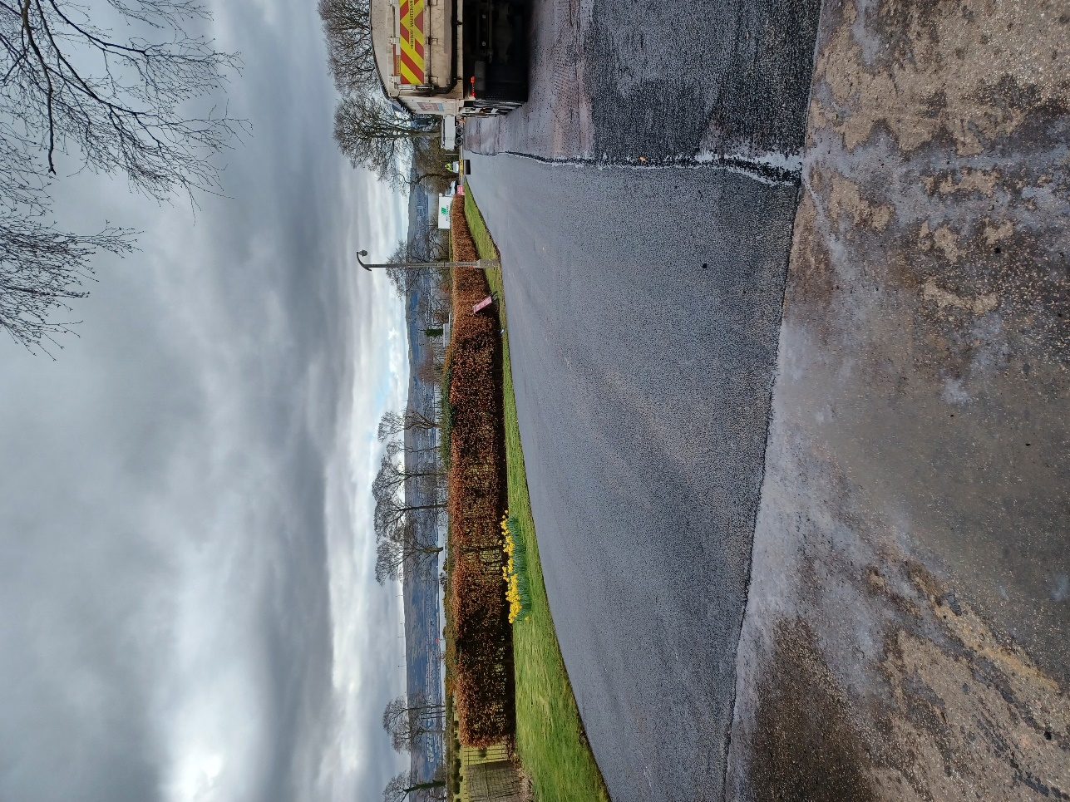

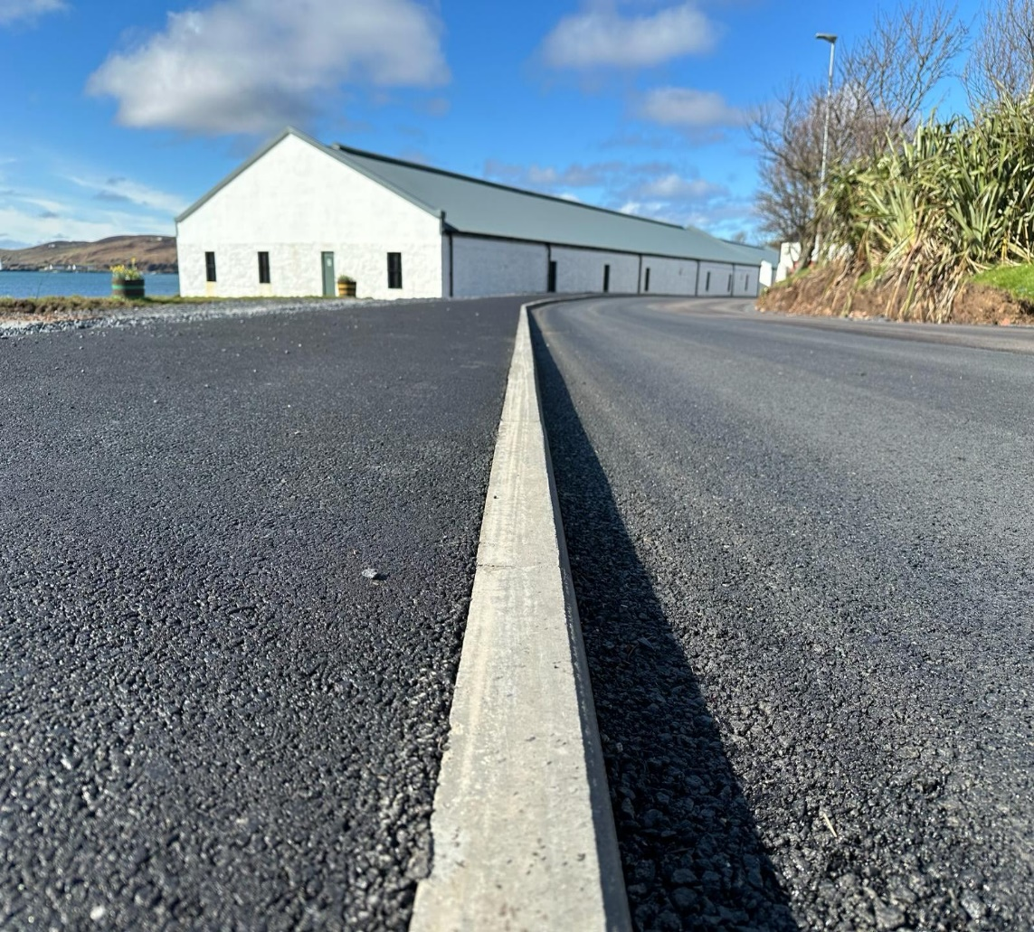
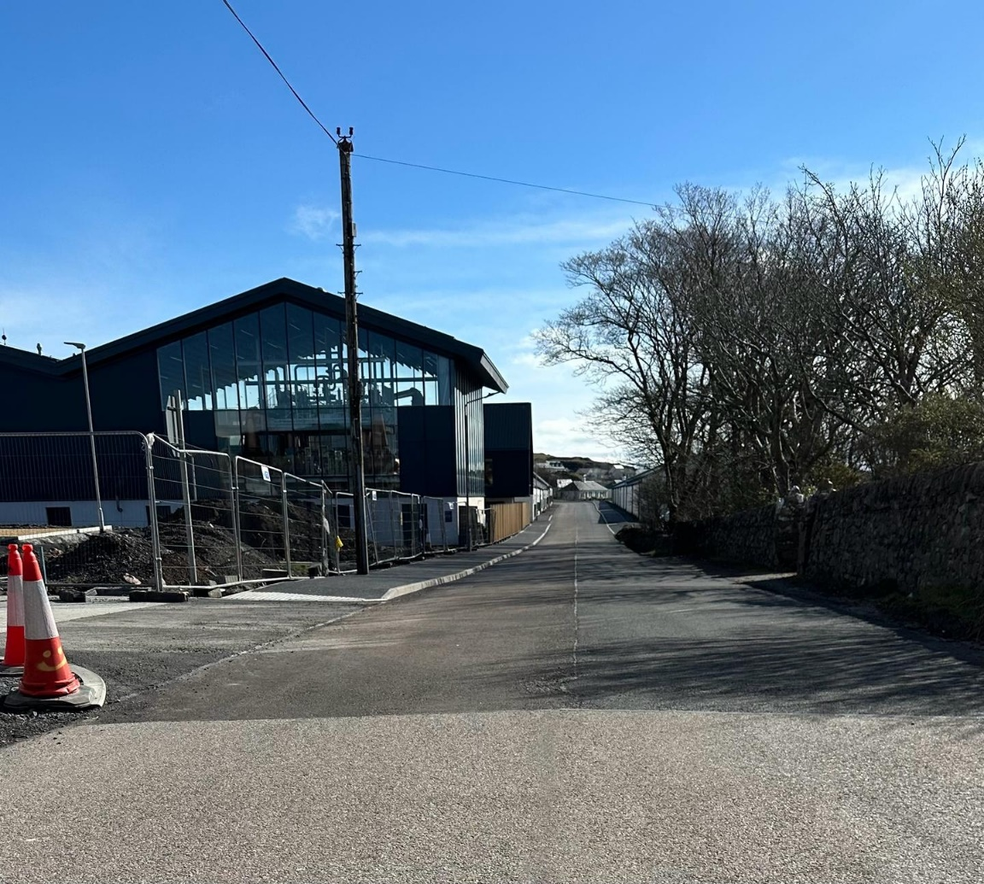
The developer funded works at Port Ellen distillery

