
Please find below a brief snapshot of both the huge range of work being undertaken across the area by Roads and Infrastructure staff this week.
Roads and Infrastructure
Weekly member briefing
Edition 139: 8th March
The updates are designed as a resource for you to be able to answer constituent queries.
You can view all previous weekly member briefings on the website

Oban, Lorn and the Isles | Helensburgh and Lomond | Mid-Argyll, Kintyre and the Islands | Bute and Cowal | All areas
Roads updates  This week we have been progressing footway improvements in Taynuilt as well as scrub cutting along the B840. This in addition to the usual day to day activities across the network like potholing, ditching etc.  Footway and lighting works are underway on Millpark Rd off Soroba Rd.  Craignure Pier  Despite recent setbacks and delays, we continue to engage positively with Marine Directorate and Nature Scotland to progress the licences required for the Ground investigation works planned for this spring.  An updated time line for works to begin will be available next week.  Mull waste collections  Members will be aware that we are having ongoing issues with waste collections on Mull because of ongoing vehicle reliability issues.  The team on Mull have been working hard including longer shifts and out at weekends. | Roads updates  The team have been undertaking machine patching this week on the A814 and at Dalmore Crescent.  This was to resurface approximately 150m2 on the A814 between Helensburgh and Cardross and approximately 300m2 at Dalmore Crescent at the junctions with Rhu road higher and Rhu road lower (before and after picture below)  Lining contractors  Lining contractors have attended this week and carried out requests to mark out gateway markings at the speed limits leading into some of the villages along the B872 and B833.  This has been funded through the road safety funding from the Scottish government (photo below of new markings into Garelochhead).  Blackhill Civic Amenity Site  Lining contractors are attending the site today to carry out internal road markings which will complete this project.  Cardross Crematorium  The crematorium will be closed again on 22nd and 23rd March for further improvement works. This will also give the opportunity to do surfacing works on the approach and cemetery improvement works. | Roads updates  Work continues on the A819 at Electric Cottage. This is a significant capital scheme to carry out edge strengthening and drainage improvement.  The jetpatcher has been working this week in Kilmichael Glen.  Brackley Cemetery  We can confirm the legal documentation has all been returned and the improvement work is programmed to commence on Monday 11th, weather permitting it should be finished by Friday 15th.  Carradale footway works Woodside  Positive discussions have taken place with the homeowners who initially raised concerns with the project.  We are hopeful that next week all documentation will be signed and returned allowing us to programme a start date for work to commence.  Port Askaig  Responses to points and questions raised by the local communities at the drop in sessions and on line, will be available next week.  The responses from Transport Scotland, CFL, CMAL and Argyll & Bute Council have been consolidated by CMAL as part of their port enabling works programme and on behalf of the Islay Projects Co-ordination Group.  Extra work is also nearing completion on drawings for the planned marshalling area to be available for comment. | Roads updates  In Cowal the team are carrying out resurfacing work along the B8000.  The jetpatcher has also been carrying out repairs in Cairndow and Glenbranter.  Footway and kerb repairs have also been undertaken along the A886 in Strachur.  In Bute the capital footway scheme at Marine Road has now been completed.  Next week the team will be carrying out preparation work for surfacing work on the A844, a 300mtr section between Ballianlay Farm and Ettrick Bay.  Streetlighting St Brides Road  We have a contractor programmed next week to carry out excavation work to assist us with required tracking work to repair faults. | Streetlighting  The team have now received the delayed delivery of lanterns. These supply chain issues have caused some delays to repairs which we can now progress.

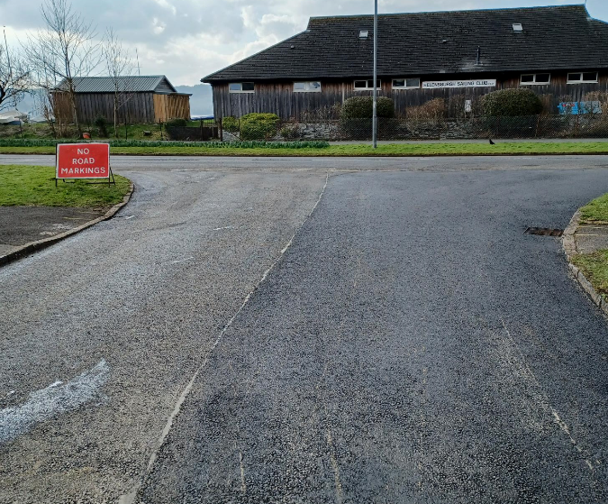
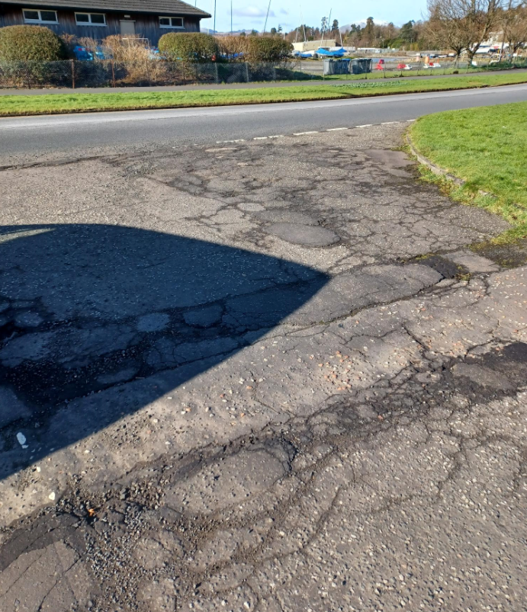

Dalmore Crescent before and after surfacing works

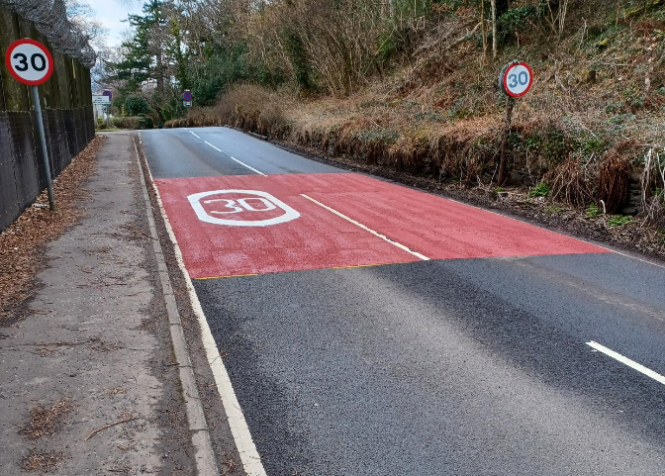

New road markings entering Garelochhead

