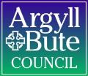
Member Zone: Member Enquiry Handling Update
To 08th March 2024
- SERVICE REQUEST PORTAL ACTIVITY
The table below shows the number of requests logged by members since the launch of Member Zone in June 2022 until 08th March 2024 and their status:
 | RIS Requests | Other Services | Total
Total Requests Made | 1704 (78%) | 482 (22%) | 2186
Requests in Action* | 150 | 38 | 188
Requests Actioned by Service(s) | 1554 | 444 | 1998
Requests Closed by Members | 1054 | 319 | 1373
Open with Members | 500 | 125 | 625
*Includes those awaiting response, escalated and where work is scheduled by Services.
Of the 188 responses in action as at 08/03/2024:
- 127 are with the Service for response
- 34 have work scheduled for completion
- 22 have had an initial response and the Member has asked for further information/clarification
- 5 have been escalated.
Of the 127 requests open with Services for response, 9 (7%) exceed their SLA response time by over one week (5 RIS and 4 Non-RIS). Note that at the last Sounding Board in October 2023 there were 151 open requests and 33 of these had exceeded their SLA by more than one week, so turnaround time is currently healthy.
Of the 2186 requests raised since inception, 185 (8%) have used the escalation process (157 automatically escalated by 20 day late rule, 26 by members and 1 by the Service).
The new autoclose function has so far resulted in 228 warning of closure emails being sent and 165 cases being closed (72%). There are currently still 625 cases with members awaiting their action.
- SERVICE REQUEST PORTAL – MEMBER FEEDBACK
  - Member Feedback On Member Zone Request Portal
In order to monitor timeliness and quality of responses over time from a Member perspective DST introduced new functionality in November 2022 to enable Members to voluntarily complete a short feedback survey on each response after they had marked it closed. In summary outcomes up to end of March 2024 are:
- 132 out of 142 (93%) respondents said they were moderately to very happy with the speed of response
- 142 out of 152 (93%) respondents were satisfied with the quality of response; 125 marking them good or excellent.
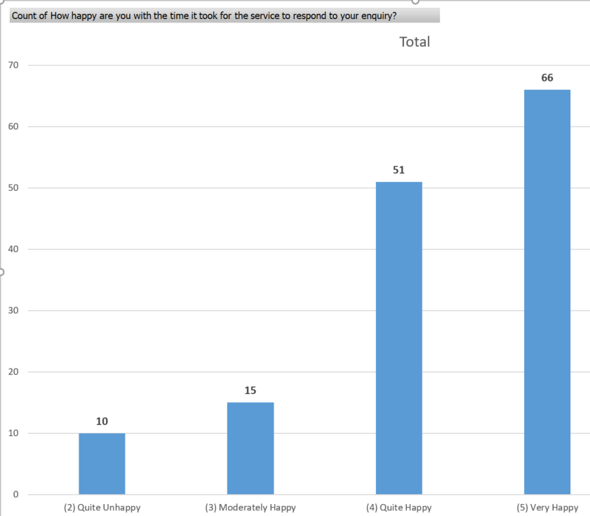
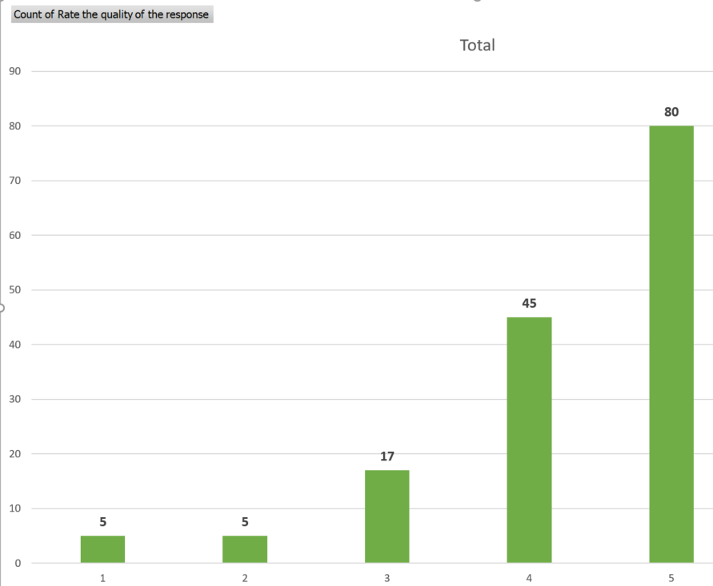
There were many positive comments including:
- This was over the New Year break and I was particularly pleased with the response I received.
- It took a while but the final result was excellent.
- The response to this was swift and compassionate and that is much appreciated.
Some less favourable feedback included:
- It was reported to Scottish Water but would have valued details of that report in order for me to follow up with Scottish Water if not resolved-a report number, or even date of reporting would have been helpful.
- Unhappy with the use of language use
RIS also have their own internal quality checking approach and feedback on requests relevant to them are reviewed as part of that to inform continual improvement.
  - Member usage of Member Zone Request Portal
It is important that the maximum number of member requests possible are routed to Services via the MZ portal as this allows Services to deal with them in a structured, efficient way and avoids perception of a two tier service to Members. It also helps members control their caseloads.
The average number of requests made per member since inception to 8th March is 61. The table below shows the number of requests per member since go live:
Banding of Number of Requests Made | Number of Members in this Banding
Zero – 40 requests made (Low) | 16 members
41 – 90 requests made (Moderate) | 13 members
91+ requests made (High) | 7 members
The highest number of requests made by a single councillor is 334. Online self service is the most popular way to raise and manage requests with 1831 (83%), of all requests managed this way, thus freeing up Member Services to help the democratic process in other ways.
Bob Miller
Customer Engagement Manager
March 2024

