

A request was received at Director level for Member Zone to be updated so that a reason could be given for any incidents that become overdue by 14+ days.
To record this, a new field has been added to Member Zone:
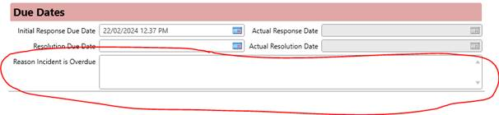
This field only requires to be filled in when an incident is 14+ days beyond its resolution due date. A scheduled report has been set up to email to Service Controllers (see attached example) for each service every day at midday. This email will only be sent if there are incidents for that service that:
- Have a status of Follow-up Response Pending
- Resolution Due Date is 14+ days overdue
- Nothing has been recorded in the above new ‘Reason Incident is Overdue’ text box

If your service receives this email, all you have to do is open any incidents that appear in the email and fill in the above Reason Incident is Overdue text box. Once the text box has been filled in for all incidents in the email, the email will no longer be sent. The report that lists all incidents overdue by 14+ days that don’t have anything in the Reason Incident is Overdue text box has been added to list of reports that service controllers can view when they’re logged in to Oracle and is called MZ: [service] - Overdue Reason Required:
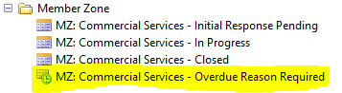
Please note that the information recorded for why a MZ incident is overdue by 14+ days will be reported on to senior management so it is important that the reason given is clear and an accurate reflection of the current position with the incident.

