
Please find below a brief snapshot of both the huge range of work being undertaken across the area by Roads and Infrastructure staff this week.
Roads and Infrastructure
Weekly member briefing
Edition 137: 23rd February
The updates are designed as a resource for you to be able to answer constituent queries.
You can view all previous weekly member briefings on the website

Oban, Lorn and the Isles | Helensburgh and Lomond | Mid-Argyll, Kintyre and the Islands | Bute and Cowal | All areas
Roads  We will complete the C32 Glencruitten capital scheme next week.  We will shortly be undertaking overlay works on the Glen Lonan Road for SSE as part of an ongoing project they are working on.  The capital job at Claddich is complete, as are passing place works on Mull. The team on Mull have also been undertaking replacement of damaged culverts on the Ulva Ferry road.  Craignure Pier fender repairs  Repairs to damaged fendering at Craignure Pier will be concluded with divers securing the final underwater bolts to the roundhead.  We have worked with our contractors to ensure that the work was carried out safely and with the minimum of disruption possible between ferry sailings.  Mull waste collections  There are still ongoing issues with waste collections on Mull which is a result of a number of vehicle breakdowns.  Crews have been working hard, working additional shifts including over last weekend and this coming weekend to try and catch up.  We are hopeful all collections will be up to date by the start of next week. | Roads  Capital footway surfacing work continues in Colgrain.  This is a large project that incorporates footways over three separate streets.  Blackhill civic amenity site  Work commenced this week to improve the surface within Blackhill Civic Amenity site (see photos below).  This includes removing over 150 tonne of material, and constructing a new road within the site which will allow for traffic to queue in the site rather than on the A818.  Work is expected to complete at the start of next week. There has been no disruption to the site for the public during the works.  Helensburgh and Lomond school transport tender  We are continuing to review the returns for this tender, which is a potential seven year contract for school transport services. | Roads  The capital footway job on Tomaig Road has now completed. The job at Killoenan Road which was subject to water damage was also completed this week.  We are continuing to work on the ongoing A819 capital project at Electric Cottage, which is a significant scheme.  We have been working on Bruichladdich footway capital project on Islay. We are also working with the nearby distillery to make improvements to the junction.  Burnside Square Consultation  We held a consultation open day earlier this week regarding finishing off Burnside Square following the significant improvements as part of the flood works.  There were a number of very positive discussions – we are in the process of collating feedback from the event and the online consultation which is ongoing.  Port Askaig plans  We have completed our draft responses to the online, written and verbal FAQs received from the public drop in sessions last month concerning our Port Askaig works.  They are being collated on behalf of CMAL, CFL, Transport Scotland and Argyll and Bute Council, and when all party responses are confirmed they will be published on line.  We will also ensure local groups and Members are aware of the responses. | Roads  On Bute we have been working on the capital footway scheme on Marine Road – this was slightly delayed as there was a minor road subsidence issue on Russell Street that required attention. We are planning to progress to the High Street footway job next week  In Cowal we have been working on capital footway works at Edward Street, King Street and Bullwood Road. These are all now complete. | Ferry service audits  Internal audits completed for our ferry services.  These are carried out to ensure compliance with various regulations and guidelines. This is a follow up to the successful MCA Document of Compliance (DoC) audits earlier in the month.  Public convenience door access control project  We are continuing to liaise with our contractor, Healthmatics, regarding the ongoing faults with the new system. There have been a number of discussions this week and we expect to see a rectification plan early next week.

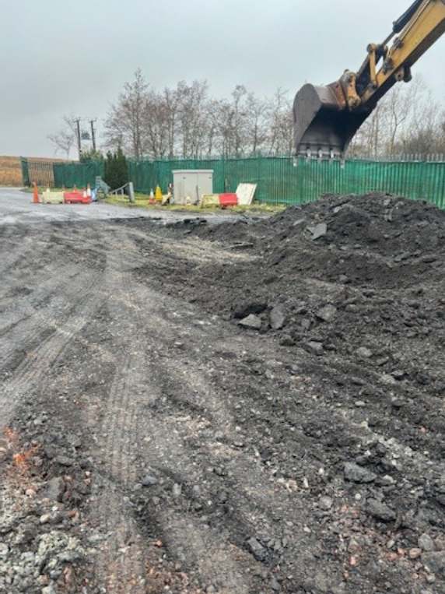
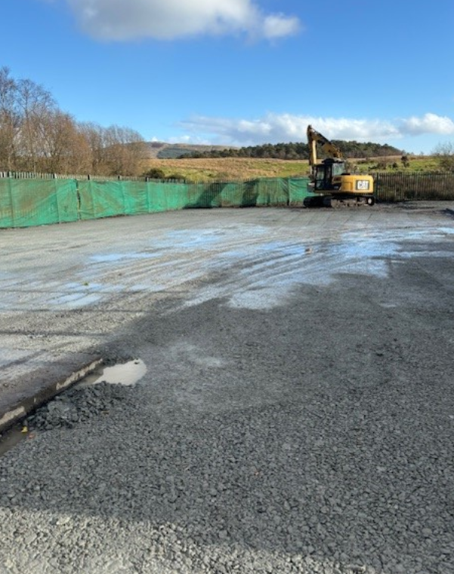
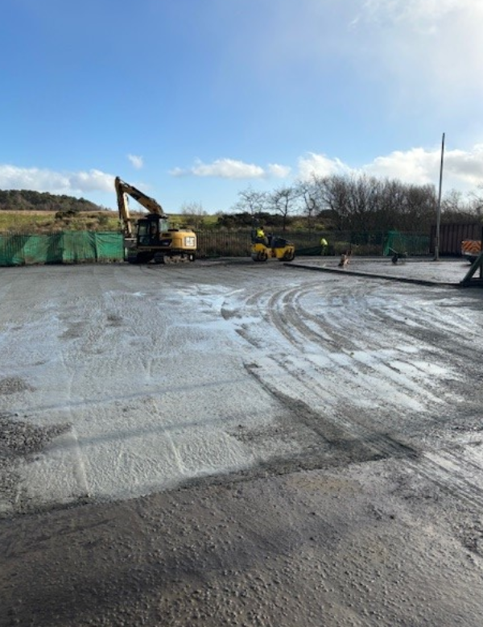
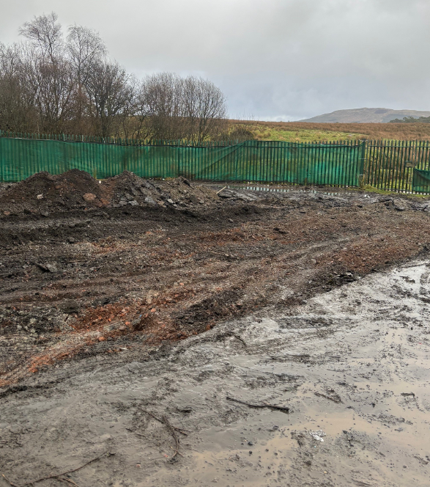
Improvement work at Blackhill Civic Amenity site

