
Please find below a brief snapshot of both the huge range of work being undertaken across the area by Roads and Infrastructure staff this week.
Roads and Infrastructure
Weekly member briefing
Edition 135: 9th February
The updates are designed as a resource for you to be able to answer constituent queries.
You can view all previous weekly member briefings on the website

Oban, Lorn and the Isles | Helensburgh and Lomond | Mid-Argyll, Kintyre and the Islands | Bute and Cowal | All areas
Roads  We are continuing to work through the significant capital job at the A819 Claddich, which we expect to conclude next week.  We’re also continuing with preparatory works ahead of surfacing on the C32 Glencruitten and replacing two culverts on the U19 Connel back road.  The team on Mull are carrying on with passing place improvements.  Streetlighting  We are gearing up for a significant capital scheme where we will be replacing 70 columns on Nant Drive and surrounding streets. We are out to tender at the moment for the new columns. Once we secure a column supplier we will be able to confirm a timeline for these works.  On Glenshellach Road a recent inspection has highlighted stability concerns with a number of columns, so we’ve acted quickly to progress column replacements, which are progressing.  Ganavan public convenience  This facility reopened this week following repairs to burst pipes. | Roads  We have been continuing with footway surfacing jobs in the Colgrain area this week, and this will continue next week.  We also have barrier contractors in next week replacing handrails in and around Garelochhead.  School transport contract  We are currently out to tender for the new school transport contract for the Lomond area.  Tigh Dearg Road flood alleviation scheme  Works are continuing on this scheme, with good progress made on excavations this week. The works were inspected earlier this week by both the Head of Service and the Principal Engineer. Meetings also took place with some of the resident to listen to the needs of the residents and discuss how the remainder of the works will be carried out, these discussions were well received.  We have appointed an independent third party engineer from AECOM (the same company we are using for the Campbeltown Flood Scheme) who will be liaising directly with local residents. We are in the process of arranging an on-site meeting for later in February  The picture below details the installation of an upsized storm water and new foul sewer, the latter being part of a Scottish Water system.  The site have very narrow access making delivering the works quite difficult. This has been compounded with rock which has had to be broken out. The works have now progressed passed the narrowest section and ground conditions have also improved meaning that the works should be progressing at a faster rate than of late. | Roads  Next week in Kintyre we will be completing the Tomaig Road footway job as well as repairs to Killoenan Road, which recently experienced some surface break up as a result of water damage.  The majority of our roads staff have been working on the A819 job at Electric Cottage, which is continuing.  We are looking to arrange to send the jetpatcher to Gigha shortly in order to repair defects which have developed over the winter.  Jura speed limit traffic order  We are going through the process of promoting a speed limit order at Craighouse on Jura. The order has been advertised and has received no objections so we will be moving to the next stage which is a further six weeks advertisement period.  Subject to receiving no objections we should be able to have the order in place towards the end of April.  Islay school and public transport contract  We’ve been to tender for this new contract. We are currently in the process of reviewing the tender returns.  Tarbert public convenience  Power was restored to the public convenience and it was able to reopen earlier this week.  Streetlighting  We have a few jobs around the area that require excavation works – we are currently arranging contractor assistance through our small works procurement framework, as our in-house teams are fully committed to cyclic and capital works including the scheme at Electric Cottage mentioned above. | Roads  On Bute capital footway resurfacing is ongoing at Port Bannatyne.  In Cowal we are also undertaking footway works at King Street, Bullwood Road, Cothouse and Hafton Court.  The jetpatcher is working in West Cowal around Tighnabruiach, the A8986 and Strachur areas.  We are also continuing with scrub cutting on the A815.  Streetlighting  There is an outage on John Street which appears to be caused by a power supply issue – we are liaising with the power supplier, SSE. In the interim we have temporary solar powered lanterns in place.  Bus shelters  We are working with our contractor to progress repairs to various bus shelters on Bute and in Cowal. | Trunk road bus shelters  We have a meeting near the end of the month with Transport Scotland to discuss potential new bus shelters at various points along the trunk road network.  Streetlighting  We are currently awaiting a large order of new lanterns (120) which will allow us to progress outstanding dark lamps repairs across the area. These should arrive in the next couple of weeks.  Scottish Flood Resilience Conference  One of our engineers, Jamie Salmon, represented the Council at the national flood resilience conference in Edinburgh this week, giving a presentation on the Campbeltown Flood Protection Scheme along with our design consultants AECOM and the principal contractor Dawson Wam.  This presentation was part of a session on funding challenges for flood schemes.  You can read more about the conference in the programme which is available here.  Winter Weather  The weather has been quite mixed over the last week, from our weather stations we have had road surface temperatures recorded as low as _7⁰C.

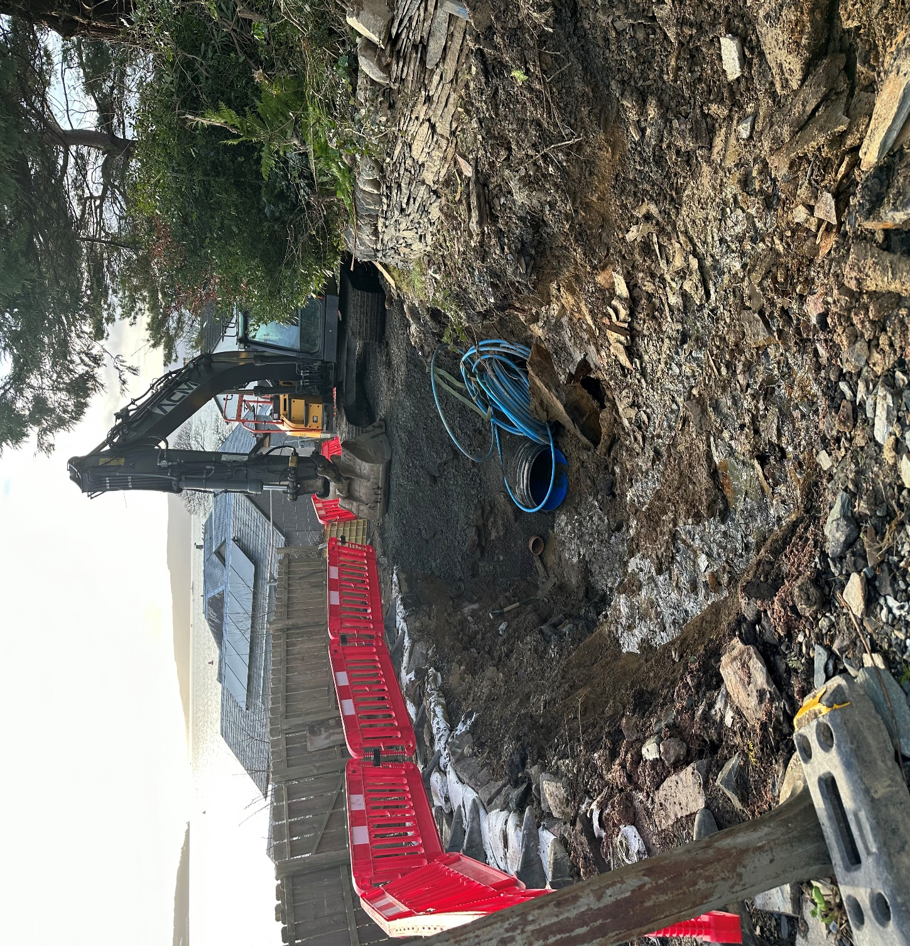
Tigh Dearg Road flood alleviation scheme – 600mm storm pipe being laid

