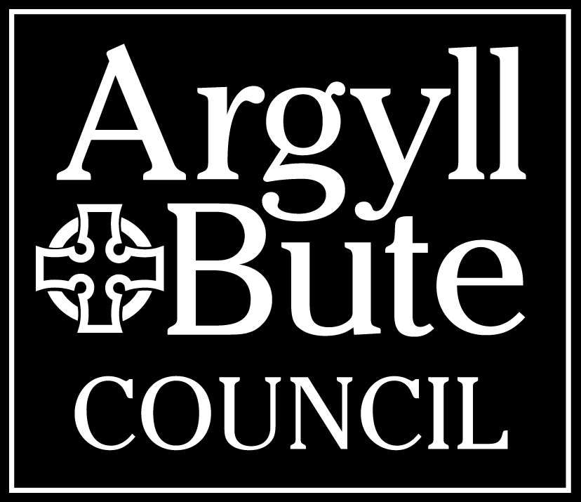

SUPPORTING COMMUNITIES FUND 2023/2024

END OF PROJECT MONITORING REPORT

We hope that your funded project / activity went well. We are grateful to you for completing this report.
The Council has a responsibility to account for spending of public funds and this report helps with that. It is a requirement that you complete all sections of this form. If you have any questions about this please get in touch at: communitydevelopment@argyll-bute.gov.uk, 01436 657 647.

Name of your Organisation:

Name of Project / Activity Funded:

Amount of funding from the Council’s Supporting Communities Fund: £

1. Spend (Please provide a full breakdown of all actual project / activity costs. The projected costs are the costs expected from your original application form).

Description (this should directly relate to your original application form). | Projected Costs (at time of application) | Actual Costs
Total:
Note: All funds allocated are to be spent by the end of September 2023, and any unspent funds require to be returned to the Council.

2. Income (Please provide brief details of how the whole project was funded e.g. other grant schemes, fundraising, own funds etc).

Source of Income | Description | Amount
3. Did you meet the aims of the project? (Please give details of the main activities undertaken, this is important as projects and activities are funded based on their aims and it is in the interest of the public for the achievements of the project to be shared).
4. What impact did your project have? (This section should also include examples of how individual participants/service users experienced the project/activity - case studies/quotes can be used. You can attach evidence and include links to social media).
5. How many people benefited from the project? Please enter the number of people in the relevant table below. The council evaluates this information to monitor equality and fairness.

If you are entering a number less than four, in the interest of anonymity. Please enter ‘0-4’.

Ethnic Minority | Low Income | LGBTI | Disability | Young People  To age 24 years | Older People  65+ | General Community

6. Did you work in partnership to deliver the project, what money or benefit did that bring?
7. Key Learning Points (Please detail anything you have learned, including anything that would be done differently in the future, any training needs or any challenges? We are interested in this as our Community Development Team can work with your group to support your growth and development).
8. Social Media (optional) Please detail which platforms you use and how they worked for this project, for example Facebook, Twitter, Instagram. Did you use hashtags such as #abplace2b?
9. Do you have any comments to help us improve our funding process?
10. Where did you hear about the Council’s Supporting Communities Fund?
It can be helpful for community groups to see the range of projects that we fund, If you have a photograph of your project that you would like to share on Argyll & Bute Council’s website/social media platforms please include it with this form (If we decide to use your project as an example we will be in touch to agree the wording of any content and GDPR requirements before anything is published).
I

Signature:
(electronic signature acceptable)
Print name:
Position held in organisation:
Date:
Please note: The Council reserves the right to request copies of all receipts for expenditure.

PLEASE RETURN THE COMPLETED FORM TO:
Service Standards Officer,
Helensburgh and Lomond Civic Centre,
38 East Clyde Street,
Helensburgh,
G84 7PG
Email: supportingcommunitiesfund@argyll-bute.gov.uk

DATA PROTECTION
The information you supply on these forms will be used for the purpose of your Supporting Communities Fund grant, and appropriate measures are in place to protect your personal data. A full privacy notice, which provides information about your rights under current data protection legislation and details about what will happen to your personal data can be found at
https://www.argyll-bute.gov.uk/privacy/community-development.
If you need this in an alternative format please contact Community Development on 01436 657647.

