

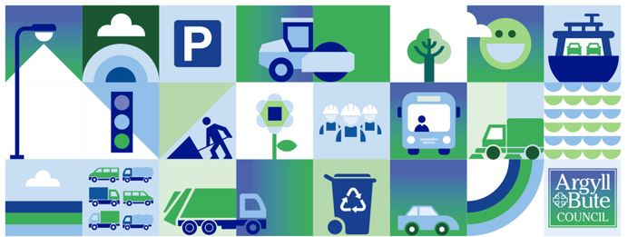
This week’s briefing takes a different format as this is the last working day for many until 3rd January, so we’ve included below details on festive working arrangements, what to do in an emergency as well as providing a brief reflection over the last calander year for the services that Roads and Infrastructure (RIS) deliver for our communities.
Roads and Infrastructure
Weekly member briefing
Edition 130: 22nd December
2023 has been an incredibly busy year across the wide and diverse range of services that RIS deliver. Great progress has been made delivering cyclic and planned work across the services. We continue to be sucessful in securing external funding, often from very competitive bids, which has enabled many additional projects to be progressed this year including but not limited to:
- flood prevention at Campbeltown with around a total of £12M* of external funding
- bridge replacement programme with around £5.5M* of external funding
- play park funding with almost £900k* of external funding
- timber transport roads funding c £390k,
- flood resilience and railings at Tobermory with around £450k of external funding
- grant received in the last quarter of 2023 for Recycling Infrastructure c£900k
*Projects which will span more than one calender/financial year.
In addition to our cyclic, planned and additional externally funded work RIS, supported by a number of suppliers and council colleagues, played a very significant part in responding to the effects of a major weather event in early October. Members will be very familiar with the activities which resulted from the weather event which included: urgent repair works to a number of bridges, a temporary ‘bailey’ bridge, a complete bridge replacement (in an impressive 2 weeks), several thousand tonnes of landslip and washout debris cleaned from the road corridor, several sites where embankments/reventments and road edges have had to be rebuilt and reinforced, an emergency by-pass road built to avoid an unstable hillside, temporary arrangments for home to school transport including a passenger ferry service, bin collection routes rescheduled using diverted routes to name but a few. These additional unplanned works effectively meant that almost all of the staff across RIS together with colleagues from many other council services, external partners and communities played a part in the initial response and subsequent recovery works. Those not directly involved had to pick up work from colleagues who were involved. Overall it was great to see and be part of such a huge collaborative effort to provide vital services to the communities we serve.
Many of our staff will be working in between Christmas and New Year, while others will be on stand-by to ensure the road network remains open and safe during any periods of poor weather, which could include being out driving gritters on Christmas Day and New Year’s Day if there is forecast cold weather. Council run ferries, refuse and recycling collection services etc only stop for Christmas Day and New Year’s Day, and our burial service have 5 burials to support between Christmas and New Year.
On the Member Zone resource library you’ll be able to access things like the winter policy and briefing notes on winter. There are also a range of useful resources such as the daily action plan on the Council website here. There you can also access gritting routes, grit bin locations, road cameras and handy FAQs.
For any out of hours emergencies we use a system called RALF, which is used by most roads authorities in the West of Scotland. They operate a call centre in Glasgow which has the contact details of our stand by rota to pass on incidents. You can call RALF on 0800 373 635. The Council’s call centre will be available on 27th, 28th and 29th December from 9am til 12.30pm. More information on the overall arrangements for the Council during this period are available here. On that page you can also find links ot the festive ferry timetables – our ferry crews will be working over the period, but not on Christmas Day or New Years Day.
There are some changes to bin collections over the festive break, and all the details are on the website here.
The A816 emergency bypass opened last week and is operating well. There continue to be parts of the network which are either restricted or closed as a result of damage from the October weather event. We are making good progress with repairs works and we have been regularly updating the service disruption section of the council website. We’ll do a final update today, and we don’t expect the situation to change over the holiday period following today’s updates. However, our teams are working and any significant changes or incidents will be posted via Service Disruptions.
Earlier this year we ran a short survey on the usefulness of these briefings – we only recevied a limited number of responses so we’ll look to run this again in the New Year. Hopefully these weekly updates are continuing to be helpful to you in answering any constituent queries and providing topical and helpful information. From the informal feed back we receive from Members we understand that you find these briefings beneficial.
We will be back with edition 131 on 12 January 2024, in the meantime all the very best over the festive period from all the team at RIS.

