

Please find below a brief snapshot of both the huge range of work being undertaken across the area by Roads and Infrastructure staff this week. The main part of this week’s briefing is in the attachment specific to the weather event and response.
Roads and Infrastructure
Weekly member briefing
Edition 129: 15th December
The updates are designed as a resource for you to be able to answer constituent queries, alongside the information on the weather impact webpage.
You can find details of the weather impact specific service disruption on the Council website here. We are continuing to update this twice daily with the live position.
You can view all previous weekly member briefings on the website


Oban, Lorn and the Isles | Helensburgh and Lomond | Mid-Argyll, Kintyre and the Islands | Bute and Cowal | All areas
Roads updates  This week crews have been assisting with the surfacing work for the new A816 bypass route.  Next week they will be carrying out some required surfacing work on Glen Lonan Road.  Work continues to progress well with the capital scheme on the A819, Claddich bends.  Harbour Revision Order  Representations from the ongoing HRO consultation are being sent to us via Transport Scotland. We are working through the responses.  The consultation runs until 10th January. | Roads updates  General maintenance is being carried out across the network such as gully cleaning, pothole repairs etc..  The barrier contractors are currently working on the A814 and will move on to repair a broken handrail on the Fairway in Garelochhead next week.  Public convenience door access control project  Unfortunately there remain some snagging issues with the installations undertaken so far in Helensburgh.  We have asked the contractor to rectify these issues, which will happen at no cost to the Council. | Roads updates  The A816 bypass roadworks are scheduled to finalise this evening with final safety checks to take place in the morning.  The route which will be unrestricted and operated under convoy will open tomorrow at 1pm.  Bus services -  Carradale Footway Programme  Local residents at have been issued with a letter to request their agreement regarding the improvement works to increase the width of the footway and carriageway at Woodside, Carradale.  As the improvement would affect the existing carpark we are proposing to enlarge the car park and the layout which will improve the available parking.  Public convenience door access control project  Unfortunately there remain some snagging issues with the installations undertaken so far in Mid Argyll.  We have asked the contractor to rectify these issues, which will happen at no cost to the Council | Roads updates  The Vactor unit successfully cleared the majority of blocked culverts on the A815.  There is one problematic covert remaining that requires further lining, pipe and concrete work to prevent further blockages.  Streetlighting  Work continues on the capital streetlighting scheme at Kilchattan.  There have been slight delays due to staffing availability however we will be looking to complete this scheme week commencing 8th January 2024.  Public convenience door access control project  Unfortunately there remain some snagging issues with the installations undertaken so far in Cowal.  We have asked the contractor to rectify these issues, which will happen at no cost to the Council. | Festive Bin arrangements  Changes to bin collections over Christmas and New Year are now published on the website here - https://www.argyll-bute.gov.uk/rubbish-and-recycling/festive-bin-arrangements  Footway Parking ban  The footway parking ban is due to came into effect on Monday 11th December, however; the Council, like most of Scotland’s local authorities, will not be in the positon to commence enforcement within 2023.  There are a number of technical details that will require to be finalised prior to enforcement being carried out by the Councils warden team, including back office IT systems and other processes and associated training for staff.  We will provide a further update on this in the new year.
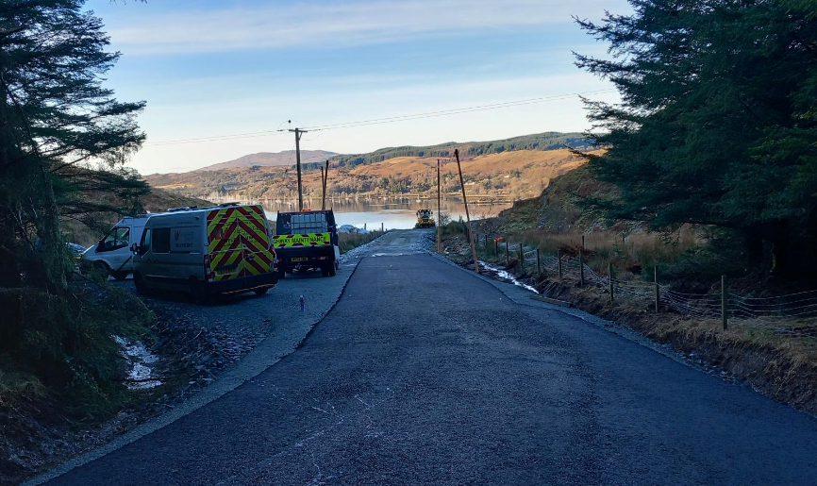
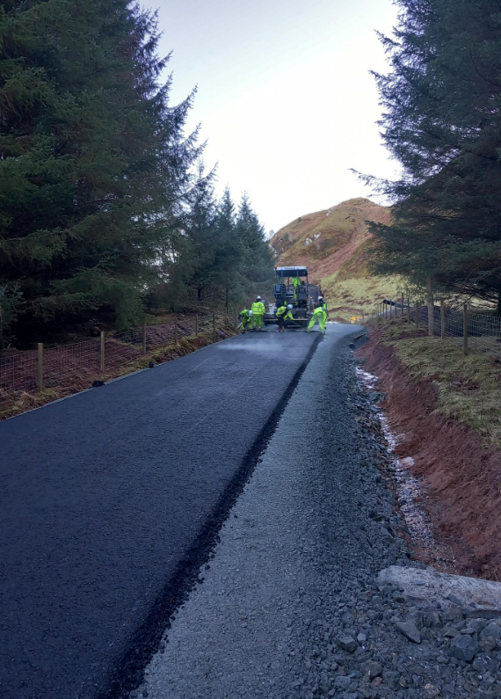

The newly surfaced bypass route on the A816, Ardfern

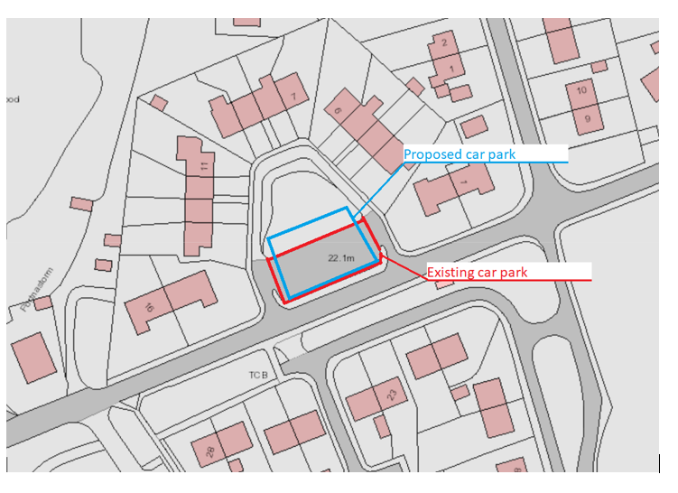
Proposed changes to parking area in Carradale

