

Please find below a brief snapshot of both the huge range of work being undertaken across the area by Roads and Infrastructure staff this week. The main part of this week’s briefing is in the attachment specific to the weather event and response.
Roads and Infrastructure
Weekly member briefing
Edition 128: 7th December
The updates are designed as a resource for you to be able to answer constituent queries, alongside the information on the weather impact webpage.
You can find details of the weather impact specific service disruption on the Council website here. We are continuing to update this twice daily with the live position.
You can view all previous weekly member briefings on the website


Oban, Lorn and the Isles | Helensburgh and Lomond | Mid-Argyll, Kintyre and the Islands | Bute and Cowal | All areas
Roads updates  Crews continue to progress with the carriageway widening work on the A819 at Claddich.  This work will continue into the new year and the site is currently is being operated under traffic management.  Streetlighting  The team have been assisting SSE to carry out repairs and to make a new connection for faults affecting Albert Street, Albert Lane, Nursery Lane and Mull Terrace.  Harbour Revision Order  Just a reminder that we have now applied to Scottish Ministers to make a Harbour Revision Order to extend the councils jurisdiction as harbour authority for Oban Harbour to the wider bay area.  The consultation is now live and will run until 10th January 2024.  More information on the order and the consultation can be found here | Roads updates  The roads team will be undertaking repairs to the footway on East Clyde street outside Farmfoods.  The team are re-instating 60 meters of footway that was damaged during the heavy rains on 7th October.  The safety barrier contractor is also due in next week to repair the safety barrier on the A814 that was damaged by a landslip also on the 7th October.  Drainage improvement work will be carried out on Red Road. The team will be installing a new underground pipe to divert excess water to help alleviate flooding issues in the area | Roads updates  Work continues to progress well with the emergency route on the A816.  The drainage and final touches to the road’s stone foundation will continue over the next couple of days with surfacing scheduled next week and the road opening on 16 December.  Image below shows the new bypass road connecting onto the existing road.  Port Askaig Development  Port Askaig will be upgraded next year to accommodate the new  larger capacity CalMac ferries with the first new ferry expected in October 2024.  Local members should have received an email with attached presentation showing the proposed changes.  Members of the Marine Operations team will be attending ebvenets at Port Askaig on 10th & 11th January and will be utilising this time to meet with Jura Community Council. Likely topics to discuss will be Craighouse and Jura Ferry routes. | Roads updates  We had a small landslip at the Coylet on the A815 last night.  Crews worked hard to get the area cleared quickly and following a safety inspection from our specialist contractors Geo-rope we were able to reopen the road around midnight last night.  A number of trees have fallen over the water course and the team will be working to clear these asap.  Rothesay passenger lift  Specialist training is required to operate the passenger release system, in case of an emergency. As this is not offered by our contractors Kone, we approached an alternate provider, once repairs to the lift completed.  Due to the specialist nature of this training, this has taken time to arrange.  Training will take place before the Christmas break and lifts will open following this and in the meantime, staff are available to help anyone who needs assistance getting on and off the boat. | Festive Bin collections  Festive bin schedules have been finalised and will be available on our website next week.  We will include a link to this information in next week’s briefing.  Free Festive Parking  All off-street parking charges will be suspended across Argyll and Bute for the two-week period prior to Christmas Day.  This is to encourage residents to support local shops in the lead-up to Christmas.  Free parking will be in place from 11th to 24th December inclusive.
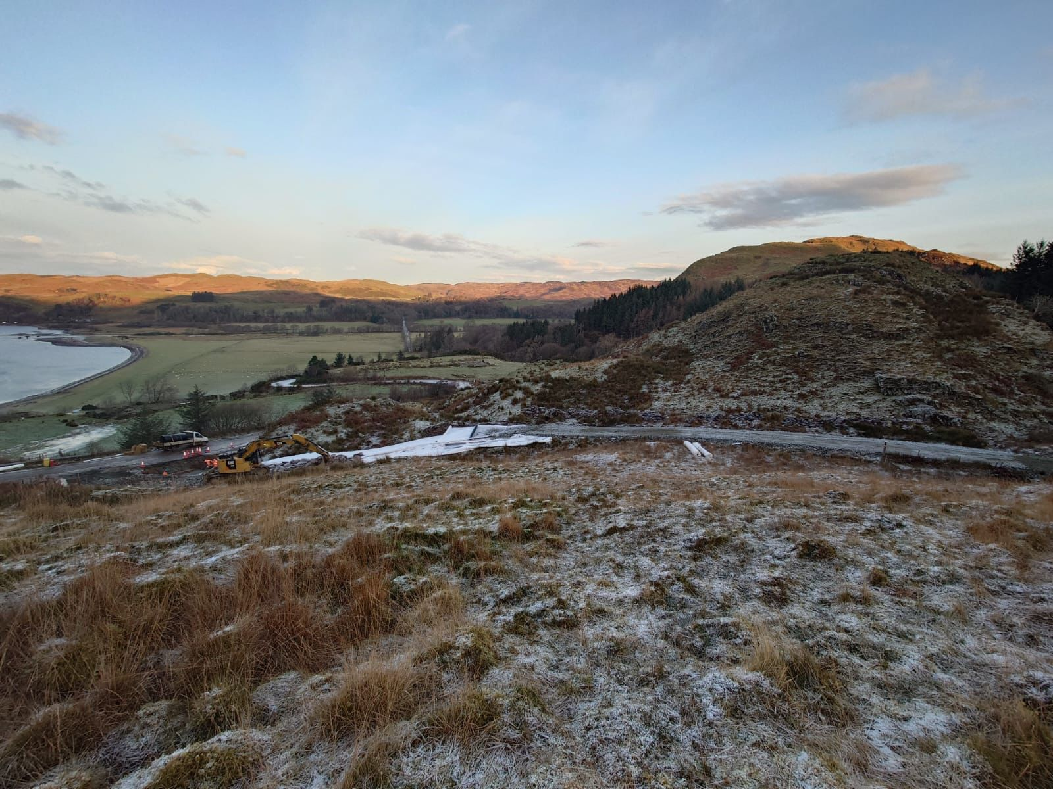
Image shows the emergency bypass route connecting to the main road (A816).
The white material is a geotextile which helps to spread wheel loads and also satisfies the Archaeologists/Historic Scotland in ensuring that disturbance is limited in the areas they have deemed as being sensitive

