

Please find below a brief snapshot of both the huge range of work being undertaken across the area by Roads and Infrastructure staff this week. The main part of this week’s briefing is in the attachment specific to the weather event and response.
Roads and Infrastructure
Weekly member briefing
Edition 127: 1st December
The updates are designed as a resource for you to be able to answer constituent queries, alongside the information on the weather impact webpage.
You can find details of the weather impact specific service disruption on the Council website here. We are continuing to update this twice daily with the live position.
You can view all previous weekly member briefings on the website

Oban, Lorn and the Isles | Helensburgh and Lomond | Mid-Argyll, Kintyre and the Islands | Bute and Cowal | All areas
Roads updates  Surfacing work in conjunction with the Tobermory handrails project was suspended this week due to the weather conditions. The team are hoping to continue with this next week.  Mull bin collections  A number of bin collections have been disrupted across Mull this week.  These collections have been rescheduled for today and over the weekend to allow crews to catch up.  Harbour Revision Order  We have now applied to Scottish Ministers to make a Harbour Revision Order (HRO), which will extend the Council’s jurisdiction as harbour authority for Oban Harbour to the wider bay area.  The consultation is now live and will run until 10th January 2024.  More information on the order and the consultation can be found here  Amenity Officer  Following the retirement of our amenity officer Stuart Clarke we welcome Andrew MacLellan into the post.  Andrew has been the stand in supervisor for Stuart for the last 15 years and is settling into his new role well. | Roads updates  The team have been installing new dropped kerbs in Luss this week and this will continue into next week.  This work is part of the Traffic order works that will improve access in and around Luss.  Emergency works to repair a damaged crash barrier on the B872 following an accident have been completed this week.  Streetlighting  All faults that’s have been identified following work carried out by Virgin Media have now been resolved.  There have been a significant amount of notices issued to Virgin Media following substandard work and we will continue to monitor future works | Roads updates  A816 Ardfern landslip  A Members Seminar was held on Wednesday this week where a presentation with an update on the A816 landslip and the wider disruption caused was given. This presentations will be available on the Members Portal soon.  Jim will also be virtually attending a meeting with Craignish Community Council on Wednesday 6th December to address any further concerns from the community.  Work is progressing well and we are currently on target for the emergency route to open on the 16th December.  Daily updates are provided on our disruption page here  Claonaig  There have been a number of technical challenges around the actual ground conditions which has resulted in various different design solutions brought forward, challenged and subsequently amended.  The design phase is coming to a conclusion and tender documents being drawn up.  There are restrictions on access to ground which we will need to occupy during the works, these relate to the shooting season.  Subject to a satisfactory tender return we are hoping to be on site March/April 2024.  Port Askaig  We have had a positive set of meetings with Transport Scotland, Calmac, CMAL and George Leslie regarding the Port Askaig Development.  A further update will be issued early next week with plans, drawings and timescales. | Roads updates  Balliemore Bridge  Following final surfacing works this afternoon the bridge fully reopened at 16.45 today.  Public transport services will resume back to their original routes tomorrow and school bus services resume back to normal Monday 4th December.  Further information can be found here  A815  The Vactor unit has been in attendance cleaning culverts along the A815 following the October storm.  A Vactor unit is designed to clean the largest, deepest and most inaccessible parts of drainage systems. It will allow us to flush the full pipe network ensuring any other blockages that haven’t yet been rectified are cleared.  Streetlighting  Crews continue to assist the streetlighting team with the capital scheme at Kilchattan Bay that will see an additional 5 new columns installed  Amenity Officer  Following a competitive interview process for the role of Amenity Officer on Bute, Ross McLaughlin, the current cemetery foreperson, has been offered and accepted the position.  It has been agreed with Ross to commence his role on Monday 4th December 2023, to allow for a handover with the current post holder, Joe McCabe, prior to Joe’s departure on 17th December 2023. | Winter maintenance  The change in weather conditions over the past week has escalated our Winter Service response to forecasts.  So far we have used 2300 tonnes of salt, this being the highest volume for this time of year, in the last 4 seasons.  Forecasts predict similar conditions will persist for another week in most districts, and snow is forecast on the leading edge of rain over the next 48 hrs with daytime low temperatures remaining a feature.  Deliveries of salt are expected early next week to ensure stocks are replenished.  Environment, Development and Infrastructure Committee  The Environment, Development and Infrastructure Committee met on Thursday 30 November where a number of Roads and Infrastructure matters were considered – Waste PPP Update, Cemetery Assets, Pay Parks and the October Weather Event.  More details and the full reports can be found on the website here:  Agenda for Environment, Development and Infrastructure Committee on Thursday, 30 November 2023, 10:30 am - Argyll and Bute Council (argyll-bute.gov.uk)

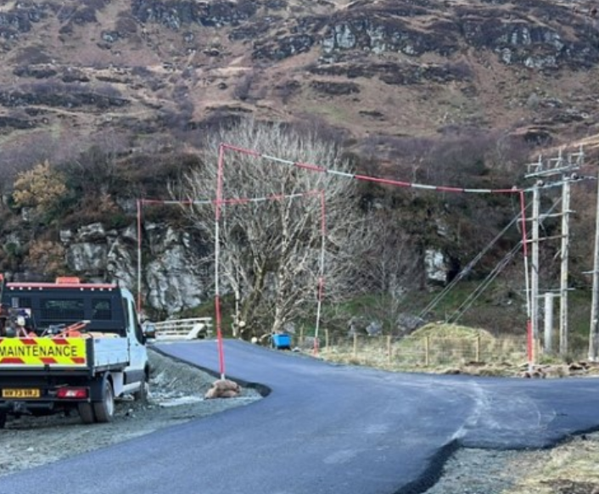
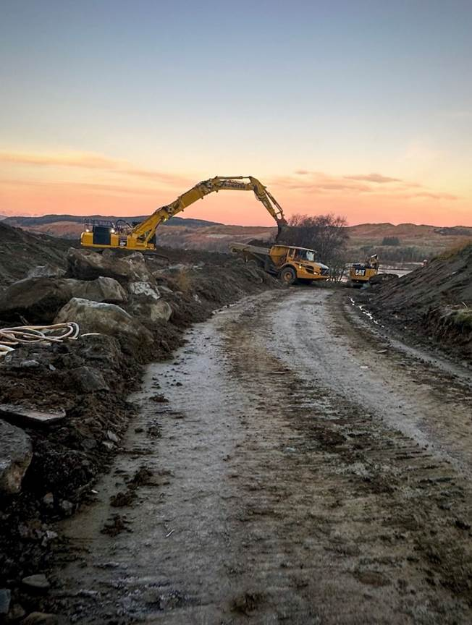

Resurfacing works ahead of the opening of the Balliemore Bridge
Emergency route being constructed on the A816

