

Please find below a brief snapshot of both the huge range of work being undertaken across the area by Roads and Infrastructure staff this week. The main part of this week’s briefing is in the attachment specific to the weather event and response.
Roads and Infrastructure
Weekly member briefing
Edition 125: 24th November
The updates are designed as a resource for you to be able to answer constituent queries, alongside the information on the weather impact webpage.
You can find details of the weather impact specific service disruption on the Council website here. We are continuing to update this twice daily with the live position.
You can view all previous weekly member briefings on the website

Oban, Lorn and the Isles | Helensburgh and Lomond | Mid-Argyll, Kintyre and the Islands | Bute and Cowal | All areas
Roads updates  Work continues on the 3rd part of the phase 2 capital scheme on the A819 at Claddich. This work is part of a £88,500 investment to improve drainage and widen the carriageway. Traffic management is currently in place.  Tobermory Railings – Phase 2  The council secured funding to make improvements to the front rails at Tobermory Main Street and help alleviate some of the flooding issues associated with Tobermory.  A new higher wall has been installed onto which the new and upgraded rails have been attached along with the flood gate and none return drainage valves.  As part of this project the council are currently making road surfacing improvements to the area of car parking adjacent to the wall.  The majority of works are due to be complete by the end of December 2023 with the flood barrier on Fishermans Pier to be installed in January. | Roads updates  Roads crew will be concentrating on gulley cleaning, shrub cutting and other general maintenance next week.  Streetlighting  Work commenced this week on the capital streetlighting scheme on Eastwood Lane, Helensburgh. This capital investment is enabling 9 column replacements along with cabling replacement  A814 road closure – 13th – 19th November  The temporary road closure that was in place from 13th to 19th of November to assist the MOD was removed after 5 hours following the success of moving the equipment by the MOD.  Pedestrian Crossing – Manse Brae, Rhu  Temporary pedestrian crossing will be in position from Monday 25th November until the repair is complete on the existing lights. | Roads updates  A816 Arfern landslip  We have reached another significant milestone with the excavation of a culvert under the observation of an Archaeologist. Whilst the Archaeologist recorded the shape and size of the culvert, possibly from an old military road there were no concerns regarding the progressing of the emergency road which is being progressed at pace.  More details and pictures will be included in a Member briefing/seminar taking place on Wednesday next week.  Also the daily disruption updates will continue to provide all the very latest news on routes affected by last month’s rain event.  Work continues on the A819 at Electric Cottage to improve drainage and carrying out edge strengthening.  Gigha bins  Due to disruptions with the Gigha ferry service on Thursday we were unable to attend and carry out any bin collections.  These collections have been rescheduled for tomorrow (Sat 25th Nov) and this information has been provided on the council website.  Gigha Pier  Temporary floodlights are in place to ensure service continuity.  Further assessment is planned for Monday and a repair plan will be drawn up following this. | Roads updates  Balliemore Bridge  We were planning for the temporary bridge to be transported to site (currently in a ‘holding yard’ in Glasgow and lifted into place with a crane on 22 November but the forecast high winds mean it is not safe for the crane to operate due to the large ‘sail’ ares of the bridge..  The forecast high winds of up to 40mph materialised over Wednesday and Thursday which means we cannot reopen this route on 24 November as planned.  The winds have died down today (Friday) , so our revised plan is to haul then install the bridge on Saturday, then carry out the surfacing and connections at each end with the new sections of road which we have already constructed.  Subject to no further weather issues etc we now expect this road to reopen to traffic on Tuesday 28th November.  In Cowal we have been concentrating our efforts on clearing culverts which we know are in hot spot areas which suffer particularly badly from debris flow in poor weather.  We have hired in a specialised vactor unit to jet out culverts over a stretch of 10 miles on the A815 between Glenbranter and Benmore next week. 5 of these culverts are problem culverts however there are over 20 that will benefit from a deep clean. | Winter maintenance  Each day our winter duty manager updates the daily action plan which is available alongside a number of helpful resources on the website here.
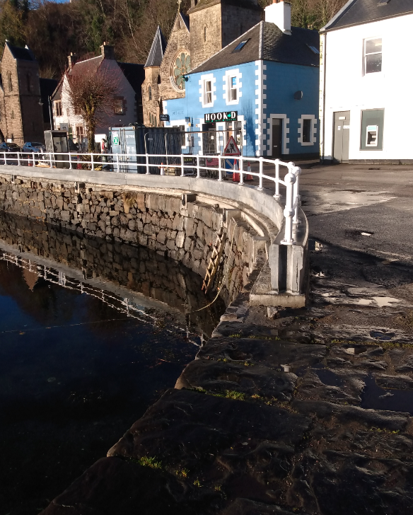
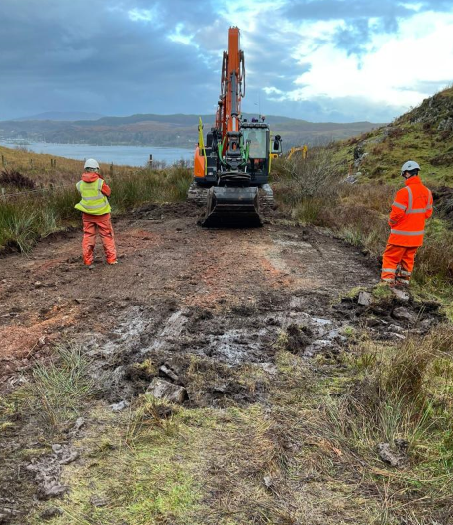

The new bypass route being progressed on the A816 – these works being the culvert excavation
The new railings at Tobermory sea wall

