

Please find below a brief snapshot of both the huge range of work being undertaken across the area by Roads and Infrastructure staff this week. The main part of this week’s briefing is in the attachment specific to the weather event and response.
Roads and Infrastructure
Weekly member briefing
Edition 124: 17th November
The updates are designed as a resource for you to be able to answer constituent queries, alongside the information on the weather impact webpage.
You can find details of the weather impact specific service disruption on the Council website here. We are continuing to update this twice daily with the live position.
You can view all previous weekly member briefings on the website

Oban, Lorn and the Isles | Helensburgh and Lomond | Mid-Argyll, Kintyre and the Islands | Bute and Cowal | All areas
Roads updates  As part of the ongoing sea wall improvement works at Tobermory our roads team will be assisting with required surfacing works on the Main Street.  Oban HRO  Scottish Government lawyers have now reviewed the Harbour Revision Order and we have been advised that we may now lodge as a formal submission and this is underway.  The required statutory notices will appear in the Edinburgh Gazette and the Oban Times on 30th November and this commences the formal 42 day consultation period.  We have carefully considered the timing of the consultation to ensure that this begins and ends out with the festive period.  The consultation period will therefore run from 30th November 2023 until 10th January 2024.  Documents and further information can be found here  Bin collections – Tuesday 21st November  Due to the sad passing of our colleague Donald MacVicar, refuse collection driver from Oban, there will be no Oban and Lorn refuse collections on Tuesday 21st to allow members of staff to attend his funeral and pay their respects.  These bin collections have been rescheduled for Friday 24th and a notice will be paced on our website on Monday. | Roads updates  Surfacing works on the A814 between Glen Douglas and Arrochar completed last night.  BT are carrying out work today and the road closure will be lifted at 5pm.  Surfacing works are scheduled on the A817 at its junction with the A82. These works will be carried out on Monday and require a closure between 09.00 and 15.00.  Local access will be available from the A814/A817 and emergency vehicles only from the A82 junction. | Roads updates  Work continues on the A819 at Electric Cottage to improve drainage and carrying out edge strengthening. This is part of a capital improvement scheme.  Due to a collapsed culvert on the U10 Glenbreakerie single track road an emergency culvert replacement was installed yesterday and the final completion works are taking place today including the resurfacing of the section of road affected  Brackley Cemetery  The road leading to Brackley cemetery is privately owned therefore we are unable to carry out any repairs to it until a formal agreement between the council and landowner is in place.  Our operations team met with the landowner at Brackley cemetery last week and provided him with a draft license agreement to be checked his solicitor.  Once a formal agreement is in place we be able to carry out the necessary repairs.  Gigha  We are dealing with an issue with the electrical supply at Gigha Pier, which is affecting the lighting at the ferry boarding area.  A temporary set of flood lights is being progressed with both the Council and CalMac working clsoly together to ensure the early and late sailings are not affected, including the school run sailings. | Roads updates  Our in house team are providing assistance to the streetlighting team on Bute next week.  5 new columns and required cabling will be installed at Kilchattan Bay on the seaward side to provide improved street lighting to the area.  Bailliemore Bridge  Works are currently underway installing a temporary bridge spanning the watercourse further upstream of the existing bridge.  Temporary bridge to be installed wc 20/11/23 and diversion route opened to traffic by the end of that week.  We will continue with the planning and Design of a permanent replacement for the existing bridge.  Estimated completion date for permanent bridge replacement is April/May 2024 subject to consents being in place.  The photos below detail the ongoing works to accommodate the tempary bridge and show the damaged bridge which is beyond repair will be demolished. | Winter maintenance  Each day our winter duty manager updates the daily action plan which is available alongside a number of helpful resources on the website here.

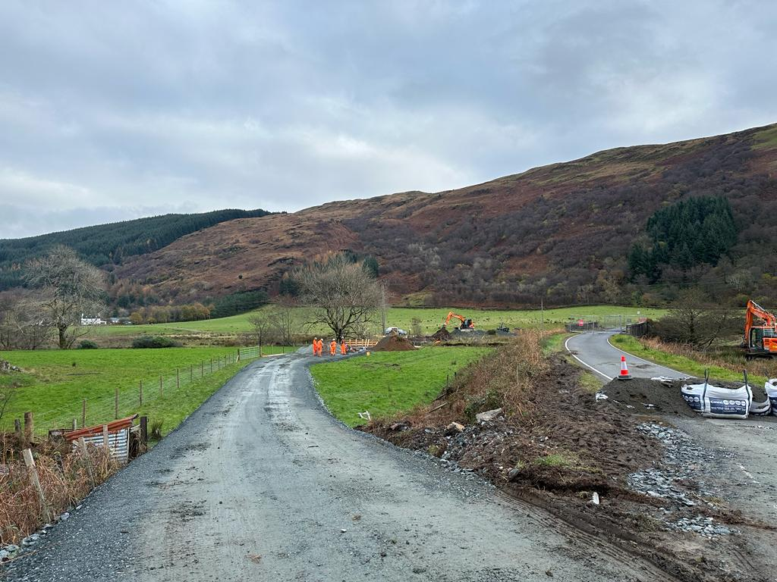
Temporary diversion road being constructed through field to north west of the Balliemore Bridge

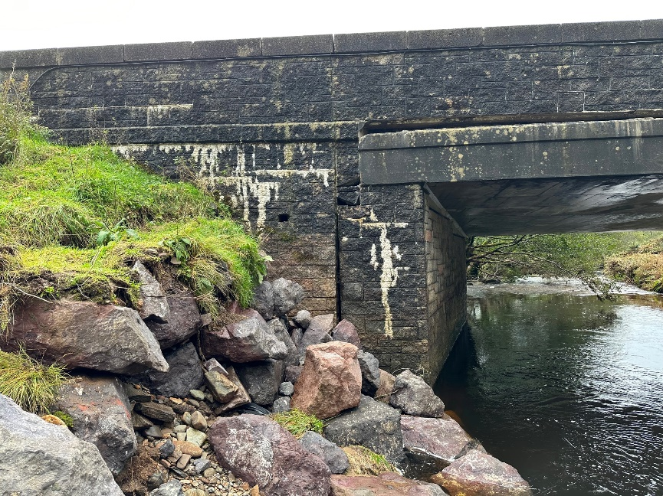
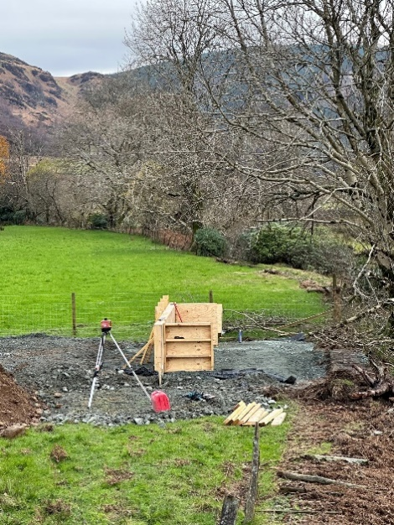
Formwork for reinforced concrete foundations for Damaged East abutment of Balliemore Bridge
temporary bridge being Constructed

