

Please find below a brief snapshot of both the huge range of work being undertaken to manage the impact of the recent extreme weather, as well as the normal day job work
Roads and Infrastructure
Weekly member briefing
Edition 121: 27th October
The updates are designed as a resource for you to be able to answer constituent queries, alongside the information on the weather impact webpage.
You can find details of the weather impact specific service disruption on the Council website here. We are continuing to update this twice daily with the live position.
You can view all previous weekly member briefings on the website

Oban, Lorn and the Isles | Helensburgh and Lomond | Mid-Argyll, Kintyre and the Islands | Bute and Cowal | All areas
Roads updates  The team are gearing up to undertake surfacing works next week associated to the Kilmelford Bridge replacement, as well as doing drainage and potholing works along the Loch Avich diversion route.  We are expecting to be able to open the bridge to light traffic cars / small vans on Monday and fully reopen it later in the week subject to concrete curing (strengthening).  The bridge deck has been waterproofed and a temporary foot bridge erected across the deck to allow pedestrian traffic to reach either side of the bridge.  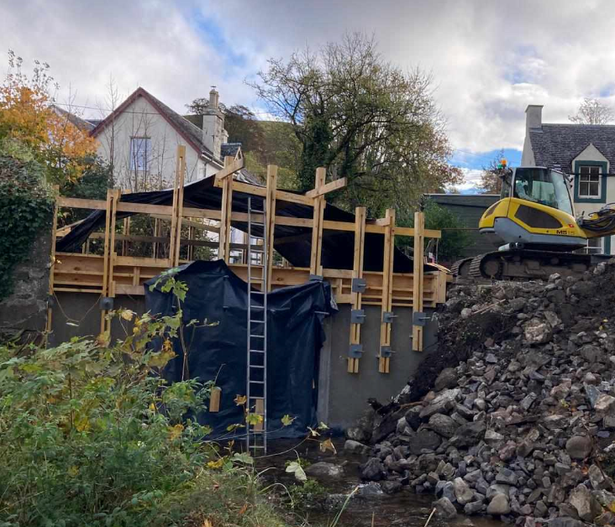  Kilninver Bridge  We await final results from lab tests regarding the strength of the concrete before we can lift the current 18 tonne weight restriction. These final lab results are taking a little longer than we had hoped.  We are now expecting the weight restriction to be lifted on Monday.  Please note the southern loop of the B844 remains closed as we have plant and equipment there which will be used to place rock armour at the side of the bridge abutment. | Roads updates  A818 – Daligan Bends Resurfacing work along the A818 has completed and the road has now been fully re-opened.  C69 Glen Douglas  Next week crews will be carrying out culvert repairs and re surfacing work along the C69 Glen Douglas road.  There will be a road closure between 9am and 5pm from Monday 30th to Friday 3rd November. A diversion route along the A82 – A83 will be in place.  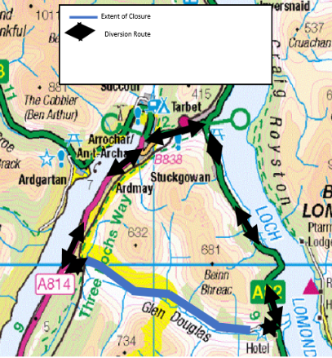  The road will re-open at 5pm and remain open overnight  Cardross Crematorium  The Crematorium will be closed on Monday and Tuesday to allow snagging works to be completed on the recent hearth upgrades. We have notified funeral directors about the closure and this does not affect any bookings  New food waste lorry  We are expecting delivery of a new food waste bin lorry this coming week.  The old vehicle was coming to the end of its useful life and there were increasing issues with its reliability – the new vehicle should increase the reliability of this service and members should see fewer complaints coming through as a result.  Public convenience door access control project  Our contractor will be returning to the Helensburgh Pier PC to finish off works on the new door access control system on 2nd November. | Roads updates  A816 at Ardfern  Work started today to clear up the 6000 tonnes of debris on the road following works earlier in the week to make boulders safe and stabilise the hillside such that the debris can be safely cleared.  Working with Forest and Land Scotland we have an arrangement in place to dispose of the debris at a disused quarry locally.  Work will continue throughout the weekend.  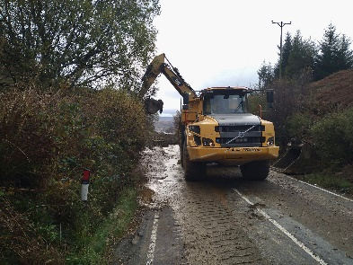  As well as the ongoing clearance and stabilisation works on the C30 West Loch Awe, the team are doing ditching and culverts works around Kilmaha.  In Kintyre next week we will be doing surfacing on the footway of Benmore Street.  Burnside Square  We are looking to arrange for the planters to be installed within the square over the next few weeks. We haven’t received any feedback from surrounding businesses regarding potential use of space within the square other than the social enterprise business who are keen to manage and maintain a planter. There will be further consultation with the community council regarding the planters.  In any event we are approaching the winter and it seems unlikely that businesses would wish to have any outdoor seating in the colder months. The planters, in keeping with the design principles of the square, are flexible e.g. they can be moved so if any of the businesses do approach us with a view to using space for seating this is something we can still take forward. The planters are also able to be moved to facilitate events in the square.  Public convenience door access control project  Our contractor has now advised us of their revised programme for completing the install works in the first phase for Mid Argyll. The programme is now:  Inveraray 3rd November  Lochgilphead 6th November  Ardrishaig 7th November | Roads updates  The team have been progressing surfacing works in Glen Masson and on Victoria Road this week.  Work will continue next week, alongside this we will be jetting culverts along the A815 Loch Eck and undertaking drainage works around Benmore.  Traffic and Development Officer vacancy  Unfortunately we are still without a Traffic & Development Officer for Bute & Cowal, as the applicant who accepted the post withdrew.  We must now re-advertise the post and will update you in due course.  In the meantime, we will continue to deal with any urgent issues with the assistance of officers from other areas.  We are grateful for your continued patience whilst the recruitment process is under way.  Public convenience door access control project  Following completion of the phase 1 sites in Lomond and Mid Argyll our contractor will move on to Sandbank 8th November | New jetpatcher  The new jetpatcher should hopefully clear the DVSA certification process in port in the next couple of weeks and be able to be delivered.  The vehicle came from the Republic of Ireland and has been held up in port because of different paperwork requirements between EU countries and the UK.

