

Please find below a brief snapshot of the huge range of work being undertaken to manage the impact of last weekend’s extreme weather.
Roads and Infrastructure
Weekly member briefing
Edition 119: 13th October
The updates are designed as a resource for you to be able to answer constituent queries, alongside the information on the weather impact webpage.
You can find details of the weather impact specific service disruption on the Council website here.
We are in the process of developing an interactive online map which will link in to specific web pages on the road closures which remain and our work to reopen these roads. This will be a useful resource going forward as we track and update on the huge range of work ongoing to reopen roads and support our communities.
You can view all previous weekly member briefings on the website
We have had a few questions in too:
Why does the Council not provide sandbags for private properties?
The Council does not, as a matter of course, provide sandbags or other defences for private properties. Our Flood Risk Management policy is available to view on the Council website here: Flood advice | Argyll and Bute Council (argyll-bute.gov.uk).
The Scottish Government makes it clear that individual property owners have primary responsibility for the prevention of flooding to their property. Landowners are responsible for the provision and maintenance of private flood defence and drainage systems on their land.
Will you provide skips?
We don’t provide a skip service and have no provision for this. Ordinarily individuals would look to their insurers to cover this sort of cost

Oban, Lorn and the Isles | Helensburgh and Lomond | Mid-Argyll, Kintyre and the Islands | Bute and Cowal | All areas
Closed roads  We had to close this road at 1400hours Wednesday.  There is around 30metres of the road surface which has been damaged – we need to excavate the damaged material then reinstate it.  We are planning a temporary solution with a stone surface here to get the road reopened. We poured concrete on Friday lunchtime and need to give it time to set.  We expect the road to reopen on Monday, then will go back later to fully reinstate the surface with asphalt.  Scammadale Road  There has been a significant landslip here along the lower verge of the road.  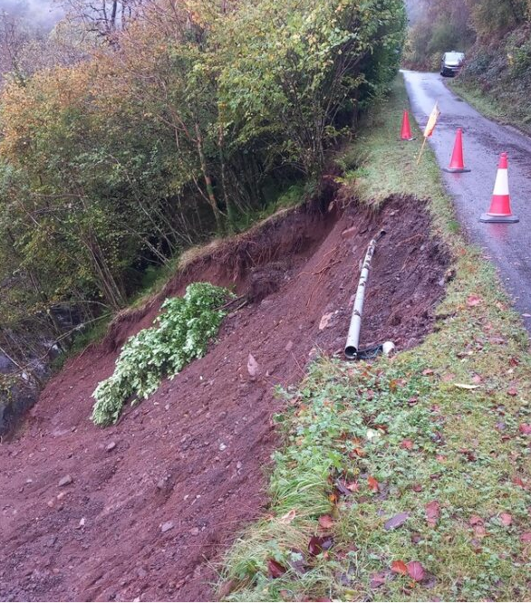  We have dug out the hillside somewhat and installed a temporary surface to in effect re-align the road allowing vehicles to pass safely.  This is a temporary safe solution while we explore a long term fix.  Lochavullin  The pumps were on here overnight during the worst of the weather, but the water levels rose again even after the rain stopped which suggests a problem with the system. We had it investigated and the engineer recommended a new control panel in a different location, which we are looking to progress  Bonawe Road  This is passable but we have asked Breedon not to run lorries from the quarry for now due to the potential fragility of the road.  Loch Nell  This road flooded about a foot deep, which was only safely passable for 4x4s. We’ve attended to clear up since the water receded.  Connel back road  This road wasn’t closed but did experience flooding. We’re continuing with the clear up  Mull Rally  The Mull Rally is planned this weekend and we’ve been going round the network on the island making sure all safety defects (actionable potholes) are attended to. | Roads which were closed, now reopened  A814 Glen Douglas between Whistlefield and Arrochar (landslip)  This reopened on Sunday evening after our stand-by crew cleared debris. The road is passable with care.  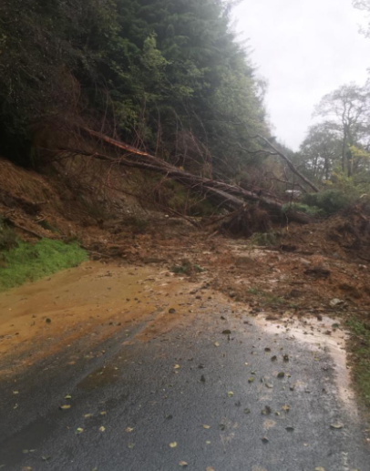  Burst water main A814  To add to the issues across the network Scottish Water experienced a burst water main outside the Farmfoods on the A814 this week.  Maitland Street is closed as a result and there are two way traffic lights on East Clyde Street.  Clean up operations  A814 north of Glen Mallan  Culverts cleared and running  B833  We’ve had the road sweeper out this week clearing debris.  Glen Douglas  Collapsed culvert which will be renewed as part of a planned surfacing scheme upcoming  School Road, Kilcreggan  The carriageway here was damaged – we are programming reinstatement works in at the moment  Cardross, Barrs Road  A fair amount of debris washed off the private section of this road onto the public road, which we will be attending to with the roadsweeper.  Station Road, Rhu  A culvert was damaged here – the repair will complete today. | Closed roads  A816 at Ardfern (landslip)  Over the weekend our specialist contractor Geo Rope has carried out a drone survey of the area.  Three separate landslides have blocked a 200m section of the A816. The landslides have started from approximately 120m above the road. The volume of debris currently on the road is estimated to be around 3000m3 (6000 tonnes), with further unstable material on the slope above the road.  There are large potentially unstable boulders (some estimated to exceed 70 tonnes) high on the slope.  We are currently undertaking further assessment after Tuesday’s predicted heavy rainfall.  Works will start with removing or stabilising potentially unstable boulders to make the area safe for clearance works.  We are planning to begin working on the site this weekend.  Current estimates are that the road will remain closed for at least 4 weeks, subject to any further weather impacts. There is a diversion in place which is via the A83 - A819 - 85 or vice versa.  C30 West Loch Awe (landslips)  This road is closed because of a landslip. We are making good progress with clearing the debris. Once this is done we will move on to reinstating the embankment supporting the road. We have cleared the first landslip and are now moving on to the second, larger one.  We are going to need to install around 700tonnes of rock armour to reinstate the steep embankment which supports the road.  Realistically this work will take at least 3 weeks.  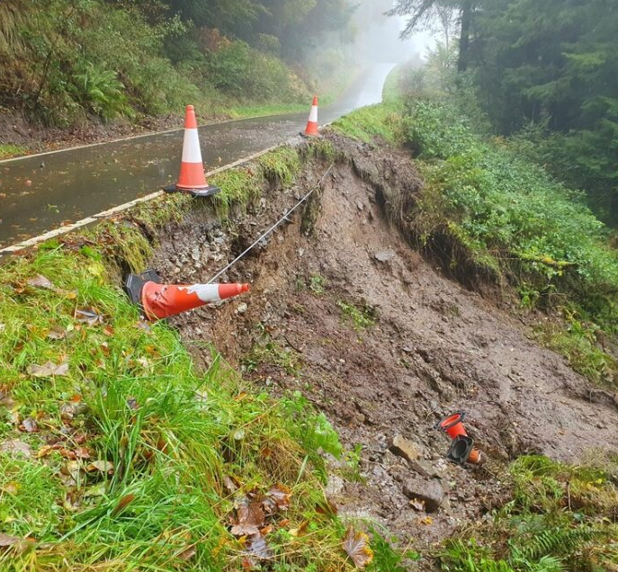  B840 between Eredine and Blarghour (landslips)  This road is closed due to a landslip. We began to clear this on Wednesday, after clearing the landslip further down the B840 on Tuesday. There is also a culvert which was damaged in the landslip – we are having this assessed at the moment ahead of taking forward repair works.  Roads reopened  B840 between Ford and Eredine (landslip)  This landslip was cleared on Tuesday and this section of road is open. There is no through road to the A819 (Cladich) but residents can travel down the B840 to the A816.  The road remains closed beyond Eredine so there is no through road.  Bridge damage, Bridgend  We have a damaged bridge here which we will be looking to programme in a repair for. Phot below shows the washout from the bridge  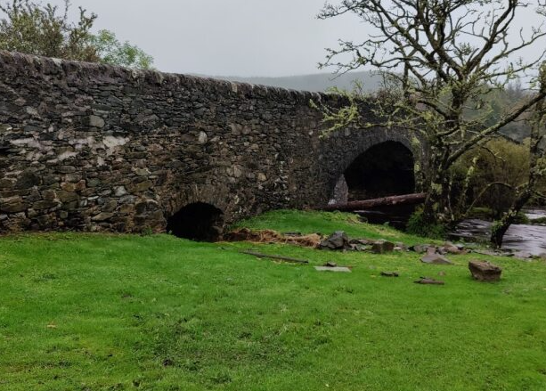  Bin collections  Recycling collections Lower Lochawe  Unfortunately, due to the issues with roads in this area, we will be unable to collect recycling bins due Thursday 12th October. We would ask those customers if they can to hold on to their recycling until their next scheduled collection on Thursday 26th October.  This is from Ford Village to Kilmaha on the West and from Ford village to Blarghour on the East.  General waste collections Lower Lochawe  Those customers in the same area who would normally have a general waste (green bin) collection Thursday 12th October can expect this to happen on Friday 13th October instead. This was caught today | Closed roads  B836 Glen Lean (partial bridge collapse and landslip)  This road will remain closed until we can plan for a bridge replacement/repair. Following an inspection on Monday morning the bridge is confirmed as damaged with the potential to fully collapse.  We are working through options at the moment one of which may be a temporary bridge (sometimes known as a Bailey Bridge)  B828 Glen Mhor (landslip)  This road is closed due to a landslip. We are progressing with site clearance and investigating slope stability. These investigations are ongoing.  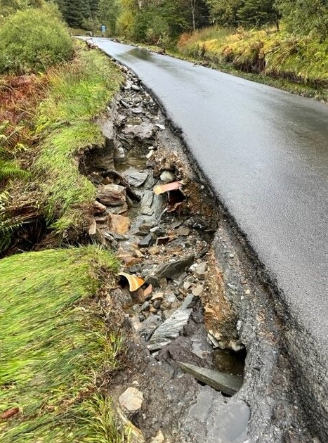  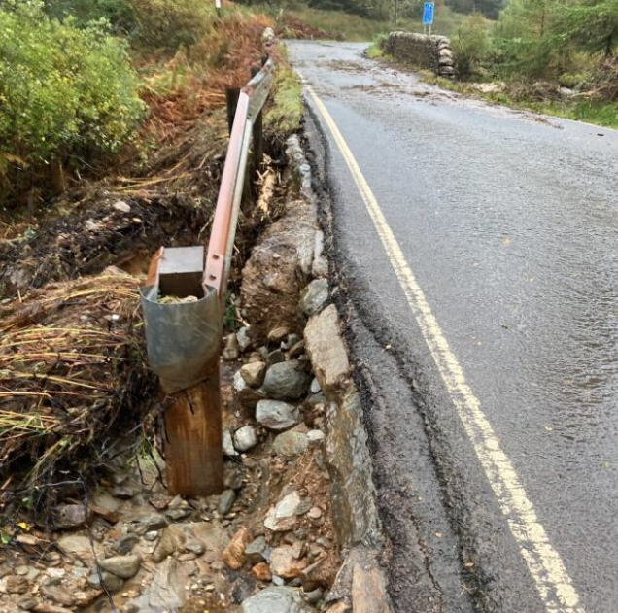  Roads reopened  A815 Loch Eck (flooding) between Strachur and Benmore  We managed to clear flooding here and re-open this road around 2030hours on Sunday. The road is passable with care.  A815 north of St Catherine’s to A83 junction (Dunoon road end)  At around 1500hours Wednesday, working with colleagues at BEAR Scotland and Transport Scotland, we opened the A815, in conjunction with BEAR reopening the A83.  This now allows normal access from the Cowal Peninsula to the trunk road network.  There was between 500 and 550 tonnes of debris on the road which, with the assistance of local contractors, we’ve managed to clear over the past few days. We also had to do some work on re-profiling roadside ditches which were damaged by the landslip.  We have had the slopes checked by our specialist contractors – it is safe to reopen the road, and the site will be regularly monitored going forward  Clean up operation  Eachaig Footbridge at Cothouse Caravan Park  Heras fencing erected with signage either side of the bridge at the bollards to close the bridge to the public.  The bridge has had previous scour issues and speaking to the manager of the caravan park there has been a lot of debris including caravans and gas canisters that have struck the bridge and passed through.  B839 Moses Well Gully motor and JCB worked to clear blocked culvert  A886 JCB and road sweeper attended to culvert overspillage between Garvie and Conchra once B839 culvert was clear and then on to Colintraive ferry to sweep/clear debris at mustering area.  A880/C9 JCB attended to remove debris from the carriageway where culverts had blocked  A885 Sandbank Road  Damage to southbound lane due to surcharged manhole. Location has been made safe and is signed and guarded until we can assess the repair requirements.  A815 Sandbank shops  Damage to northbound carriageway at layby due to surcharging manhole. Location has been made safe and is signed and guarded until we can assess the repair requirements.  West Cowal  Operatives carried out hand ditching/culvert clearing before meeting with squad attending to A886. | Culverts and drains  Across the whole network our teams are proactive about clearing culverts and drains before weather events.  Unfortunately in extreme rainfall all it takes is one branch coming down to block a drain, and in any event most of the drainage systems simply cannot cope with the sheer volume of rainfall experienced, which in some reports has been quoted as being up to a month’s worth of rain in a single day.  Bin collections  Commercial glass collections  Due to the travel challenges we are standing down this service and will review the situation again on Monday 16th October. If you were expecting a glass collection this week we apologise for the disruption. We’ll be in touch with commercial waste customers directly about next steps.  Public glass recycling points  The same lorry which services commercial glass customers empties the public glass recycling points, so none of these will be attended to this week. We’ll put a plan in place to catch up next week.  Winter coming early!  Just to add to our teams workload, winter is forecast to come early this weekend (ahead of our normal stand by period starting at the end of October)  We have crews prepared and will be going our gritting where needed to keep the road network safe and open.

