

Please find below a brief update on various key areas of work.
Roads and Infrastructure
Weekly member briefing
Edition 117: 29th September
Please let us know if you find these briefings useful and if there is any specific information you would like or alterations to the format.
The updates are designed as a resource for you to be able to answer constituent queries.
You can find details of notable service disruptions on key service areas like bin collections and street lighting on the Council website here.
You can view all member briefings on the website

Oban, Lorn and the Isles | Helensburgh and Lomond | Mid-Argyll, Kintyre and the Islands | Bute and Cowal | All areas
Roads updates  Work is continuing to progress well with phase 2 on the Claddich bends on the A819.  Streetlighting  The streetlighting team have managed to secure a ferry booking for the 9th October to attend lighting faults on Mull.  Oude bridge consultation  Members of the public are invited to attend a public consultation regarding the options to replace the road bridge (A816-120) on the A816 at Oude.  The consultation will take place on Thursday 5th October at Kilmelford & Kilninver Village Hall between 2pm & 8pm  Tobermory EV Charger  As part of the HITRANS FASTER project work has been underway this week to replace the 1st generation electrical vehicle charger in Tobermory with a new rapid EV charger. This site is being treated as priority work.  Moleigh closure  Discussions are ongoing between ourselves and Renewi regarding a possible 4 day closure of the Moleigh civic amenity site in Oban. This is to accommodate resurfacing work and is expected to be at the start of November.  Once dates have been confirmed we will provide a further update and also include our website etc | Roads updates  Work is expected to complete today on all surfacing schemes along the B833.  Next week crews will be moving to carry out footway improvement work at Straid Bheag in Clynder. This will involve resurfacing the footway and installing  Tigh Dearg Road  Contractors are schedule to commence work on this project on Monday 2nd October.  The project aims to reduce surface water going into Scottish Waters combined sewer and therefore alleviate flooding along Tigh Dearg Road. | Roads updates  Work continues on the culvert replacement on the A846 at Esknish.  Jet patcher is working across Mid Argyll and Kintyre carrying out repairs to road safety defects, weather permitting.  Islay landslip  On Thursday afternoon there was a landslip at Kilchiaran on Islay. The area has been coned off for safety. The slip happened at a wider point on the road meaning traffic is still able to pass safely.  We hope to have all the debris cleared by the close of play today.  Glenedgadale bridge consultation  The council is inviting members of the public to give their views on options to replace the road bridge (A846-270) on the A846 at Glenegedale, Islay  This public consultation will take place on Tuesday 3rd October at Ramsay Memorial Hall between 2pm and 8pm. | Roads updates  In Dunoon the capital resurfacing works on Victoria Road and Hamilton Street complete today.  Surfacing work on the A815 Shore Road Sandbank, will commence next week.  Dunoon linkspan  The Dunoon Link Span has suffered a technical issue with one of the hydraulic rams which has resulted in it being removed from service for repair.  Investigations so far have not been able to identify the cause of the issue and it remains unclear if this is related to a previous problem.  Specialist support will continue to investigate and we are planning a structural inspection for Monday 2nd October.  We are unable to say at this point how long the Link Span will be out of service. | Storm Agnes  Weather monitoring in advance of storm Agnes took place across all areas with teams prepared for any weather event such as flooding, fallen trees etc  Sandbags were distributed to known areas prone to flooding and grids and culverts were checked to ensure that they were free for obstruction.  WDM integration  Various officers are involved in the WDM Roads and Lighting system upgrade, which is transferring to the Cloud, making it much easier for inspectors and other RIS teams to work remotely using mobile tablets. Testing is going very well, and it's hoped to go live later in the year.  High spring tides  High spring tides are due this weekend which may result in tidal surge and localised flooding depending on wind direction and wind speed. Our teams will be on call to keep transport routes available where possible and safe to do so.

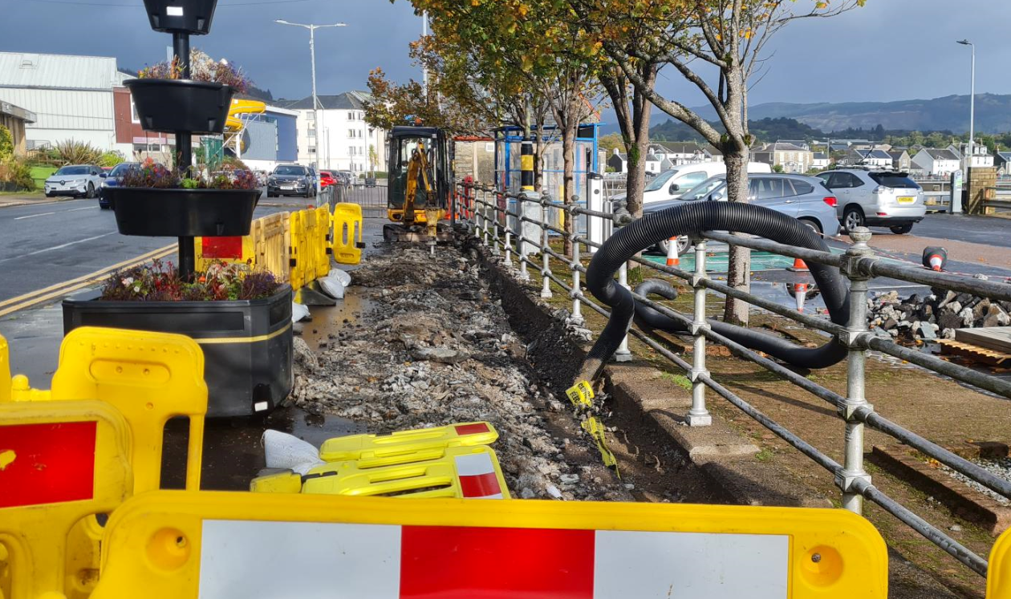

Work underway for the installation of new EV chargers at the Coal Pier

