
Member Zone: Member Enquiry Handling Update
To 22nd September 2023
- SERVICE REQUEST PORTAL ACTIVITY
The table below shows the number of requests logged by members since the launch of Member Zone in June 2022 until 22nd September 2023 and their status:
 | RIS Requests | Other Services | Total
Total Requests Made | 1246 (78%) | 357 (22%) | 1603
Requests in Action* | 188 | 17 | 205
Requests Actioned by Services | 1058 | 340 | 1398
Requests Closed by Members | 621 | 215 | 836
Open with Members | 437 | 142 | 579
*Includes those awaiting response, escalated and where work is scheduled by Services.
Of the 205 responses in action as at 22/09/23:
- 151 are with the Service for response
- 27 have work scheduled for completion
- 24 have had an initial response and the Member has asked for further information/clarification
- 3 have been escalated.
Of the 151 requests open with the Service for response, 33 (22%) exceed their SLA response time by over one week or more (34 RIS and 3 Non-RIS)
The average response time for RIS requests since inception for an initial response is 2.8 working days for a full response is 20.8 days. The equivalent for other Services is 8.5 working days for an initial response and 14 days for a full response.
- SERVICE REQUEST PORTAL – MEMBER FEEDBACK
  - Member Feedback On Member Zone Request Portal
In order to monitor timeliness and quality of responses over time from a Member perspective DST introduced new functionality in November 2022 to enable Members to voluntarily complete a short feedback survey on each response after they had marked it closed. Outcomes up to end of September in summary are:
- 70 out of 79 (89%) respondents said they were moderately to very happy with the speed of response
- 82 out of 90 respondents were satisfied with the quality of response (91%); 75 marking them good or excellent 83%)
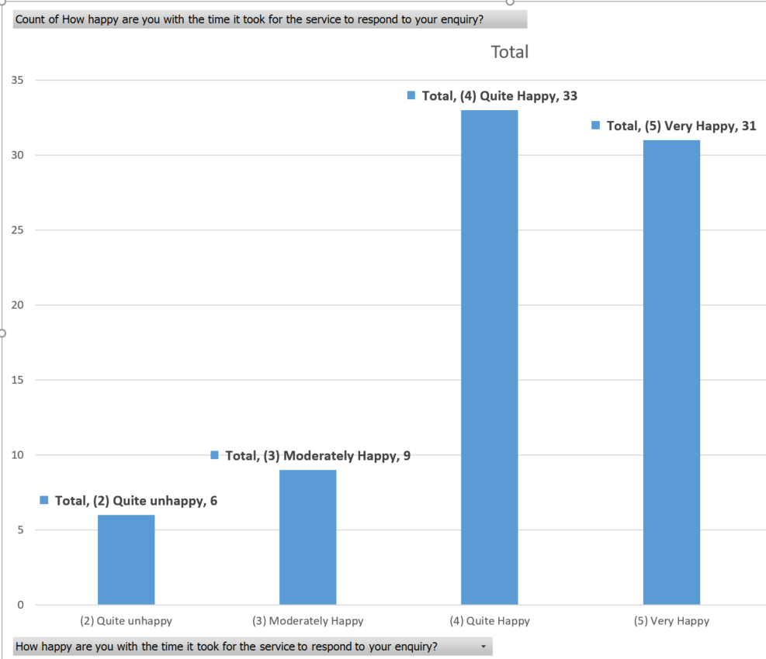

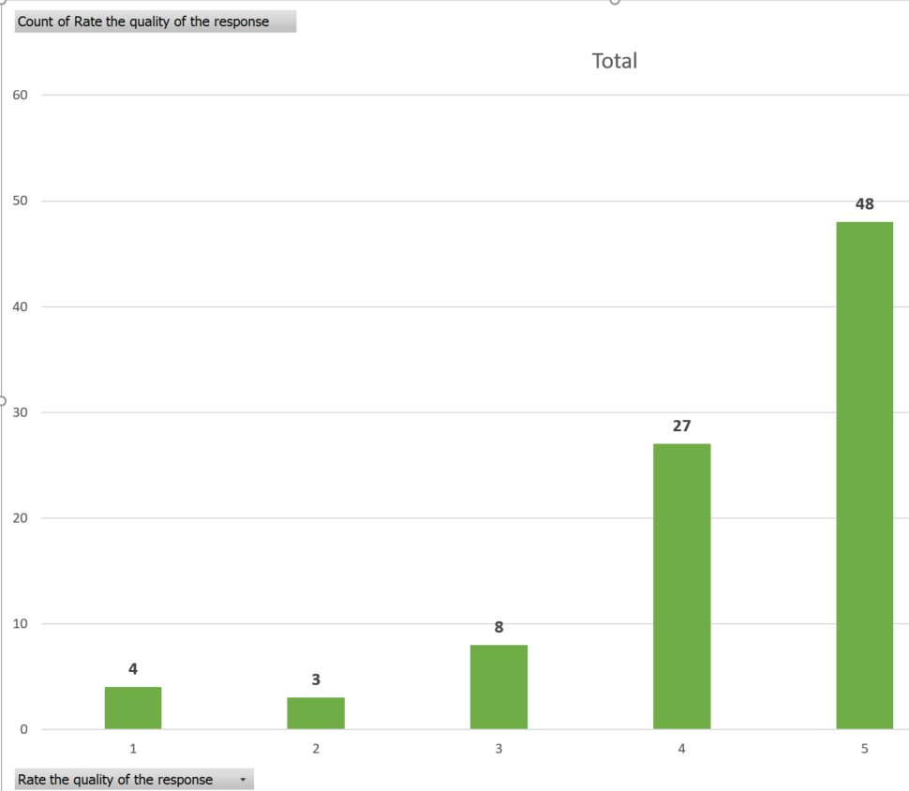
There were many positive comments including:
- I appreciate the swift response to my query and the officers' continued patience with me banging on about pavements!
- This was an urgent incident which received immediate attention and is being resolved
- Excellent response, result and quick action.
Some less favourable feedback included:
- No update provided. I had to re-visit the site to find the work had been completed.
- Road is still in poor condition.
- Putting a sticker on an overflowing bin won't resolve the issue.
RIS also have their own internal quality checking approach and feedback on requests relevant to them are reviewed as part of that to inform continual improvement.
  - Member usage of Member Zone Request Portal
It is important that the maximum number of member requests possible are routed to Services via the MZ portal as this allows Services to deal with them in a structured, efficient way and avoids perception of a two tier service to Members. It also helps members control their caseloads.
The average number of requests made per member since inception to end September 2023 is 45. The table below shows the number of requests per member since go live:

Banding of Number of Requests Made | Number of Members in this Banding
Zero – 29 requests made (Low) | 15 members
30 – 69 requests made (Moderate) | 15 members
70+ requests made (High) | 6 members
The highest number of requests made by a single councillor is 190. Online self service is the most popular way to raise and manage requests with 1253 (78%), of all requests managed this way, thus freeing up Member Services to help the democratic process in other ways.
Bob Miller
Customer Engagement Manager
September 2023

