

Please find below a brief update on various key areas of work.
Roads and Infrastructure
Weekly member briefing
Edition 114: 8th September
Please let us know if you find these briefings useful and if there is any specific information you would like or alterations to the format.
The updates are designed as a resource for you to be able to answer constituent queries.
You can find details of notable service disruptions on key service areas like bin collections and street lighting on the Council website here.
You can view all member briefings on the website

Oban, Lorn and the Isles | Helensburgh and Lomond | Mid-Argyll, Kintyre and the Islands | Bute and Cowal | All areas
Roads updates  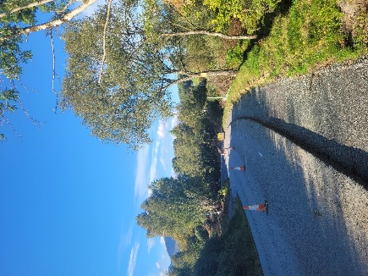  The capital works on the A816 at Claddich are continuing – they are scheduled to last another six weeks or so. We’ve included below some images of the works which include road edge strengthening. There has been a significant investment along the A819 in recent years given its strategic importance and use as an alternative/diversion if there are any issues on either the A85 or A83 trunk roads.  The capital overlay job on the A816 at Arduaine should finish by Monday. This is an £80,000 scheme which is seeing 3000 square metres of road surface improved.  We are expecting to make a start on the inlay scheme at the C25 Queen’s Brae in North Connell – a £40,000 investment. Inlay is the removal and replacement of surface over entire width of carriageway, where levels fixed by kerbs etc.  Subject to ferry availability for materials, we are also expecting to start the footway job at Prison Brae in Tobermory. That scheme is estimated to last 15 days (or three weeks).  Streetlighting  We have been struggling to secure a ferry booking to get our streetlighting team and equipment (including tower wagon) over to Mull to attend to reported streetlighting faults. This is causing a delay in the normal repair timescales/targets – we have put a message on the disruptions section of the Council website, which is then emailed out to anyone who has signed up to updates, to keep customers advised of the situation. We aim to attend site at the earliest opportunity, pending ferry availability.  Lismore bin collections  Following on from the theme of ferry availability, we are struggling to get bookings on the Lismore ferry for our bin lorry. Our booked sailing has been cancelled until a week Monday, which will delay scheduled bin collections for these customers. We have posted a notice on the website etc.  Road traffic collision/police incident, Oban Wednesday  There was a lengthy road closure within Oban on Wednesday because of an accident. This led to lengthy delays for the travelling public – our home to school transport team worked through these issues and got all children safely to school, albeit a little late in some cases. Whilst the police and trunk road operator were able to move some traffic the restricted one way network meant that many had to be diverted via Dalmally, Inveraray and Lochgilphead. | Roads updates  The job at Camsail Road has successfully completed this week and our lining contractor should, weather depending, be attending shortly to reline the road.  The surfacing squad will be moving on now to the B833 where there are three separate capital works sites on the stretch of road between Altnabui and Pier Cottage. Due to the nature of the work and to keep the workforce and traveling public safe we will be operating a convoy system, which is likely to cause some delays for those driving the road.  All three of the schemes are overlay jobs. This is where the existing road surface is overlaid with an additional bituminous surface, which adds strength to the road. This is a technique usually used on rural roads. These works will see around 4500 square metres of the carriageway improved.  Public convenience door access control project  After a planning period which was longer than we would have liked due to supply chain issues, our contractor has provided us with an indicative start date for the works to install new toilet doors and payment system to the Helensburgh Pier public convenience. This will be the first of 16 installs across the area.  At this stage we are looking at these works starting week beginning 18th September. We have a further meeting with the contractor on Tuesday of next week to confirm arrangements. While these works are ongoing the toilet will be closed for 1-2 days. Once the start date is confirmed we’ll post notices at the facility and on the website etc.  Bus stop improvements  In this area we benefit from being part of the Strathclyde Partnership for Transport region and receive around £150,000 per year for bus shelter upgrades.  We have replaced a large number of shelters over the years with new ones and have improved accessibility, so the focus this year is on installing additional or upgraded real time information signs at various shelters, as well as replacing some shelter panels with glass where there is a history of the polycarbonate panels being vandalised with rude messages and images scratched into them. This is much harder to do on glass panelling.  Officers met SPT on site on Monday this week to discuss the works programme – we will look to follow up in a future briefing with the confirmed programme. | Roads updates  The jetpatcher has been on Islay this week working through routine maintenance.  Our squads are also carrying out safety defect repairs, ditching and scrub clearance across the network.  The main focus on major works is on the job at Electric Cottage on the A819 which is seeing almost £200,000 invested in edge strengthening and road drainage improvements. In one of the phots blow you can see a new drainage pipe being installed. These works will last into November  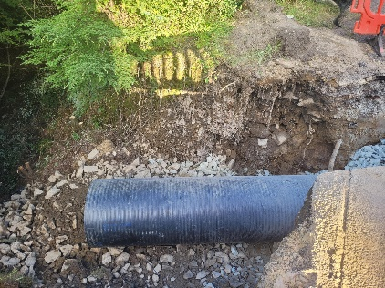  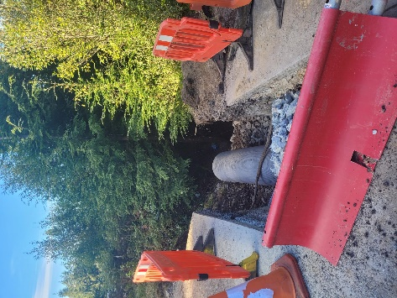  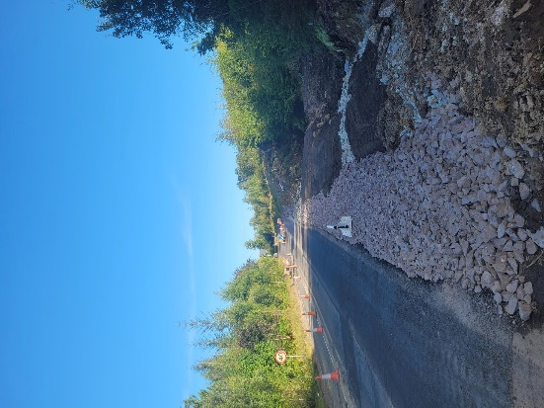  Campbeltown Flood Protection Scheme (CFPS)  We have been doing some promotion of the public pop up information event at Dalintober Primary School on Thursday 14th this week including social media posts on both the Council and school pages and physical leaflet drops. We’ll be following up with more promotion next week including an email out to all email addresses we have for customers in South Kintyre.  Unfortunately we have had very limited feedback from possible users of Burnside Square about options for electric points, which have been built into the plans, as well as the possibility of using outdoor spaces. We’ll be following up on this next week and hopefully the event will provide an opportunity to discuss with interested parties. Any assistance in promoting the event and/or getting feedback on the above would be much appreciated.  There was also a site walk round with local members and the policy leads along with colleagues from Dawson Wam earlier this week to allow members to view and discuss the works. | Roads updates  The team are progressing with the capital scheme at Tighnabruaich on the A8003.  This job is co-funded through the Strategic Timber Transport Scheme and involves carriageway extension, road realignment and a new vehicle safety fence.  Those works will continue next week and we will also be moving on to the capital works in Dunoon on the B8042 which is in two sections – between Argyll Street and Alfred Street and from the A815 to Royal Crescent North.  Next week will be preparatory works where we will plane out the old road surface ahead of laying a new surface. This technique is called inlay.  In total this is a £180,000 job which will see almost 6000 square metres of new surface laid.  If we are able to make good progress on the above we may also be able to do the preparatory works for the other inlay scheme at Sandbank on the A815 from Rankins Brae to Fir Brae.  Streetlighting  We are just completing the footway reinstatements for the streetlighting works at St Bride’s Road before moving on next week to excavations Ladeside Place.  Grass cutting  The team has been slightly behind with grass cutting due to staff absence on Bute but have made good progress in the good weather this week and things are back on track.  Traffic and Development Officer post  We conducted the interviews for this post and are hoping to make an appointment shortly. | Persistent organic pollutants (POPs)  At the Environment, Development and Infrastructure committee last week there was a report up on POPs which includes appendices covering draft SEPA guidance and possible cost implications for the Council. There are available at Item 14 here.  Historically POPs have been disposed of in landfill. It is anticipated that, in line with recent changes in England, landfilling of POPs will be banned in Scotland and that the material will need to be disposed of via Energy from Waste (EfW). POPs are generally found in items such as sofas and mattresses. Disposal of POPs via EfW will introduce cost pressures to the Council associated with the processing of these materials in terms of transportation, shredding and the processing of the shredded material through EfW.  We are continuing to monitor the situation and are proactively engaging with SEPA to understand more about timescales and possible implications of a ban in Scotland.  The EDI Committee formally called on the Scottish Government to both introduce a grace period and provide full funding to the Council to cover the costs of any future ban.  Ferry availability  The availability of space on a number of CalMac ferry services has resulted in some changes to programmed works. Where materials, plant and labour cannot be transported the affected works will be reprogrammed and delivered at new dates to be confirmed.

