

Please find below a brief update on various key areas of work.
Roads and Infrastructure
Weekly member briefing
Edition 98: 19th May
Please let us know if you find these briefings useful and if there is any specific information you would like or alterations to the format.
The updates are designed as a resource for you to be able to answer constituent queries.
You can find details of notable service disruptions on key service areas like bin collections and street lighting on the Council website here.
You can view all member briefings on the website

Oban, Lorn and the Isles | Helensburgh and Lomond | Mid-Argyll, Kintyre and the Islands | Bute and Cowal | All areas
Capital work  On Mull the surface preparation work on the C34 Hill Road was completed this week and there were no issues with ferry / freight availability  Next week we will be focusing on pre surface dressing work on the U009 Dervaig and also the B8073 Tobermory to Dervaig.  In Lorn we are concentrating on preparation work such as scrub and drainage work on capital sites across the area  Streetlighting  All required cable replacement has now been completed with Mossfield Avenue and Glencruitten Drive and all streetlights now operational again  Tobermory Cemetery  Work is progressing well with the expansion of Tobermory cemetery with footways, foundations and wooden handrails currently being installed – see photos below.  Luing ferry  Following its annual maintenance dry docking, the Luing ferry is now back in service.  Oban North Pier  Earlier the cruise ship Ocean Nova berthed at North Pier (whilst a number of cruise ships have been into Oban this is the first cruise ship to berth alongside the pier since the pandemic).The vessel was carrying 65 passengers. On Sunday we have the Hebridean Sky in, a 90M vessel carrying around 115 passengers and 70 crew.  Oban Municipal Harbour – Harbour Revision Order (HRO)  Good progress continues to be made with Transport Scotland with the HRO for Oban. A further briefing will be issued soon detailing the good progress that has been made, next steps etc.  Iona public convenience  The Iona PC has been repaired and is now open for use. | Capital work  Pre surface dressing work in Rosneath has completed this week.  The team will move to Luss next week to continue with preparation works ahead of the capital improvements.  Bus infrastructure  We are pleased to advise we were successful in securing £150,000 from Strathclyde Partnership for Transport (SPT) for bus infrastructure improvements.  We are in the process of pulling together a works programme which we will share shortly  Blackhill Civic Amenity site  Anyone who has used the CA site this week may have noticed contractors on site – they are there to repair the perimeter fencing. This work will continue into next week – it was no effect on the day to day operations. | Capital work  Pre surface dressing will commence on the A816 Kilmartin to Carnassarie next week  This is preparation work for the £182,000 surface dressing scheme that will take place later in the year.  The jet patcher continues with pre surface dressing preparation work on Islay  Campbeltown Flood Prevention Scheme  Work is progressing well with the flood scheme project.  At Millknowe the sheet piling and combined sewer diversion works are complete. The drainage and embankment work has commenced and is currently ongoing.  At the Burnside site drainage work has been completed for Argyll Street with Castlehill and Ralston Road scheduled to complete next week.  Drainage work on Burnside Street is ongoing.  Burnside Square block paving is progressing well  At The Meadows reinstatement work has been carried out between the flood storage ponds.  Islay burials and grass cutting  On Islay we are slightly behind with our grass cutting as we have had a higher than normal number of burials which have taken priority.  Crinan bottle bank  In agreement with Scottish Canals a new glass bin has been placed at the Crinan Basin car park for public use.  This will be serviced fortnightly | Capital work  Pre surface preparation works across both areas continues including patching, scrub cutting and drainage work  Lining  Lining contractors have completed the required work on Bute this week and have confirmed they are able to continue with work in Cowal next week  Rothesay Fountain  The fountain re-opened this week but unfortunately due to vandalism [people filling it with soap] had to be closed again.  The water is treated to prevent legionella bacteria forming and any additional products i.e. soap / bubbles that are added interfere with the chemicals and pump use.  The system needs to be flushed and checked before re-opening again, which will be next week at some point  Glen Morag car park  We have placed notices on a number of caravans and trailers which appear to be abandoned in this car park following a number of complaints from local residents.  The notice asks people to remove their vehicles from the car park within the next 15 days or risk having them removed and destroyed.  You can find more information about this in a press release issued earlier this week. | Grass cutting  Across all areas our teams are progressing with scheduled grass cutting.  The grass cutting season is generally 1st April to 31st October, although we have seen the need to extend this in recent years with warmer Novembers.  Schedules are determined on a route basis in order to optimise logistics to deliver the service as efficiently as possible.  All sports fields are scheduled to be cut 21 times per year. The remainder of grass which includes amenity areas, cemeteries etc. are scheduled to be cut as per the list below, these frequencies having been previously agreed with area committees and Council through workshop sessions where Members agreed area based specifications based on a menu of activities and budget level. . These frequencies can vary slightly depending on the extent of the growing season and the number of scheduled games/matches which take place in each individual area.  Bute – 12 cuts  Cowal – 15 cuts  Mid Argyll – 14 cuts  Kintyre – 14 cuts  Islay – 14 cuts  Lorn – 17 cuts  Mull – 13 cuts  Lomond – 17 cuts  The current service standards are achievable within the existing budget, staffing and machinery framework, however, resources are so closely matched to those standards that there is limited if any resilience to respond to issues which inevitably arise [like this week’s increase in burials on Islay].  Decisions are having to be made on a regular basis to prioritise what work can be carried out with the available resource. It is not unusual for our operational supervisors and managers to be faced with competing demands including digging graves/burying the dead, collecting bins, making safe potentially dangerous defects and grass cutting. Inevitably, but unfortunately, grass cutting often suffers as a result of other duties which are statutory.
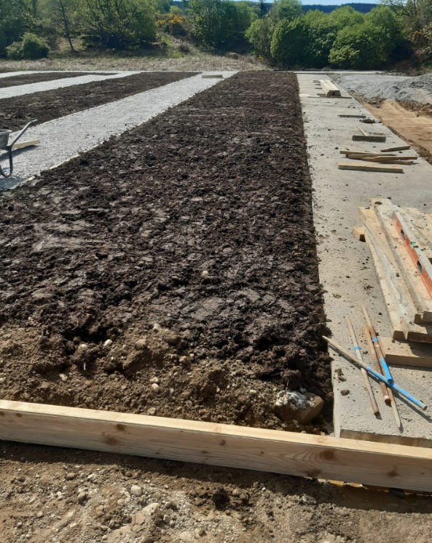
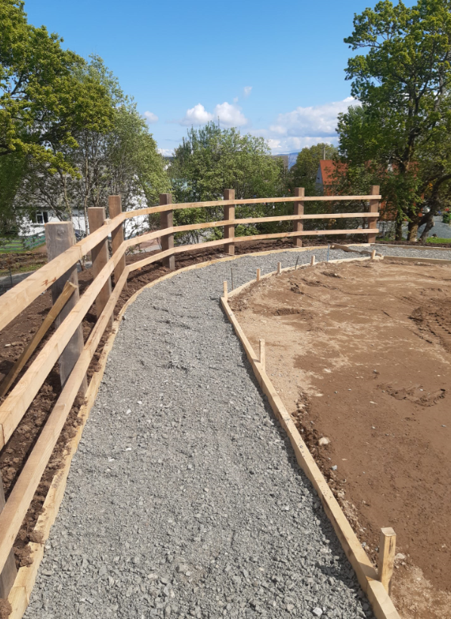
Images showing the ongoing work to expand lair availability along with footways at Tobermory Cemetery

