
[Grab your reader’s attention with a great quote from the document or use this space to emphasize a key point. To place this text box anywhere on the page, just drag it.]

Please find below a brief update on various key areas of work.
Roads and Infrastructure
Weekly member briefing
Edition 96: 5th May
Please let us know if you find these briefings useful and if there is any specific information you would like or alterations to the format.
The updates are designed as a resource for you to be able to answer constituent queries.
You can find details of notable service disruptions on key service areas like bin collections and street lighting on the Council website here.
You can view all member briefings on the website

Oban, Lorn and the Isles | Helensburgh and Lomond | Mid-Argyll, Kintyre and the Islands | Bute and Cowal | All areas
Roads  Capital work to commence on Mull next week with crews initially concentrating on Glengorm Road, Tobermory and Caliach Road.  Whilst on Mull crews will also concentrate on gully clearance, pre-surface dressing work and repairing potholes  Craignure Linkspan  There were issues with the Cragnure linkspan yesterday which meant that only foot passengers could disembark on Mull.  The linkspan was essentially locked in the down or parked position and could not be raised to accommodate ferry off ramps for vehicles.  This was because of an issue with the hydraulics.  Engineers attended and made use of local supplies because they couldn’t get plant over on to the island.  We managed to find an innovative interim solution to bypass the failed items to get the linkspan working again.  We are now looking to understand more about what happened and effect a long term repair. | Roads  Pre surface dressing work on Cumberland Avenue and Kidston Drive are both complete.  Next week the team will move to the B833 Rosneath to carry our pre surface dressing patching work  Lining  Lining contractors are scheduled to be in the area all next week, weather dependent.  Dog fouling Helensburgh Cemetery  We have received reports of dog fouling issues at Helensburgh Cemetery. We are organising a clean-up and will be stepping up patrols in the area. | Roads  Junction improvement work at Ballomony junction has been completed this week  Pre surface dressing works are still ongoing on Islay  Signage replacement programme is also underway on Islay  Lining  Lining contractors will be attending Kintyre to carry out any remaining disabled bay markings etc. from last year.  This will be weather dependant.  Jura Ferry  The Jura Ferry, MV Eilean Dhiura has completed its annual maintenance dry docking and is back in service today. The ferry stopped over night at Oban’s North Pier on its way back from the yard near Mallaig | Roads  Crews continue with pre surface dressing work across the area  Lining  We are currently liaising with the lining contractor for Bute. A purchase order has been raised for them to attend for three days to complete any outstanding disabled bays along with any recent additions to the programme.  Tighnabruaich new EV charger  The newly installed Electric vehicle charger at Tighnabruaich car park, Shore Road (B8000) will be commissioned and available to use from 11th May  Dog fouling  We have received a petition regarding dog fouling on Bute.  A number of new, replacement bins have now been delivered and installed in Rothesay. These are positioned such that there is no excuse for the bins not to be used by responsible dog owners.  We will continue with routine patrols to help reduce any littering and dog fouling and also intend, subject to resources being available, to carry out a collaborative initiative with joint patrols with Police Scotland  Camper vans/abandoned vehicles Glen Morag car park  We will shortly be undertaking an exercise to address this ongoing issue, including placing removal notices on the vehicles. | New bin lorries  Two new bin lorries will be arriving in Lochgilphead next week as part of our ongoing replacement programme, boosted by the £700,000 budget allocation this year.  This will allow us to now have one spare per administrative area while also rotating older vehicles out of the fleet.

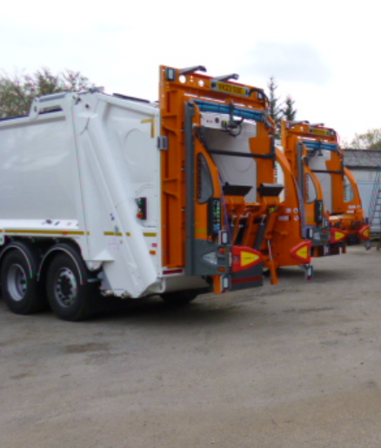
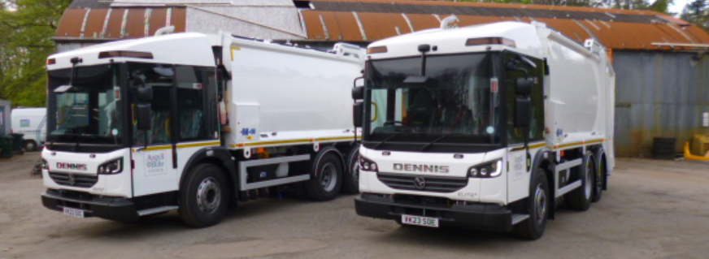

New bin lorries that will arrive in Lochgilphead next week

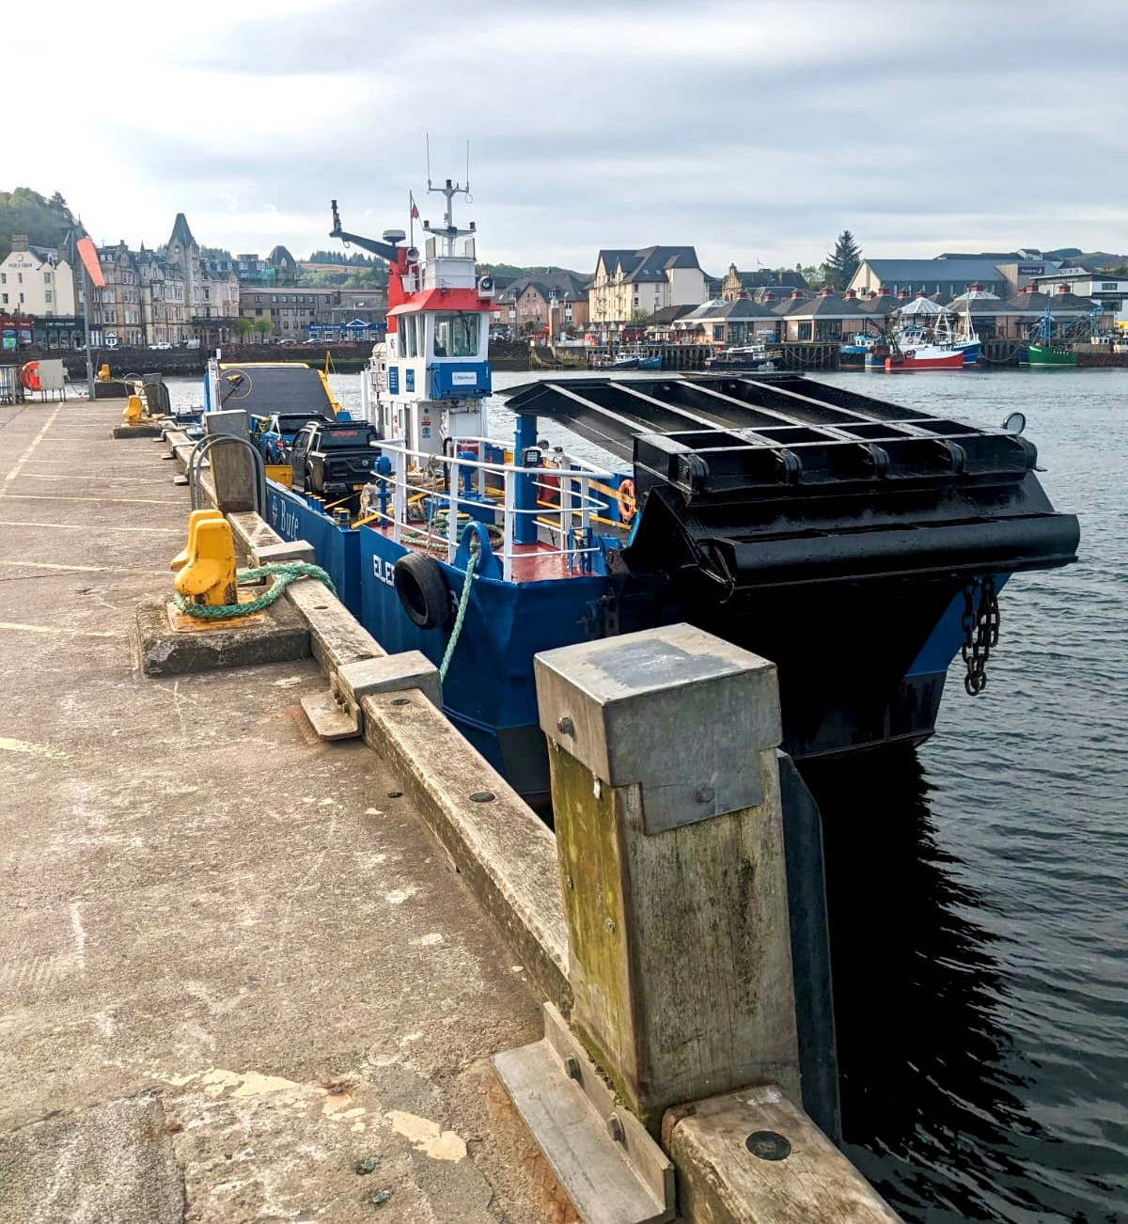
The photo below is the Jura Ferry which stopped overnight in Oban returning from its annual overhaul and inspection. The vessel sailed a day early to make the most of a weather window.

