

Please find below a brief update on various key areas of work.
Roads and Infrastructure
Weekly member briefing
Edition 95: 28th April
Please let us know if you find these briefings useful and if there is any specific information you would like or alterations to the format.
The updates are designed as a resource for you to be able to answer constituent queries.
You can find details of notable service disruptions on key service areas like bin collections and street lighting on the Council website here.
You can view all member briefings on the website

Oban, Lorn and the Isles | Helensburgh and Lomond | Mid-Argyll, Kintyre and the Islands | Bute and Cowal | All areas
Roads  This week the team have been concentrating on surface dressing preparation work on the C33 Lerags Road  Luing bin collections  Next week the Luing ferry will be having its annual refit.  During this time a temporary vessel will be used, however due to weight restrictions it is not suitable for our bin lorry to travel on.  Alternative arrangements have been made for the bin collections next week and these have been placed on our website to alert customers  Fionnphort and Iona marine consultations  There was a strong attendance at both consultations last week.  In general we received a positive response to both the proposed new breakwater and overnight facility, including a small harbour at Fionnphort and the new breakwater at Iona  A further update will be provided once the feedback have been fully analysed. | Roads  Next week the team will be commencing pre surface dressing work at Kidston Drive and Cumberland Avenue in Helensburgh  Bendarroch Playpark  The playpark area was re-opened last Thursday (20th April)  The park now has new swings and chains, the climbing frame bridge, the climbing wall and the slide have all been repaired.  Two additional items of equipment have been installed in the play area, a horse rocker and a spinning disk that were previously installed at the Hermitage park play area. The items were cleaned and serviced before installing.  The roundabout remains a problem, the horticultural mechanic has tried to the best of his ability to carry out repairs, without success.  We are currently assessing the cost for a new roundabout and will provide a further update on this once we have quotes etc. | Roads  The Jetpatcher will be attending Islay next week to carry out pre surface dressing for capital schemes whilst also carrying out some revenue repairs where possible.  Campbeltown cycle path  We are in the final stages of work for the completion of Campbeltown cycle path.  The work will be substantially complete by the end of next week.  Gigha bin collections  We have been having difficulties servicing residents on Gigha recently due to ferry issues. We have now made a new arrangement with CalMac for a block ferry booking on a Friday, which works well within our existing work patterns.  This will mean that recycling collections days change for Gigha residents from Tuesday to Friday. We are currently in the process of working up new calendars and expect to have these available shortly ahead of a go-live date for the new schedule. Ultimately this change should provide a more reliable service for these customers. | Roads  For both Bute and Cowal we are continuing with pre-surface dressing patching and preparation ahead of the surface dressing programme which should take place from late May.  The pre-surface dressing includes involve patching the carriageways at each location utilising the Roadmaster for most along with hot material for pothole patching.  There will also be scrub cutting and ditch cleaning on the rural sites.  Rothesay Fountain  The installation of the lights and the painting of the fountain are now complete.  On the week commencing 15th May the fountain will be cleaned, filled and have the relevant chemicals added.  Our team will receive training on how to maintain i.e. testing the water for legionella on 19th May enabling the fountain to be open to the public once again | Penalty Charge Notice [PCN] fees  Using a new flexibility available to local authorities, the Council agreed yesterday to increase the fees for parking penalty charge notices to £100, reduced to £50 if paid within 14 days.  This is the first time these fees have been increased in over 20 years, and the new figure is below inflation.  The purpose of parking enforcement is to safely keep Argyll and Bute moving, ensuring parking churn in our town centres, which in turn supports economic activity.  Drivers can avoid receives PCNs by following parking restrictions.  Electric vehicle charger usage  Since January 2023 we have had 7,750 charging sessions across our 28 EVC network.  Our chargers have been accessed by just over 2,000 unique EVC drivers which nearly a 34% increase on the number of sessions in the same period last year.  This provides for a CO2 saving for the area of 83.5tonnes or the equivalent of 501 trees

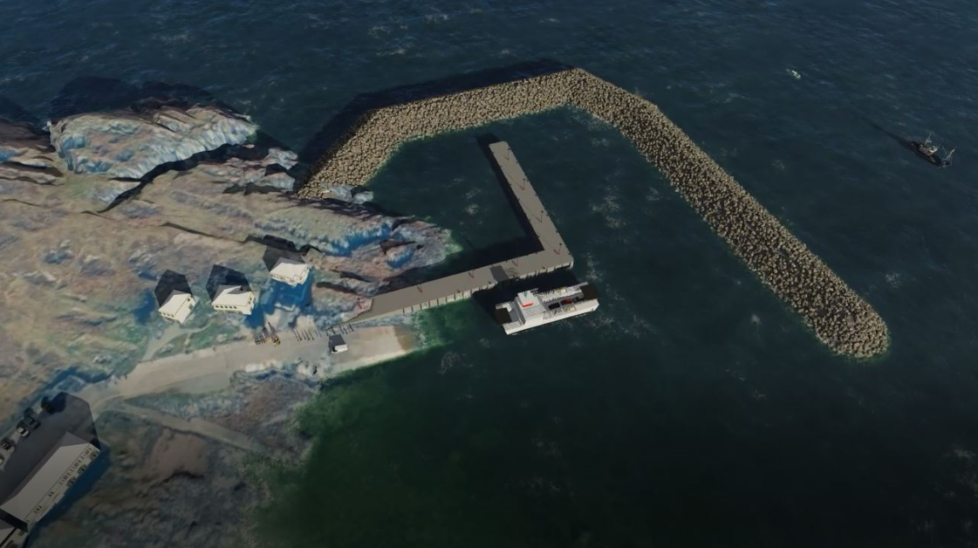
Proposed design for breakwater and small harbour at Fionnphort

BENDARROCH PLAY PARK

