

Please find below a brief update on various key areas of work.
Roads and Infrastructure
Weekly member briefing
Edition 105: 7th July
Please let us know if you find these briefings useful and if there is any specific information you would like or alterations to the format.
The updates are designed as a resource for you to be able to answer constituent queries.
You can find details of notable service disruptions on key service areas like bin collections and street lighting on the Council website here.
You can view all member briefings on the website

Oban, Lorn and the Isles | Helensburgh and Lomond | Mid-Argyll, Kintyre and the Islands | Bute and Cowal | All areas
Roads updates  The team have been continuing with the £32,000 inlay scheme at Croft Road, Oban.  They will be moving on to carry out some maintenance patching work at Bayview road,  Rural grass cutting is ongoing in all areas. | Streetlighting  Our roads team have assisted with excavation work in preparation for streetlighting column and cabling replacement scheme at Rosedale Gardens.  Barrier contractors have been carrying out small works such as fencing / handrails in Rhu, Garleochhead and Clynder this week. The below photo show a fence replacement in Clynder on an area opposite the bowling club.  Once all these small works are complete they will be moving on to repair the damaged crash barrier on the A817.  Arrochar EV charger  We have successfully moved the EV charger mentioned in last weeks briefing and our roads team is assisting with the resurfacing work today  Tigh Dearg Road, Kilcreggan flooding issues  We have been developing a design proposal to separate foul and surface water drainage by constructing two systems of sufficient capacity.  The design has been complicated due to the narrow working area, topography, ground conditions, and the need to design a bespoke outfall to the Clyde. We are working with Scottish Water to achieve the aims of the project namely reduce surface water flooding on Tigh Dearg Road and the amount of surface water going into Scottish water’s combined sewer.  The project will be joint funded by Argyll and Bute Council and Scottish Water and therefore the design requires both bodies approval.  The tender process to closes on 11th July and subject to approving a contractor we expect work to commence in September this year | Roads updates  Surfacing work is scheduled to complete this week along the UC16 Killypole near Machrihanish.  The jet patcher is currently working through a schedule of repairs between Jura and Islay before returning to Mid Argyll week commencing 17th July.  Keily Brothers are programmed to attend Islay to carry our resurfacing work.  Our local team will be starting slurry sealing of footways in Bowmore on the 19th July.  Slurry seal is a maintenance treatment that prolongs the life of the footway by applying a thin coat of bitumen and fine aggregate (sand type material) which seals and regulates the surface to remove some imperfections and preventswater ingress.  Tarbert Seafood Festival  Following the success of Tarbert Seafood Festival which is organised by the local community we received positive feedback through social media regarding one of employees.  The local street cleaner Damon was praised for keeping the streets and pavements looking clean for the event.  Lingerton Fire  A fire occurred on the landfill at Lingerton during the Wednesday night around 3am.  A member of the public from Ardrishaig spotted the fire and raised the alarm.  The fire brigade attended the scene and between them and Renewi staff the fire was extinguished.  Burnside Square  Burnside Square is now open to the public (pedestrians only). All construction fencing /cones/barriers will be fully removed by 5pm today with concrete kelly blocks remaining temporarily in place to block the entrance and exit. Picture below | Roads updates  Work continues on the capital streetlighting scheme and footway improvement works at St Blaines Terrace on Bute.  The jet patcher has been carrying out repairs along the A815.  Rural grass cutting is ongoing in Cowal.  Dunoon linkspan  The Dunoon linkspan suffered a technical problem on the evening of Friday 30th June which temporarily put it out of service.  Hydraulic engineer specialists were on site from 1am Saturday 1st July and managed to raise and lock the linkspan in to a safe position to allow them to begin the fault finding process on the hydraulic control system.  The safety of passengers and protection of the environment are paramount so it is important that the correct process was followed during the fault finding and testing, especially as we were dealing with a hydraulic oil system so close to the water.  The issues have now been resolved and the service resumed at 13.50 yesterday afternoon (06/07/23).  Westlands household waste recycling centre  Renewi, who operate this site on behalf of the Council, have advised us that they are looking to undertake essential resurfacing works beginning 24th July.  While these works are ongoing the site capacity will be reduced, and Renewi will be asking domestic vans and trailers not to visit the site between 24th July and 3rd August, similar to the method used during the recent works at the Roading in Campbeltown. | Electric mini buses  New all electric 9 seater mini buses have been received which will be used mostly for home to school and general school transport.  A picture of new minibuses is attached below.  Scottish Water devices  Scottish Water CAT 5 installation works Contract for Oban North Pier including Berthing Facility, Campbeltown Old Pier including Berthing Facility, Carradale Pier, and West Loch Tarbert Pier has been awarded to a local contractor this week.  The Cat 5 work is required to ensure that private and local public water supplies are protected from backflow contamination and that harbours/ terminals/pontoons etc. are adequately protected to fluid category 5

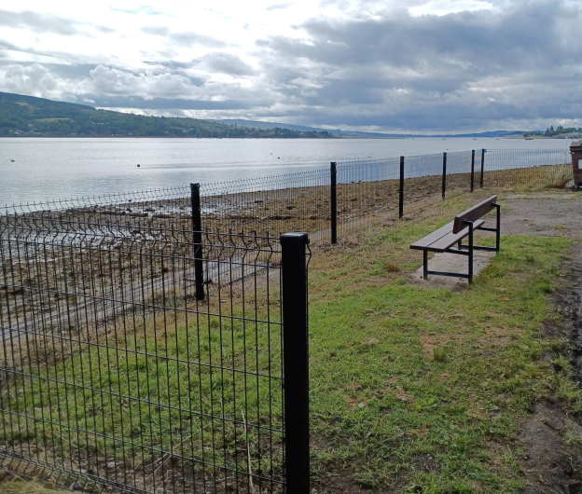
New fencing at Clynder erected by our barrier contractors

New 9 seater Electric mini buses


Tobermory railings job on site

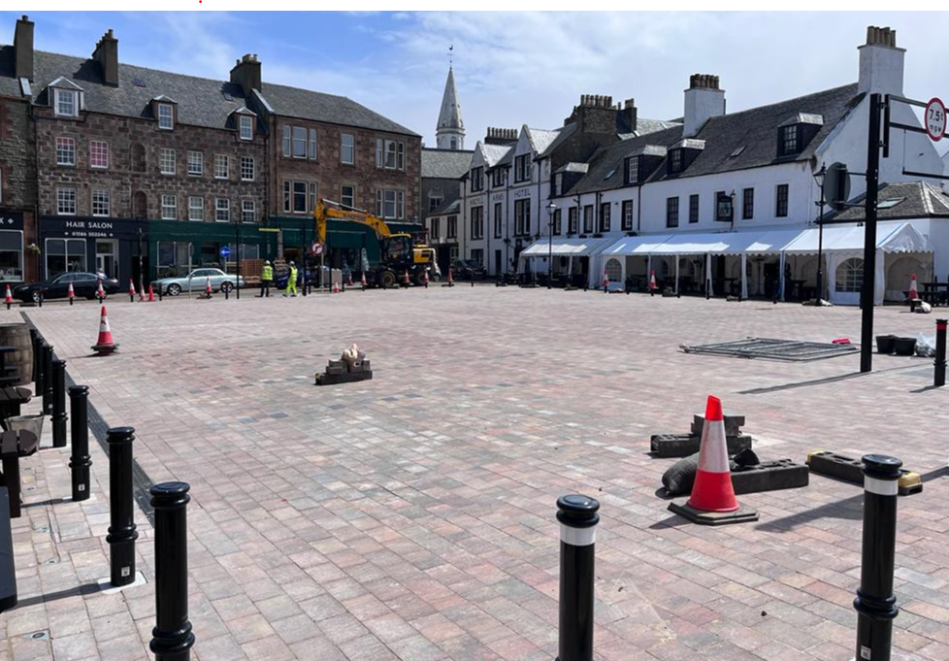
Burnside Square

