

Please find below a brief update on various key areas of work.
Roads and Infrastructure
Weekly member briefing
Edition 104: 30th June
Please let us know if you find these briefings useful and if there is any specific information you would like or alterations to the format.
The updates are designed as a resource for you to be able to answer constituent queries.
You can find details of notable service disruptions on key service areas like bin collections and street lighting on the Council website here.
You can view all member briefings on the website

Oban, Lorn and the Isles | Helensburgh and Lomond | Mid-Argyll, Kintyre and the Islands | Bute and Cowal | All areas
Roads updates  The carriageway widening element of the Kilninver capital job will finish tonight.  The team have also been progressing with road repairs on Luing this week before moving on to the £32,000 inlay scheme at Croft Road, Oban [U004] next week.  Surface dressing jobs were suspended due to wet weather.  Tobermory Cemetery  As advised last week, this scheme is now complete, and has been certified. As part of the contract there is a six month landscape maintenance programme. Like all projects, there are a few minor defects for the contractor to pick up. These are dealt with under a standard contractual 52 week defects period, at no cost to the Council.  We’ve included some photos below.  Tobermory railings  We have included a photo of these works below following on from the update last week.  Fionnphort marine works  The Environmental Impact Assessment [EIA] is ongoing, which includes a socioeconomic assessment.  Once the EIA is approved by Marine Scotland we will be able to progress with the necessary licences with a view to tendering for these works around the summer of 2024.  Iona breakwater  We are in the process of submitting the planning application for the breakwater. We are hoping to be able to tender for these works later this year, then appoint a contractor around the middle of next year. | Streetlighting  The civils works for the streetlighting scheme in Kathleen Park have been completed and we’re now moving on to the column and cabling works.  Our roads team are now moving on to Rosedale Gardens to undertake excavations ahead of that column and cable replacement scheme.  Roads updates  Surface dressing works have been able to progress in Lomond this week despite the poor weather elsewhere.  The following jobs were completed:  Darleith Road [£60,000]  Red Road [£46,000]  Lineside Walk [£15,000]  Portincaple Road [£34,000]  The £72,000 scheme at the B833 Mill Brae is 95% complete, with the small remaining section to be completed by the contractor when they return to the area later in the year.  Arrochar EV charger  We are looking to move the EV charger at the Luss Estates car park in Arrochar [previously leased by the Council] to the Glen Loin 2 car park, which we own.  We need to install a new power supply and feeder pillar in advance of the charger install. This involves digging up the footway outside the car park. This will be done under traffic control on Thursday and Friday next week. | Roads updates  The jetpatcher will be going across to Islay again next week.  We are progressing with capital works at the following locations:  Bolgam Street [£17,000 – inlay]  Range Road [£30,000 – inlay]  Next week we are planning to move on to the £29,000 overlay job on the B843 West Trodigal.  Surface dressing was suspended due to wet weather.  Kilkerran Cemetery  As part of the ongoing work to look at future burial options for Campbeltown, we undertook trial digs at, and around the existing cemetery on Tuesday.  The results of these digs are being analysed, and will help determine what can and can’t be done at this location. | Streetlighting  The civils works for the streetlighting capital job at St Brides Road are ongoing. As well as streetlighting upgrades, this will also provide an improved footway for local residents.  Roads updates  Surface dressing was suspended due to the wet weather.  All preparations for these works are complete. There is a small issue at the North end of the A815 Cluniter Point to Braemar Cottage scheme.  A damaged sewer connection has resulted in some subsidence to the northbound lane. This is an issue for Scottish Water – we have been in contact with them with a view to having a repair progressed by 15th July. The location has been signed and guarded to advise road users.  Next week we are planning to progress with capital footway works at the U01 Ardenslate Road and the U08 Bencorrum Brae. The best time to do these works is once the school holidays commence in order to minimise disruption.  Glenmorag  Following the recent work to clear the car park of abandoned motorhomes, trailers and caravans, the car park continues to be clear and available for day parking.  Westlands household waste recycling centre  Renewi, who operate this site on behalf of the Council, have advised us that they are looking to undertake essential resurfacing works beginning 24th July. While these works are ongoing the site capacity will be reduced, and Renewi will be asking domestic vans and trailers not to visit the site between 24th July and 3rd August, similar to the method used during the recent works at the Roading in Campbeltown. | Surface dressing  Many of the planned surface dressing jobs across the area had to be suspended this week because of the wet weather.  In case you receive any constituent queries along the lines that these works should have been progressed earlier in the year during the prolonged period of very sunny weather, while wet weather causes problems for the delivery of surface dressing, so does extremely hot weather. In these conditions the material can literally melt, and does not take properly to the road surface.  New circular economy bill  Members may have seen news reports this week of fly tipping fines increasing. This is part of the new National Litter and Flytipping Strategy Action Plan, which sets out a new national approach, with a view to enhancing Scotland’s environment and to ensure safer and cleaner communities.  Alongside the strategy there is an action plan for 2023-24.  Both of these documents and more information can be found on the Zero Waste Scotland website here.

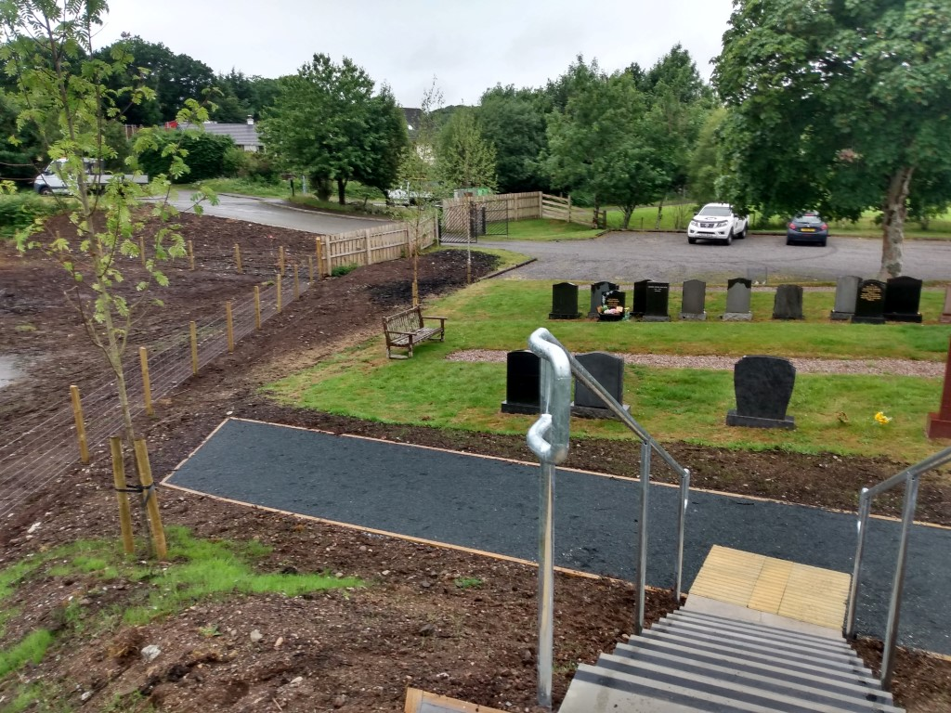
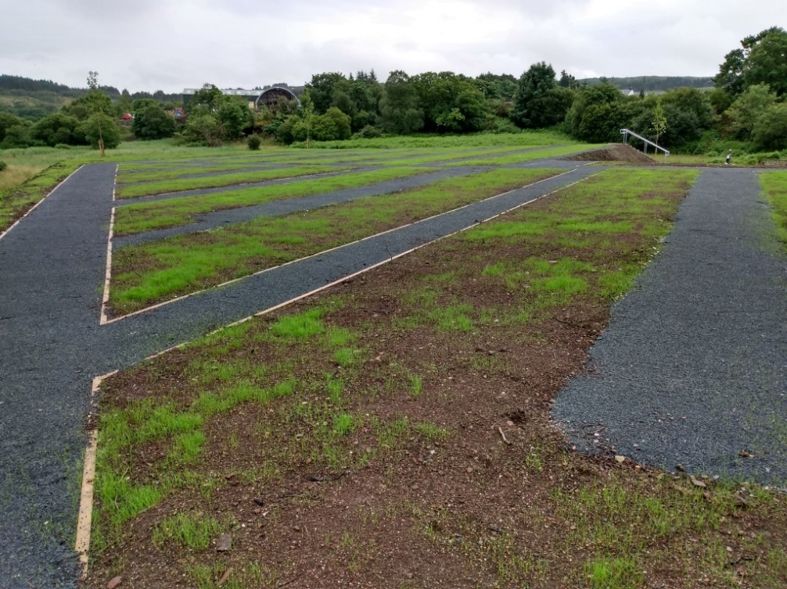
Tobermory cemetery works

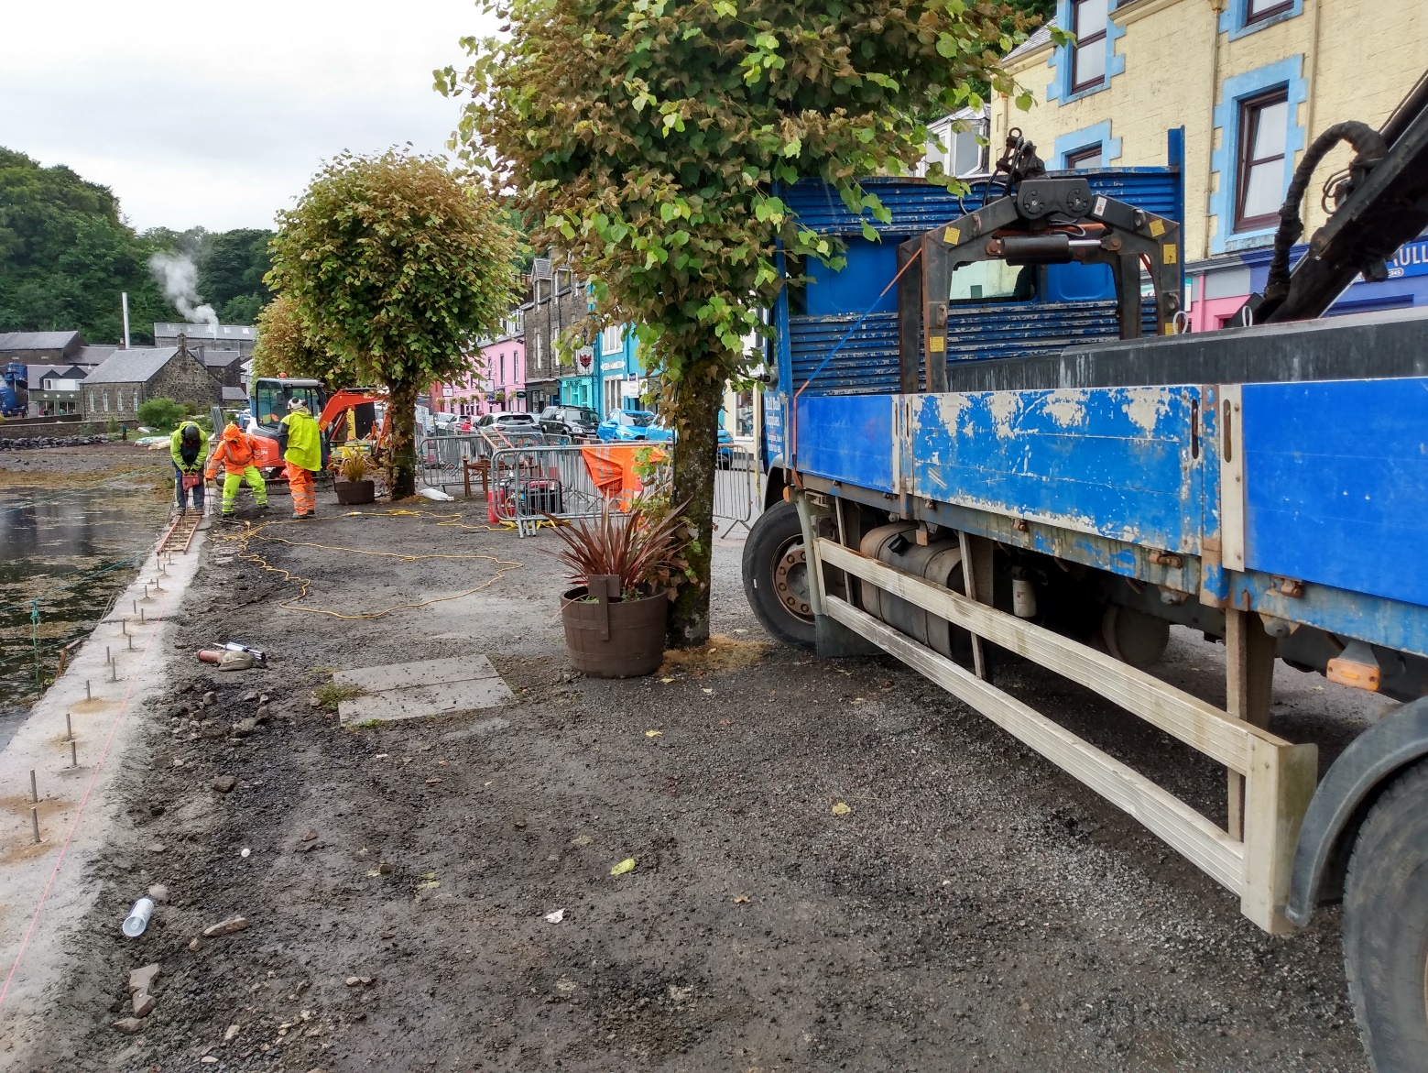
Tobermory railings job on site

