

Please find below a brief update on various key areas of work.
Roads and Infrastructure
Weekly member briefing
Edition 102: 16th June
Please let us know if you find these briefings useful and if there is any specific information you would like or alterations to the format.
The updates are designed as a resource for you to be able to answer constituent queries.
You can find details of notable service disruptions on key service areas like bin collections and street lighting on the Council website here.
You can view all member briefings on the website

Oban, Lorn and the Isles | Helensburgh and Lomond | Mid-Argyll, Kintyre and the Islands | Bute and Cowal | All areas
Roads  Work has commenced on the phase seven of capital improvements at Kilninver on the A816.  This work is part of a £148,500 investment for which includes carriageway improvements and a new vehicles safety barrier.  Luing school transport  Local members along with the Head of Service and Service Managers visited Luing this week to meet with parents and the Community Council to discuss a range of subjects including ferry and school transport provision.  The meeting was positive and we are looking at some options for the future of the school transport service.  Oban High School transport  Teachers and pupils from Oban High School were at an event in Glasgow yesterday, planning to get home by train.  Unfortunately Scotrail cancelled the evening Oban service.  Our school transport team mobilised and worked on until around midnight to ensure everyone got home safely. | Roads  Pre surface dressing will commence on the B833 Mill Brae, Garelochhead on the 19th June. This is preparation work for the £94,000 surface dressing scheme.  Kilcreggan Pier project  This week Officers and the Policy Lead visited Helensburgh, Cove and Kilcreggan meeting with local communities and members of the public concerning the proposed ferry service upgrades.  We listened to concerns and discussed the technical constraints of the project.  An agreement was made that once we have confirmation of the vessel funding we will visit again with presentations on the next steps, keeping everyone involved in the process.  Cardross Crematorium  The new hearth has now been fully installed and Cardross and the crematorium has re-opened and is operating well. | Roads  Our team have now completed their work on the Campbeltown Cycle way and this has now been opened to the public.  Pre-surface dressing work on C19 between Kilkerran road and Fachoig is now completed.  Next week we moving to the B843 West Trodigal, Machrihanish to carry out some overlay work.  The U33 Woodlands Drive and Range Road will also see capital inlay work commence there next week.  Port Askaig  There was an incident at Port Askaig earlier where a private vehicle and trailer struck a private building adjacent to our port.  Thankfully nobody was seriously injured, and this has had no impact on the ferry crossings – they continue to operate as normal.  From a Port Marine Safety perspective we are in the process of investigating the incident and in the mean time we have suspended the process of dropping trailers at the facility. | Roads  Surfacing of the capital inlay scheme on the A815 at Strachur will complete today.  The final pre surface dressing works on the A815 between Rashfield and Orchard will complete next week.  The streetlighting capital scheme at Ballochgoy on Bute is ongoing – this work should be completed in the next fortnight.  Bute Seawall  Studies at Ardbeg Road to inform the designs continue.  Site works for a ground investigation have been recently completed, and a wave modelling study is currently underway.  Further surveys shall be concluded before the detailed design for the permanent works can be progressed.  Once the detailed designs are completed, the works contract can be tendered and constructed.  The timeframe to appoint a Contractor is within this financial year, subject to Marine Scotland and Crown Estate consents. | Play park consultation  Our playpark consultation is still live and closes on the 14th July.  To help us prioritise work and funding please encourage your constituents to complete the short online survey found on the following link:  Electric vehicles  Below is an image of one of our new school transport vehicles using the recently installed EV chargers at the Helensburgh Civic Centre.  Over the past few years we have changed over 70 petrol or diesel vehicles to low emission ones, either fully electric of hybrid, as well as installing a number of chargers at key offices and depots.  We are currently working on plans to change over more vehicles and to access further funding for more charger installs at other key locations.

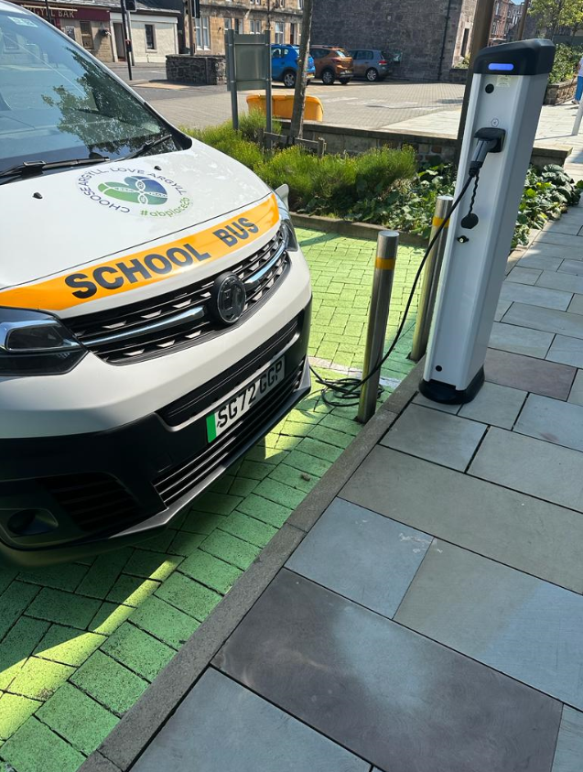
Our new electric school transport vehicle using the recently installed chargers in Helensburgh

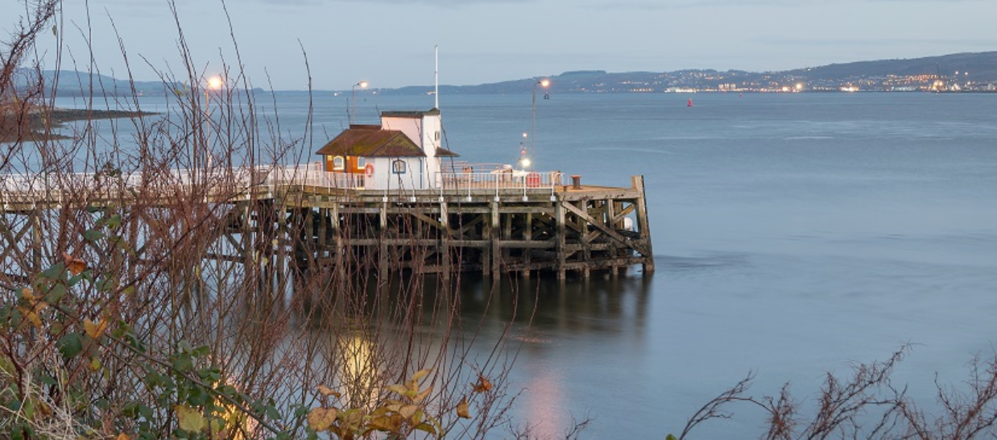
Existing Pier at Kilcreggan

