

Please find below a brief update on various key areas of work.
Roads and Infrastructure
Weekly member briefing
Edition 101: 9th June
Please let us know if you find these briefings useful and if there is any specific information you would like or alterations to the format.
The updates are designed as a resource for you to be able to answer constituent queries.
You can find details of notable service disruptions on key service areas like bin collections and street lighting on the Council website here.
You can view all member briefings on the website

Oban, Lorn and the Isles | Helensburgh and Lomond | Mid-Argyll, Kintyre and the Islands | Bute and Cowal | All areas
Roads  This package of capital work has now completed on Mull [pre surface dressing]  This batch of works has seen over £80,000 invested in preparing the A848, A849 and C47 for their surface dressing schemes.  On Mull next week we will be undertaking footway surfacing works in Bunessan.  In Lorn, we are gearing up for capital schemes, with the A819 overlay job at Inveraray Fish Farm, a £61,000 scheme, starting on Wednesday next week.  The verge cutting operation has started in Lorn this week and will be getting underway on Mull next week.  Inspection of the Glengorm landfill and civic amenity site  Colleagues from SEPA were on site at Glengorm last Friday, 2nd June, to carry out a routine inspection of the facilities and the processes in place for managing waste and recycling.  Initial feedback is that they were happy with the site and operations, no particular issues raised.  Well done to all our staff working on the site and involved in the waste service on the island.  Argyll Square traffic lights  We have had contractors on site this week to look at the faulty crossing, which was previously running through its cycle very quickly once a pedestrian activated the crossing, causing issues with traffic flows through the town, particularly at peak times.  Now when the crossing is activated the red light sequence will commence after 20 seconds, which allows 10-15 cars through, allowing more pedestrians to gather at the crossing and cross as a single group.  The crossing time allowance is now 15 seconds, which is ample time for a single lane crossing for pedestrians of all capabilities.  The crossing is ultimately likely to require more significant works, which we are currently getting a price for.  Public toilets on Mull  Both Salen and Craignure toilets have reopened following last week’s closure advised by Scottish Water due to water shortages on the island.  Pier user meeting, Coll  On Wednesday evening our officers held a physical meeting on Coll to discuss the use of the Middle Pier at Arinagour. This also provided an opportunity for discussions regarding the road network, recycling facilities, refuse collection etc. Officers also carried out an informal inspection of the full road network and the Civic Amenity site, accompanied by our single island staff member, Randolph.  The photos below detail some actions picked up. | Streetlighting  The £43,000 capital project at Kathleen Park is getting underway – we will be replacing all existing infrastructure which includes lighting columns, underground cabling, ducting and feeder pillars.  Our roads team will be carrying out the civils works [excavations and reinstatements] associated to this job.  Ultimately this will provide better, more reliable streetlights in this area.  Roads  As well as supporting the above project, our roads squads will be out grass cutting next week along the A814.  Cleansing  Members may have noticed the street cleaning machine being deployed in and around the town this week. The team have also been out weed spraying.  Cardross Crematorium  The scheduled maintenance works at the Crematorium are going to schedule and we are on track to reopen as planned on Monday.  We have taken the opportunity of the facility being closed to the public to undertake some staff training and development, particularly for some new starts in the team.  The number of bookings for next week has increased to over 20 now. | Roads  Grass verge cutting has been ongoing in the southern end of Kintyre, as well as pre surface dressing on the C19 Learside Road. The patching work here ahead of the surface dressing scheme is to the value of £150,000, with a similar amount being invested in the actual surface dressing works planned for later this month.  Surfacing works are starting next Monday, 19th June, on Woodland Drive and Range Road in Campbeltown. In addition, as part of the reinstatement works for the Campbeltown Flood Protection Scheme, resurfacing works will begin on Smith Drive on Tuesday, 20th June.  Pre surface dressing work along the B8024 Ormsary Road is now complete.  The Roading resurfacing works  Just a reminder about the resurfacing works at the Roading civic amenity site, which are set to being Monday 12th June.  Whilst the site will remain open there will be some restrictions in place for users whilst these essential works are undertaken.  Campbeltown Flood Protection Scheme  A further project update newsletter will go out to those on the mailing list on Monday. If you are not on the mailing list why not sign up and receive the newsletters? There is also some useful content on the council website.  Main headlines are:  We are now looking at Burnside Square reopening for public/pedestrian use before the end of June, but remaining closed to cars/traffic until later in July. This is to allow the new entrance and exits to be completed and for the appropriate signage to be in place, as well as allowing drainage works on Burnside Street to be completed.  Drainage works are required on Witchburn Road and because of the nature of the works and the narrowness of the road, it seems likely that a road closure will be required  We are working with the contractor to develop these plans, and have asked them to carry the works out during the summer months, rather than during school times. Like previous road closures on the scheme, this is likely to be what is called a rolling closure, where sections of the road are closed at a time, rather than a whole stretch.  The area affected will be from the junction of Big Kiln Street and Burnside Street to The Creamery Building on Witchburn Road.  The statutory road closure consultation is now beginning, and as part of that the draft notice will be circulated to Members for any comments. | Roads  We are continuing to work through pre surface dressing works on Bute. This involves a small amount of preparatory work on the A866 and a larger amount of work on the B881.  In Cowal we are working through pre surface dressing on the A815 Orchard to Rashfield.  We have also commenced capital inlay works at Strachur, a £112,000 scheme on the A815 between the A886 junction and the Fire Station. Please note that this is a different scheme to the one going ahead shortly from the Sawmill to the Fire Station, which is a surface dressing job.  Streetlighting  The capital footway and streetlighting scheme at Ballochgoy on Bute has started this week. This is a £42,000 scheme that is being delivered in house and will see 18 columns replaced and the footway resurfaced afterwards.  West Cowal school hostel transport  The new contract with West Coast Motors for this service starts on Monday.  The new service is substantially similar to the previous service, the provider for which has now retired. We will be monitoring the new service in the lead up to the summer break and making any tweaks as required ahead of the new school session in August.  Rothesay fountain  The fountain is now back up and running and at full capacity following the recent vandalism. | Roadside verge cutting programme  You will have seen updates in the past few briefings about grass verge cutting being underway in certain areas/on certain roads.  This programme is delivered mainly by our in house operations team, with the assistance of external contractors on our framework as required. .  In total we use eight tractors to allow the cutting operation to proceed in all areas at the programmed time.  The service specification is for a first summer cut of 1m swathe plus sightlines across the whole network, then a reduced second cut on principal routes and sightlines later in the summer.  The priority network for secondary treatments are the strategic mainland and island A roads, and other A and B roads carrying most traffic between centres of population.  The programme is designed to catch the period of maximum growth to minimise the requirement for a full secondary cut, thus preserving the revenue budget allocated to this activity. Cut grass is not picked up but is left to mulch back into the verge.  To prevent the spread of Japanese knotweed all routes are inspected and marked off to prevent further spread during the cutting operation.  The purpose of this work is to ensure vegetation does not restrict visibility and it therefore enhances the safety of the road users, whilst also allowing pedestrians to step off the carriageway on narrow roads and avoid approaching traffic.  Cutting the roadside verges also reduces vegetation encroaching into the road edge which could narrow the available road width and potentially damage the fabric of the road.

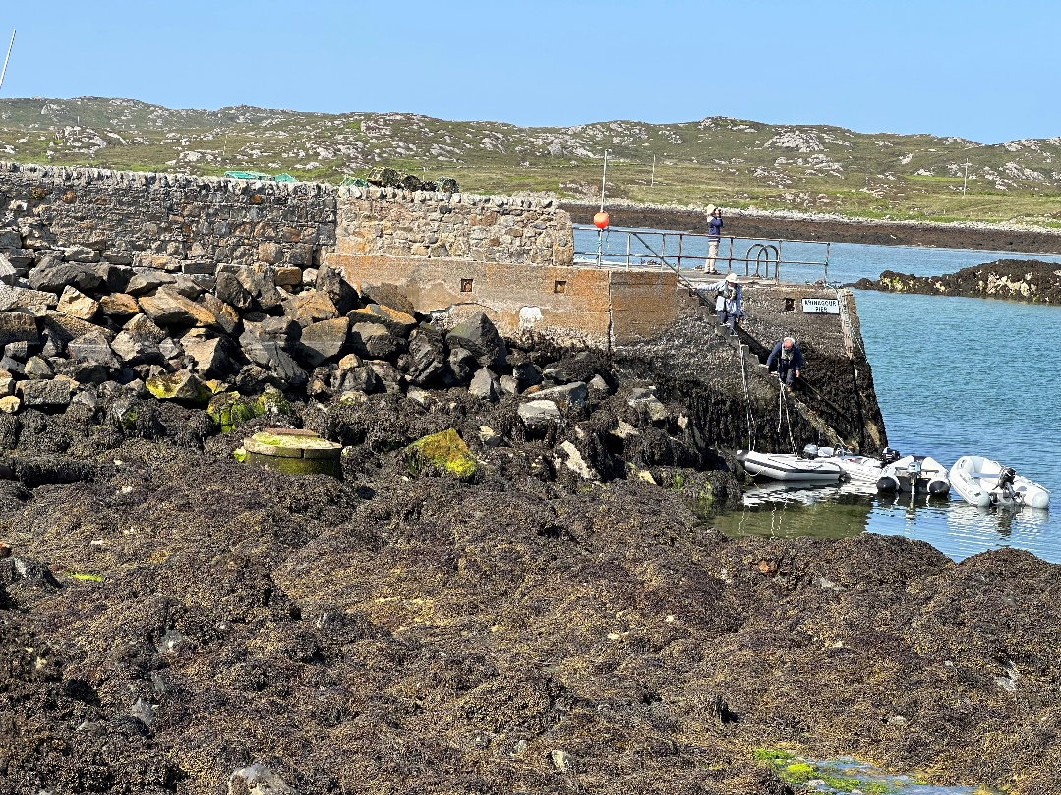
Middle Pier Coll – some minor remedial works have been identified which will be scheduled for action

Minor damage to a bridge parapet coping stone from cattle rubbing – remedial works will be carried before any further damage occurs

