

Please find below a brief update on various key areas of work.
Roads and Infrastructure
Weekly member briefing
Edition 94: 21st April
Please let us know if you find these briefings useful and if there is any specific information you would like or alterations to the format.
The updates are designed as a resource for you to be able to answer constituent queries.
You can find details of notable service disruptions on key service areas like bin collections and street lighting on the Council website here.
You can view all member briefings on the website

Oban, Lorn and the Isles | Helensburgh and Lomond | Mid-Argyll, Kintyre and the Islands | Bute and Cowal | All areas
Capital work  The team have begun pre surfacing dressing work on the Cregan Loop Road in Barcaldine.  This work is in preparation for two schemes included in the capital programme (U37 & U134) costing in total £532,500  Next week we will be doing capital surfacing works on the B844 Lerags Road.  On Mull we continue to carry out scrub and drainage improvements on the A849 with capital works commencing on the 9th May.  Tobermory Cemetery  Work continues to go well on the extension of Tobermory Cemetery.  Currently the headstone foundations are being constructed for the lairs.  Tobermory Railings Phase Two  We are currently working towards a start on site mid to late May, given the lead times for various items like the hand rail elements, which we are currently in the process of procuring.  Earlier this week we secured planning permission for the works, which is a key milestone.  Iona and Fionnphort consultation  Just a reminder that there are some planned consultation events next week in relation to proposed licensable marine activity at Iona ferry terminal and Fionnphort ferry terminal.  The scope of the works will involve the improvement of the ferry infrastructure that connects the two islands, with the construction of a breakwater at Iona and another at Fionnphort, and an overnight berthing facility which includes the extension of the existing pier at Fionnphort.  These events will take place on:  Tuesday 25th April 09.30 – 20.00 at Creich Community Hall  and  Wednesday 26th April 09.15 – 16.15 at Carnegie Library | Luss Traffic Regulation Order  Transport Scotland, on behalf of Scottish Ministers, granted consent on 11 April 2023 and the Order has now been signed. This means the Order is now made and Officers can commence the next phase of the process.  The Order requires to be advertised, following this there is a six week period where challenges can be submitted to the Council for referral to the Court of Session. This is not a further objection period but rather a period which allows challenges to be submitted in relation to any breaches of procedure or law, or that the Authority has acted beyond its powers. The Notice will be advertised in the Helensburgh Advertiser on 27 April 2023. In addition to this Officers are intending on placing a Notice in the Lochside Press but are currently awaiting confirmation of this.  In the meantime, Officers are developing signing and lining plans for implementation as soon as practicable following the six week challenge period.  Capital work  Work has commenced on the A818 Daligan Bends to clear sightlines in preparation for the £55,000 resurfacing scheme scheduled later in the year.  The removal of trees / shrubs just now is to ensure we do not disrupt nesting season. | Capital work  Pre surface dressing work along with essential repairs have been carried out in Mid Argyll and Kintyre area this week.  In Mid Argyll crews have been carrying out the preparation work for the B8024 Ormsary Hill £226,000 resurfacing scheme.  Whilst in Kintyre the crews have begun on C19 Learside Road, between Kilkerran Rd & Fachoig, which is part of the £310,000 resurfacing scheme  Work has also got underway on the C20, between New Bridge and Arnicle, Bar Glen Road which is part of a £101,000 scheme  We are in the process of trying to schedule a visit to Islay to carry out the same kind of preparation work on the island.  This is hoped to be either the first or second week of May. This will be dependent on ferry availability  Burnside Square  Burnside Square in Campbeltown has now been backfilled following the successful installation of the flood storage tank (see picture below).  This is not the finished surface – paving will be installed which will be in keeping with the previous finishes.  We are continuing to engage with our design consultants AECOM in order to balance the principles for the new square previously agreed with the infrastructure requirements around the tank and its safe operation and access.  We are having a drawing done soon which will show the area available for pavement café spaces on Harvey’s Lane and Cross Street, while maintaining a pedestrian walkway.  We are also looking to utilise spaces within the square itself for further designated/segregated pavement café areas which could be available for use by licence.  This drawing and accompanying design statement should be available to review shortly. | Capital work  Pre surface dressing along the A815 between Rashfield and Orchard has commenced. This is part of an overall £63,500 scheme  Kilfinan Cemetery  The team are currently in the process of repairing a bulging wall that is now affecting the neighbouring property.  The wall has been stripped down and will be rebuilt  Dunoon Stadium  Crews are carrying out drainage improvement work on the pitch and will then commence with grass cutting  Innellan dropped kerbs  Footway improvements have commenced along the A815 Shore Road, Innellan.  The first phase of the improvement work is to install dropped kerbs at key points to make the footway more accessible.  This work is coinciding with a capital streetlighting project that will see Shore Road benefit from an allocation of £204,600 to replace 60 columns and underground cabling.  The second phase of the footway improvement work will be to resurface the footway once the streetlighting work has been carried out  Glendaruel Bridge  Following on from last week’s update, we now have an outline proposal from a contractor to strengthen the bridge, which we are in the process of reviewing | Deposit Return Scheme  It was announced recently that Scotland's Deposit Return Scheme (DRS) has been delayed.  The scheme, which had been due to start in August next year, will not now begin until 1 March 2024.  Unlike previous new national waste initiatives, in this case local authorities have no responsibility for administering the scheme  The scheme is operated and administered on behalf of the Scottish Government by a newly created body called Circularity Scotland.  Bin collections  Following last week’s update, we are pleased to advise that thanks to the continued hard work across our teams, the position with the refuse collection vehicle [RCV] fleet is much improved, and collections schedules should start afresh come Monday.

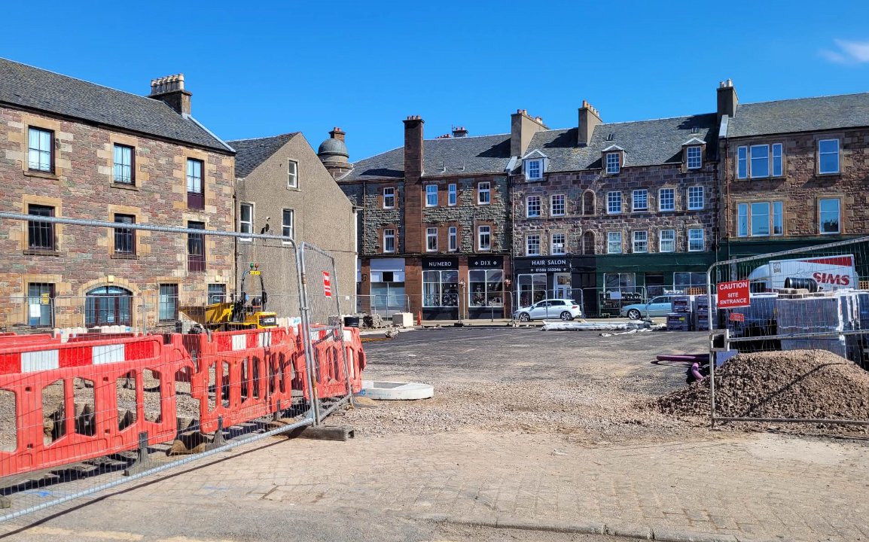
Burnside Square earlier this week. The cleared space is a significant size, and will be available in an improved, flexible form for community use and to support café culture at the conclusion of the flood protection scheme

