

Please find below a brief update on various key areas of work.
Roads and Infrastructure
Weekly member briefing
Edition 93: 14th April
Please let us know if you find these briefings useful and if there is any specific information you would like or alterations to the format.
The updates are designed as a resource for you to be able to answer constituent queries.
You can find details of notable service disruptions on key service areas like bin collections and street lighting on the Council website here.
As well as the updates on notable roads and footway schemes in the table below, the whole roads and footway capital programmes are available online – you can access the full list of schemes here.
You can view all member briefings on the website

Oban, Lorn and the Isles | Helensburgh and Lomond | Mid-Argyll, Kintyre and the Islands | Bute and Cowal | All areas
Streetlighting  Following on from last week’s update, we’re happy to advise that the power company attended at Lynn Road and Soroba Road in Oban this week and successfully repaired underground cabling faults as well as replacing distribution units.  Pre surface dressing works  Works are scheduled to begin at the following locations next week:  C31 Kilchrenan – Ardanasaig Road  B845 Kilchrenan - Taychreggan Road  U37 Barcaldine – Loch Creran Road  U134 Barcaldine – Loch Creran Road  We have included below a short explanation of what surface dressing is and what preparatory work is undertaken in advance.  Flooding  There were a couple of instances of localised flooding in and around Appin overnight, Tuesday/into Wednesday morning which our teams attended to.  Bus shelter improvements  We have made our first bus shelter improvement of the financial year at McCaig Road in Oban. Before and after photos are below – we have created a new accessible footpath, connected to the nearest footway, to allow people to safely access the shelter.  We have a very limited budget for bus shelter improvements [£40,000 across the three non-SPT areas] and look to progress schemes where a need has been identified either through inspections or community feedback. The works we do focus on making bus shelters more accessible for all.  Generally a new bus shelter would cost in the region of £4,000 and a new base [including kerbing etc.] around £3,000. | Food waste  Working with our colleagues in the Communications Team we are looking to shortly put out some public messaging on the benefits of using the food waste kerbside service available in Helensburgh and Lomond.  The take up rate by households currently stands around 50% - we are keen to promote the benefits of this service to encourage people to separate out their food waste. Ultimately food waste can be recycled and turned into energy through a process called anaerobic digestion, whereas food waste placed in general waste bins goes to landfill and is therefore not recycled.  Pre-surface dressing works  As advised last week, the team have mobilised for the pre-surface dressing works and these are now underway. We’ll be working through the following sites:  U81 Helensburgh - Cumberland Avenue;  U170 Helensburgh - Kidston Drive;  U189 Rhu - Lineside Walk;  B833 Rosneath - Mill Brae  U244 Cardross - Red Road  U237 Cardross - Darleith Road  U228 Old A82 – Luss to A82  Scottish Water works A814  Scottish Water are undertaking works on the A814 under traffic management. We understand these works have been quite disruptive this week and we are engaging with Scottish Water about the best way for them to manage these works whilst minimising disruption for the travelling public. | Recycling collections  Due to ongoing issues with our refuse vehicles there have unfortunately continued to be disruptions to both the general waste and recycling waste collections across Mid Argyll this week.  To enable us to catch up with the general waste collections, which are the priority, we have had to delay any recycling collections scheduled for this week until the next scheduled collection date.  See the RCV update to the right for more information.  A further disruption notice has been placed on the website and a ‘keep me in the loop’ email issued to those signed up to the service. If you have not signed up to ‘keep me in the loop’ it is the best way to receive live information on service disruptions across all Council services.  Pre-surface dressing works  We are completing works on the Campbeltown cycleway scheme this week before moving on to pre-surface dressing towards the end of next week.  Works are scheduled to begin at the following locations:  A816 Kilmartin – Kilmartin to Carnassarie  B8024 Kilberry – Middle Hill to Ormsary House  B842 Southend - Second half of Killellen to Achnaglach Site.  C19 Learside Road - Between Kilkerran Road and Fachoig  B879 Carradale - B879 junc to Network Centre.  C20 Bar Glen Road - Between New Bridge and Arnicle  Campbeltown Harbour  We are receiving enquiries again this year from cruise ship companies interested in coming into Campbeltown; we will keep you informed of any bookings received and our preparations to welcome visitors to the town.  Jura Ferry  The MV James is currently in service as the relief vessel whilst the Jura ferry goes in for its annual maintenance checks.  The MV James carries large HGVs so the freight carrying capacity for the route is maintained. We delayed the dry docking of the usual vessel to ensure the James was available – this approach seems to have been well received by the local community. | Glendaruel Bridge  Following completion of the temporary works, this bridge now has a weight restriction of 3 tonnes which will help to ensure that no further deterioration occurs from overloading.  In the background we will be working up designs/possible solutions to strengthen the bridge such that it can again accommodate heavier vehicles, but realistically that is likely to be some time away.  We will look to provide updates on how those designs are progressing periodically in this weekly briefing.  Pre-surface dressing works and road schemes  In Cowal we are looking to proceed with these works from the end of next week.  The surface dressing locations in this area are:  A815 Strachur – Sawmill to Fire Station;  A815 Sandbank – Rashfield to Orchard;  A815 Innellan - Ardhallow to Cluniter House;  A815 Innellan - Cluniter Point to Pier Road;  A885 Sandbank – A815 to Bencorum Brae;  A885 Tighnabruaich – A886 to North Lodge;  On Bute we have completed pothole repairs on the approach to the Joint Campus, and installed new kerbing at St Andrews Primary School which will help to prevent irresponsible use by vehicles of a pedestrian footpath. | Surface dressing contract  We are in the process of completing a contract award for our surface dressing works.  For a number of years surface dressing has been carried out by an external contractor, which has proven to be the most effective way of delivering this particular type of treatment as part of our well established mixed economy delivery model which uses our internal teams, SMEs and national contractors providing a flexible and responsive model.  We have a provisional start date of 29th May for surface dressing works, and will provide more detail on this by way of a specific briefing note once the contract is officially awarded and arrangements are firmed up with the successful bidder.  Lining framework contract  We are in the process of making updates to our call off framework for lining contractors. This is an annual process which provides us with a list of approved contractors and agreed rates such that we can go to them directly for lining jobs, as opposed to running a full tender process.  Going forward we expect to be less reliant on the contractor market for this work given the recent welcome budget allocation for our own lining vehicle.  We are working through a tender process for that at the moment. We do not as yet have a timescale but understand that these vehicles come bespoke as opposed to off the shelf and there will be a lead in time of several months once we place an order.  We will look to prepare a specific, detailed briefing on this as well as the funding to purchase an additional jetpatcher over the next few weeks.  Refuse Collection Vehicles (RCVs)  We have experienced a number of service disruptions due to the availability of RCVs.  The problems we have been faced with are due to a number of issues including the availability of spares, electrical faults (in some instances on quite new vehicles, still under warranty) and the limited number of replacement vehicles available to hire.  We currently operate with two spare vehicles and this will soon increase to four which will provide additional resilience.  Two new RCVs are due to be delivered on 27th April as part of the additional funds provided as part of the February budget process. These vehicles will improve resilience.  Our Fleet and Operations teams, supported by Comms, are working incredibly hard to maximise service delivery and provide customer updates.  Two of the vehicles which have been off the road for a while are due back in service on Monday. One vehicle has been with the main dealer since mid-January awaiting a part. The dealer had confirmed that they had 70 of these parts on order with no delivery date. Our team managed to source the part from a salvage yard in England and that vehicle is now able to be brought back into service thanks to the team being creative in finding a solution.

Before and after photos McCaig Road, Oban – new bus shelter path
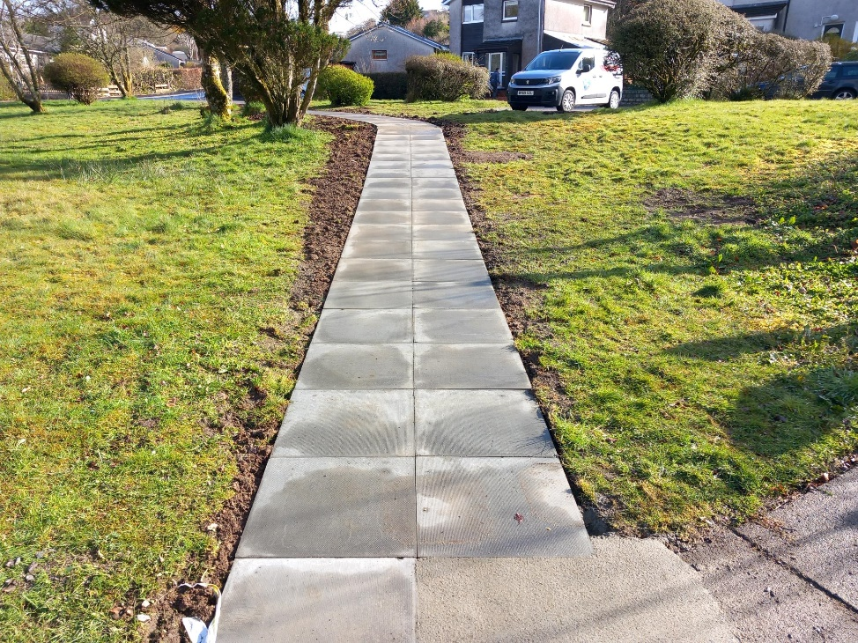
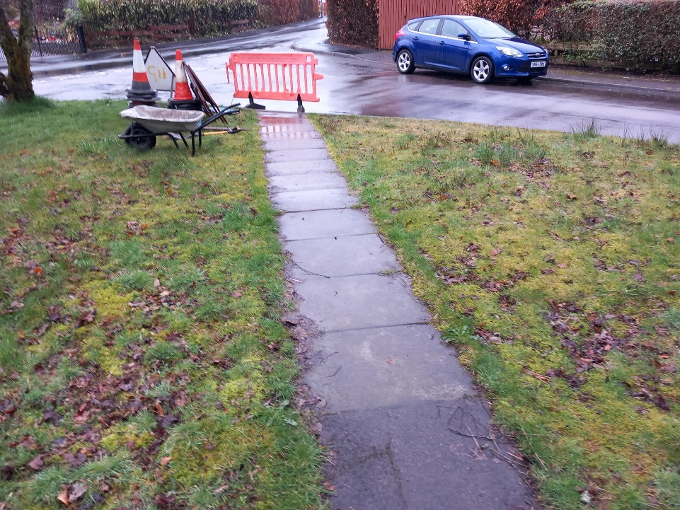

Surface dressing
Surface dressing is a cost effective road treatment which restores the road surface and seals it in one process.
There are a number of designs/types of surface dressing which range from a single dressing which has one layer of binder and one layer of chips to the more durable double dressing which incorporates two layers of chipping’s (the larger size on the bottom) and two applications of binder, the second one being placed between the new layers of chips. The bitumen (the glue which holds the stone chips in place) varies from simple emulsion binders to technically sophisticated polymer modified binders. The type of dressing used is determined by the road condition, the volume of traffic being carried and a number of other factors such as bends and tree canopies (surface dressing works better when summer tempartures warm the surface sufficiently for stone chips to become embedded into the road – in some situations tree canopies can prevent embedment.
Surface dressing targets areas of road in the earlier stages of deterioration – it improves skid resistance, helps seal cracks and prevents water ingress (which is the main cause of deterioration) which protect previous investment and to extend the life of the existing roads.
Pre surface dressing effectively involves patching any potholes/surface defects in advance to get the road ready for dressing (surface dressing itself does not fix potholes which have already formed although it is very effective in preventing future pot holes from forming).
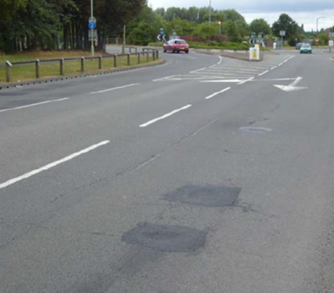
Below is a photo showing potholes having been patched – in this photo you can see the cracks in the old road surface which are still clearly visible. The dressing fills and seals these cracks.

The next photo shows the same road approximately three months after the dressing was completed. The patches and cracks are now covered:

