

Please find below a brief update on various key areas of work.
Roads and Infrastructure
Weekly member briefing
Edition 91: 31st March
Please let us know if you find these briefings useful and if there is any specific information you would like or alterations to the format.
The updates are designed as a resource for you to be able to answer constituent queries.
You can find details of notable service disruptions on key service areas like bin collections and street lighting on the Council website here.
As well as the updates on notable roads and footway schemes in the table below, the whole roads and footway capital programmes are available online – you can access the full list of schemes here.
You can view all member briefings on the website

Oban, Lorn and the Isles | Helensburgh and Lomond | Mid-Argyll, Kintyre and the Islands | Bute and Cowal | All areas
Iona and Fionnphort ferry terminal  There are some planned consultation events at the end of April in relation to proposed licensable marine activity at Iona ferry terminal and Fionnphort ferry terminal.  The scope of the works will involve the improvement of the ferry infrastructure that connects the two islands, with the construction of a breakwater at Iona and another at Fionnphort, and an overnight berthing facility which includes the extension of the existing pier at Fionnphort.  These events will take place on:  Tuesday 25th April 09.30 – 20.00 at Creich Community Hall  and  Wednesday 26th April 09.15 – 16.15 at Carnegie Library  The events will be advertised through statutory notices as well as through the Council’s normal channels – social media, press releases etc.  Tiree and Coll recycling collections  As advised a few weeks ago, we are looking to make improvements to the kerbside recycling service for residents of Coll and Tiree.  On Coll, From the week beginning Monday 17th April, people will be able to put their cans, paper, card and plastics [bottles, tubs, pots, trays] into the same recycling bag.  From the same date on Tiree people will be able to put all of the above items directly into their blue bin, and no longer need to separately bag them first.  Bin collection dates will remain the same. We will shortly be sending letters out to all residents about this | Footway improvement work  Footway surfacing work at Cardross have now completed. This scheme involved resurfacing works at a cost of just under £30,000 – the outcome of the work is that we now have a significant stretch of improved footway connecting the village with the Crematorium and adjacent cemetery.  Cardross Crematorium  Works are scheduled to take place on the cremator hearth between Monday 5th and Friday 9th June.  We could use the old cremator during that time but we expect the works to be noisy and disruptive. We have decided that it wouldn’t be appropriate to have that sort of work going on during services, so have decided to close the crematorium for that week. We will shortly be writing to funeral directors about this.  Kilcreggan marine infrastructure consultation  The consultation closed last week. We are currently working through the findings with our consultants, Mott MacDonald, and expect to be reporting these back to the Harbour Board once the analysis is complete and a report prepared. | Campbeltown Flood Protection Scheme  Good progress continues to be made on the various live works.  We have asked our design team at AECOM to provide a single cover-all drawing showing the proposed changes for Burnside Square and to provide commentary against each of the design aspects agreed following public consultation.  This should come through shortly.  In the meantime the contractor is progressing with the hard infrastructure as per the original tender drawings. The additional elements like electricity points, new access and egress etc. are not affected by the work currently ongoing.  Further works are expected to commence in the Millknowe area from this coming Monday. The objective of this element of the scheme is to provide suitable flood protection works and storage to attenuate flood flows passing downstream into the Millknowe Burn culvert and from overtopping and flowing overland down Millknowe Road and reducing the risk of flooding into the town itself.  The works include:  • Sheet piling and embankment works to form new dam.  • Construction of new reservoir outlet structure  • Drainage works.  The Millknowe Flood Storage Dam is located to the northwest of playing field next to Millknowe Road in the north west of the town. The storage area sits in the low ground next to the Millknowe Burn between the Industrial estate and Hillside Road. | Rothesay Fountain  Our local team have power washed the fountain and its base again this week, and the sump has been cleared out.  The next stage is to wash down the base with acid ahead of painting – this is a specialist task that we are arranging through the Council’s property term contractor.  These are important tasks that need to be completed before we can refill the fountain.  We don’t yet have a firm timescale for the next stage of works but will provide a further update when we do.  Bute Resilience Easter event  The Bute Resilience group are planning a widely advertised event at the event space on Montague Street over the Easter weekend.  Unfortunately we only received a completed application pack earlier this week. We are doing all we can to assist the group in processing things to allow their event to go ahead. To ensure things happen safely there are a number of partners we need to consult with, as well as ensuring the correct licences and insurances are in place. This is normally something that happens over several weeks in advance of any planned event on Council land. We will provide a further update next week  Emergency weight restriction, Glendaruel Bridge  Glendaruel Bridge spans the River Ruel and is located between Kilmodan Recreation Ground and Camquhart Farm at the south end of the U022 (Glendaruel West Road), near Clachan of Glendaruel, off the A886.  The bridge is displaying significant cracking, tilting and bulging of the spandrel walls, which retain and stabilise the road above. This has resulted in cracking and rutting (sinking) in the carriageway above.  If the spandrel wall fails, the road will collapse and the rest of the structure including the two arch barrels will be severely affected increasing risk of a major collapse of the bridge.  As a result we have placed an emergency weight restriction of 3tonne maximum gross weight. This means most cars can still use the bridge but heavier vehicles should not.  We are working on the details of a diversion at the moment – we expect this to be:  • From Lower Camquhart - northbound along the U022 Glendaruel West Road, past Kilbridemore, and re-join A886 near Dunans Castle.  • From Kilmodan Recreational Ground / Kilmodan Primary School - re-join A886 northbound to U022 Glendaruel West Road junction south of Dunans castle, then southbound past Kilbridemore.  The current weight restriction and some emergency/temporary works will stabilise the bridge for the time being while we look at options for strengthening it back to a minimum 7.5tonne limit. | Roads capital programme  All areas are currently programming their capital work schedules with pre- surface dressing work being prioritised for April and May to allow for surface dressing programmes to commence in June/July.  Finalised versions of these programmes will be published on the newly Council website when it goes live which is scheduled for mid/end April.  Strategic Timber Transport Scheme [STTS] funding  We have submitted an application for £530,000 of STTS co funding for the six schemes below that are included in our approved capital programme  - A816 Blaran (phase 4)  - A816 Barrichbeyan bends (phase 2)  - A816 Kilninver (phase 7)  - A819 Claddich bends (phase 2)  - A819 Electric Cottage (phase 3)  - A8003 Tighnabruaich (phase 7)  Without the STTS funding, the initial capital funded works will still go ahead, however, these would be considerably enhanced should the STTS bid be successful.  We should receive a decision on our application in early May and we will provide a further update then.  Please note no work can commence on these schemes until a decision on the STTS bid has been made
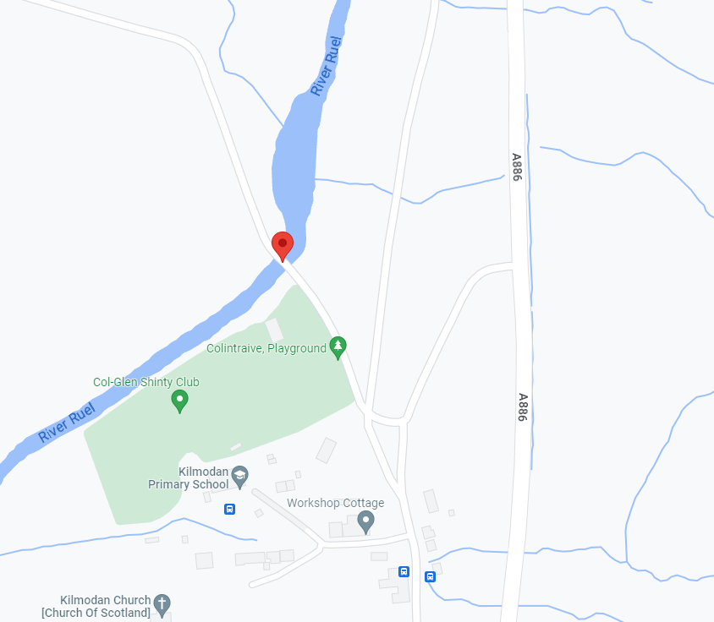
Map showing location of Glendaruel Bridge

