

Please find below a brief update on various key areas of work.
Roads and Infrastructure
Weekly member briefing
Edition 90: 24th March
Please let us know if you find these briefings useful and if there is any specific information you would like or alterations to the format.
The updates are designed as a resource for you to be able to answer constituent queries.
You can find details of notable service disruptions on key service areas like bin collections and street lighting on the Council website here.
As well as the updates on notable roads and footway schemes in the table below, the whole roads and footway capital programmes are available online – you can access the full list of schemes here.
You can view all member briefings on the website

Oban, Lorn and the Isles | Helensburgh and Lomond | Mid-Argyll, Kintyre and the Islands | Bute and Cowal | All areas
Lady of Lismore  Dry dock was recently completed and the vessel put back into service. The usual servicing and certification checks were supplemented with successful modifications and improvements.  Oban North Pier  The final load of timber cargo was loaded from North Pier this week for the present Euroforest contract. The exercise has been a great success involving coordination across multiple teams (picture below).  Tobermory seawall and railings  Our appointed contractor TSL are expected to commence work on this scheme Monday 3rd April.  This project follows on from the earlier phase one scheme, which worked well in the recent poor weather.  We will be installing a new 500mm wall which will add extra flood protection, and new railings will sit on top of this wall making up a total height of 1.15metres.  We are also installing a flood barrier on Fisherman’s Pier and undertaking grouting work to seal any areas which could suffer from water ingress.  The project will cost in the region of £400,000 and should be completed in the Autumn.  We will be providing regular updates on the works through this weekly briefing. | Cardross Crematorium  As some members may know, the Cardross Crematorium Superintendent Tommy McLean is retiring on 31st March.  Tommy started with Dumbarton District Council in 1978, transferring to Argyll and Bute following local government reorganisation in 1996.  Despite two recruitment efforts we have been unable to secure a suitable candidate. We have an interim arrangement in place through a Crematoria Agency to provide service continuity while we run a further recruitment exercise.  In Tommy’s final week we have 18 cremations booked.  Kilcreggan ferry consultation  Just a reminder that the Kilcreggan Pier consultation will end on Sunday (26th March). Working with our colleagues in the Communication Team we have done a push on social media this week, highlighting the consultation and key facts around the project. | Port Askaig  We have now appointed traffic management consultants SYSTRA to carry out a supportive survey on the marshalling area for the new Islay ferries. A contract kick off meeting is set for Monday 27th March.  Islay road faults  We have made good progress working through road faults on Islay – this work is currently around 70% complete.  Eilean Dhiura  The dry dock for Eilean Dhiura is booked to commence Tuesday 11th April for 10-14 days.  The relief vessel is MV James, which has freight carrying capability, has been arranged to cover.  Gartbreck landfill site  On Wednesday 29th March there will be a power outage at Gartbreck landfill site which means there will be no weigh bridge facility in use.  As we cannot charge by weight, any commercial customer wishing to tip at the landfill on this date will be charged the maximum carrying capacity of the vehicle used to take the waste to site.  We advise that commercial waste customers hold on to their waste until the power has been restored and the site is back in full operation. | U12 Succoth  Improvement works along the U12 require a small amount of surfacing work to be carried out next week which will then see the job complete.  Ardenslate Road  Footway improvement works are on schedule and the work is expected to complete before 31st March  Junction sign replacement programme  Replacement junction signs have been installed along the A815 and the A886 in Cowal. The team will continue to install the remaining signs over the next week  Signage replacement is also underway on the A886 Bute for the Kames Castle Junction and Rhubodach Farm.  A886 landslip  The temporary road was removed this week and traffic is now back using the normal road. A few bits and pieces remain outstanding and these are expected to be complete by the start of April. | Grass cutting  Grass cutting schedules will commence in all areas next week.  Council teams undertake a programme of grass cutting and ground maintenance to sports pitches, public open spaces, cemeteries etc.  Over the course of a year we will cut 32.4 million square metres of grass - that’s the equivalent of cutting a one metre wide straight line of grass all the way from Edinburgh to Sydney and back!  Route optimisation project  Following the recent report to the Environment, Development and Infrastructure committee there have been initial meetings with the supplier and we are in the process of supplying key data sets in a format that will feed into the system.  This is very detailed necessary background that, once completed, will allow us to provide a more detailed timeline for the project as well as a demonstration to members  Public Convenience door access control project  The contractor has undertaken their inspections of the 16 high use facilities where we intend to install charging infrastructure.  We are awaiting the technical report which will then allow us to agree a project plan and to provide a timescale for the completion of the project

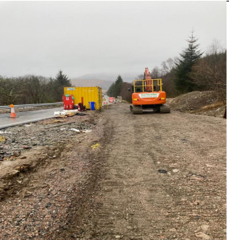
Temporary road removed along the A886

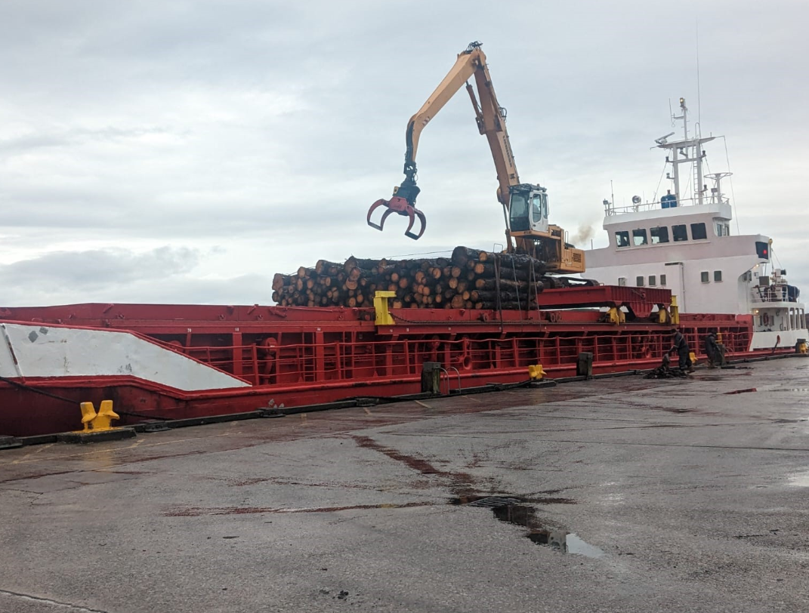

Timber being loaded on the North Pier in Oban

