

Please find below a brief update on various key areas of work.
Roads and Infrastructure
Weekly member briefing
Edition 89: 17th March
Please let us know if you find these briefings useful and if there is any specific information you would like or alterations to the format.
The updates are designed as a resource for you to be able to answer constituent queries.
You can find details of notable service disruptions on key service areas like bin collections and street lighting on the Council website here.
As well as the updates on notable roads and footway schemes in the table below, the whole roads and footway capital programmes are available online – you can access the full list of schemes here.
You can view all member briefings on the website

Oban, Lorn and the Isles | Helensburgh and Lomond | Mid-Argyll, Kintyre and the Islands | Bute and Cowal | All areas
Roads  As we approach the end of the financial year all teams are running through day-to-day maintenance activities while work goes on in the background to mobilise for the £8million roads reconstruction programme.  Our teams in this area are currently working through ditching in and around the Dalmally area and patching work in Kilchrenan, as well as footpath improvements in Pennyfuir Cemetery.  Oban Bay  Positive discussions have taken place between council officers (technical and legal), and Transport Scotland.  Transport Scotland have asked for some minor alterations to the style and presentation of the paperwork which are considered to be non-material.  Once these minor updates are made the Scottish Government’s legal team will review the draft Order.  Terms of Reference have been drawn up for the proposed Consultative Forums. Based on the guidelines and recommendations of the Port Marine Safety Code (PMSC), it is proposed to have an administrative management level group made up of the organisations with financial and legal responsibility in the bay and a broader Consultative Forum made up from the stakeholders and communities who rely on Oban Harbour.  Recruitment is currently underway for a replacement Assistant Harbour Master to fill an existing vacancy. | Roads  In this area, we are continuing with footway improvement work between the Crematorium and Cardross. Members who have driven past this week will have seen a significant length of the footway starting from the Crematorium already resurfaced and work is ongoing on the remaining section working towards the village.  The works in Glen Douglas previously reported are expected to conclude next week.  Kilcreggan ferry consultation  The consultation has been extended until 26th March.  An updated FAQ sheet has been posted on the web page and we will also upload visualisations on the preferred option shortly.  School transport  Our transport team are currently working on specifications for Helensburgh and Lomond School Transport contracts which are due for renewal in August 2023. | Roads  On the mainland our squads have been supporting the Campbeltown Cycleway scheme this week as well as day-to-day maintenance of the road network.  We had the jetpatcher and additional resources on Islay this week working through road faults across the island.  Port Askaig marshalling area  We expect to soon be appointing traffic management consultants to carry out a supportive survey on the proposed marshalling area to support the introduction of the new Islay ferries by CMAL.  CMAL themselves are also progressing with the required enabling works for the pier. | Roads  Capital footway works are well underway in Dunoon on the UC01 Ardenslate Road between Argyll Road and Hunter Street.  Dunoon ferry consultation  The consultation received 222 responses and results show no option has majority support.  The preferred option (1d) was the most popular with 32% followed by Option 1c with 29%.  A breakdown of the basic results are:  ● 32% prefer Option 1d,  ● 29% prefer Option 1c,  ● 17% prefer Option 3b,  ● 15% don’t know,  ● 3% prefer Option 2c,  ● 2% prefer Option 4c, and  ● 2% did not select an option.  70% of respondents who did not support the preferred option 1d, mentioned a future car ferry or the retention of the linkspan in their written response.  In the feedback comments for option 1c ‘Linkspan retention’ and ‘cost’ were most frequently mentioned as opposed to ‘Reliability’ and ‘Accessibility’ with option 1d.  Taking account of comments received, the focus of public opinion is on retention of the linkspan and provision of a car ferry service, followed by improving reliability, selecting a cost-effective solution and preserving the Victorian Pier.  Given the feedback received, we are now considering how best to pick up on concerns raised in relation to retention of the linkspan and how this fits with current Scottish Government and Council policies. | Fleet services  We have included below some images of live work happening in our new fleet workshop at Jackson’s Quarry in Oban.  Our fleet team support the council’s entire fleet [over 500 vehicles] from road rollers to gritters to school minibuses to pool cars.  As well as maintaining the Council fleet, we also support other public sector partners like ACHA [one of their vehicles can be seen in the below images] and carry out work for commercial customers.

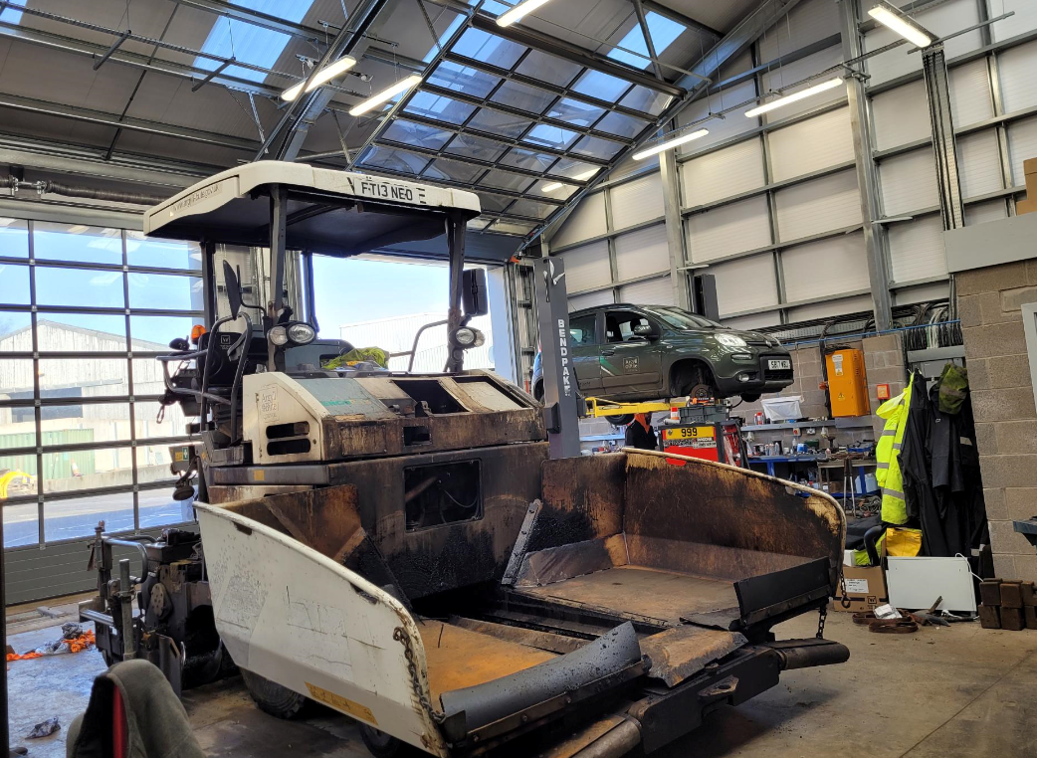
Fleet workshop – Jackson’s Quarry, Oban

