

Please find below a brief update on various key areas of work.
Roads and Infrastructure
Weekly member briefing
Edition 88: 10th March
Please let us know if you find these briefings useful and if there is any specific information you would like or alterations to the format.
The updates are designed as a resource for you to be able to answer constituent queries.
You can find details of notable service disruptions on key service areas like bin collections and street lighting on the Council website here.
As well as the updates on notable roads and footway schemes in the table below, the whole roads and footway capital programmes are available online – you can access the full list of schemes here.
You can view all member briefings on the website

Oban, Lorn and the Isles | Helensburgh and Lomond | Mid-Argyll, Kintyre and the Islands | Bute and Cowal | All areas
Roads  Routine maintenance work in Oban and Mull including ditching, pothole repairs etc.  Pennyfuir Cemetery  The local team have been carrying out some improvements to the internal paths within the cemetery.  Tobermory seawall and railings  Tobermory Wall and Railings Phase 2 is currently progressing through funding of the Island Programme, Place Based Investment and Crown Estate.  A requirement in order to obtain the full funding was that a contract had to be awarded prior to the end of March 2023.  This week a successful contract award was made to TSL, a local contractor. | Roads  Footway surfacing at Faslane has been completed.  The capital footway work at Cardoss began yesterday with crews also concentrating on the completion of capital work, including drainage, at Glen Douglas, which will begin next week  Kilcreggan Pier  We are receiving a large volume of correspondence from members of the public wishing to express their opinions on the proposed designs for Kilcreggan Pier.  The consultation, which can be found here has been extended by two weeks to incorporate an option for people living in other areas to comment.  The consultation will now end on 26th March and this is the best way for people to submit their views to allow all the data to be analysed together.  Bendarroch playpark  We are progressing with repairs of some of the equipment at Bendarroch playpark which will hopefully see it re-open shortly.  We mentioned in our briefing last week the concerns around vandalism and would be grateful of any information that can be passed on to us or local police regarding this. | Roads  The jet patcher wasn’t able to attend Islay this week due to the limited ferry timetable currently operating. We have made new arrangements and the jet patcher will now travel to Islay on Sunday and will be there for 6 days to assist with maintenance works across the island.  We have been working through road faults on Jura this week and have made good progress. We have completed repairs on the higher grade roads on which we use bituminous material. On the lower grade roads we use a different material called Type 1; these repairs are ongoing.  Campbeltown Cycle path  The team continue to work on the new cycle path Campbeltown. We are delivering this scheme directly, effectively working as a contractor, and the overall scheme is managed by our colleagues in the Development and Economic Growth team  Work includes widening the pedestrian routes, building a new cycleway and improving bus stops, making it safer and easier for pedestrians, cyclists and bus users to travel between Ralston Road and Meadows Avenue. | Roads  U12 Succoth improvement works are near completion. The project has seen sections of the carriageway widened, passing place improvements and new footway works.  This has carried out in partnership with the forest owner, and part funded by them  All capital work on Bute is now complete. The team will continue with revenue maintenance work e.g. safety defects, drainage work and sign maintenance.  A886 Strachur landslip  The new VRS (vehicle restraint system) has been installed along with a timber pedestrian parapet along the edge of the retaining wall. The pedestrian parapet is a safety barrier that is installed if any future inspections of the wall are required.  Next week the plan is to transfer traffic onto the original (and repaired) section of road and begin to remove the temporary diversion | Winter maintenance  Due to the cold weather conditions this week the gritters have been deployed daily  Over the last 7 days we have used over 900 tonnes of salt to keep the road network safe and open. This figure includes the replenishment of grit bins / heaps.  This follows on from February being a fairly low activity month. 4200 tonnes of salt were delivered but only 900 tonnes used over the month.  This puts our overall stock at over 11,000 tonnes.  Bin collections  There have been a significant number of breakdowns within our fleet this week causing disruptions in most areas.  We are updating the website regularly with information for customers affected [these updates go out by email to anyone who has signed up]  There are no single issues for the breakdowns however we are experiencing delays with the delivery of replacement parts, which appears to be an issue across the industry.  We are currently looking at how best to use the additional £700,000 recently allocated for additional refuse collection vehicles and expect to begin procurement shortly.

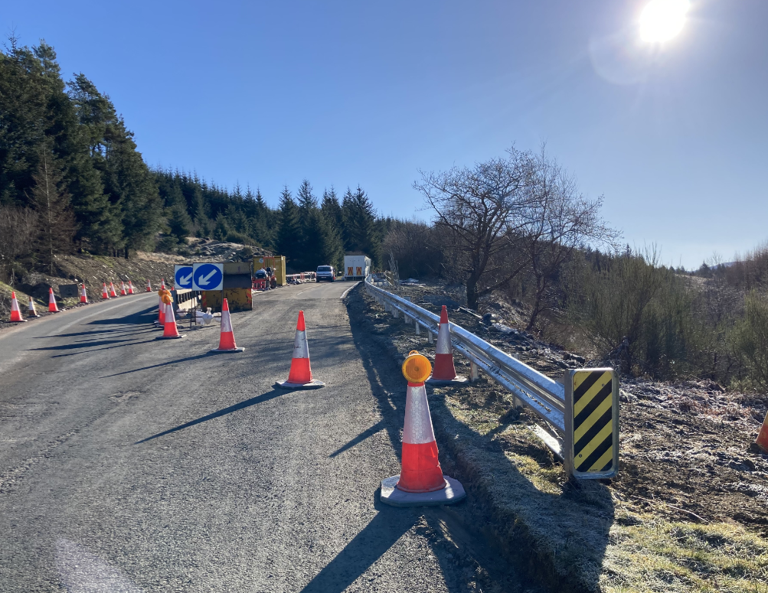
Newly installed VRS along the A886 at Strachur

