

Please find below a brief update on various key areas of work.
Roads and Infrastructure
Weekly member briefing
Edition 86: 24th February
Please let us know if you find these briefings useful and if there is any specific information you would like or alterations to the format.
The updates are designed as a resource for you to be able to answer constituent queries.
You can find details of notable service disruptions on key service areas like bin collections and street lighting on the Council website here.
As well as the updates on notable roads and footway schemes in the table below, the whole roads and footway capital programmes are available online – you can access the full list of schemes here.
You can view all member briefings on the website

Oban, Lorn and the Isles | Helensburgh and Lomond | Mid-Argyll, Kintyre and the Islands | Bute and Cowal | All areas
Oban Bay  The Council’s Harbour Board at its meeting on 22nd December 2022 gave approval for the draft Harbour Revision Order to be submitted to Transport Scotland.  The draft was submitted prior to the festive break.  Positive discussions have taken place and are continuing between Argyll and Bute Council technical and legal officers; the Council’s legal advisors and Transport Scotland [TS].  We would hope to have a firm timeline on the progress of the Order from TS soon.  Road schemes  We are currently carrying out some surface dressing patching work on Ardansaig Road in Kilchrenan.  The team on Mull are replacing a damaged cattle grid on the Grasspoint Road after safety defects were highlighted on recent inspection.  Tobermory Cemetery extension works  Cemetery works are ongoing which involve the placement and compaction of materials to raise the cemetery to the appropriate height as per SEPA guidance. – see pic below.  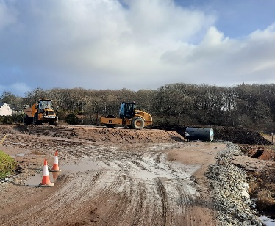  An SSE electrical cable is due to be relocated because of an initial incorrect alignment installation by SSE.  An outage will occur on the 1st March to carry out these works, anyone that will be affected should have been contacted by SSE.  Our design colleagues are also looking at a potential deer fence as it was reported that there is a current issue with deer accessing the site - these works will be subject to additional available funding  Lady of Lismore  Lismore Ferry came back into service last weekend after an extended dry-docking which saw some improvements made as well as the warranty and remedial works completed satisfactorily. | Luss Traffic Regulation Order  We are awaiting an update from Transport Scotland (TS) on the progress of the Order – our Traffic and Development team are in touch with TS and it is hoped a timeline will be available soon.  Blackhill Civic Amenity Site  We are progressing some minor works on and around the site to – fencing repairs etc. – over the next couple of weeks. Although contractors will be on site there should be no interruption to normal service.  Cardross Crematorium  We had previously included an update in one of these Friday briefings on a recent inspection of the Crematorium by the Federation of Burial and Cremation Authorities. This inspection found an excellent level of service provision.  A report on the inspection findings is going to the Environment, Development and Infrastructure Committee next week – that report and the appended inspector’s report can be found here at Item 9.  Kilcreggan Ferry Terminal consultation  The council needs to make improvements to the ferry terminal infrastructure at both Dunoon and Kilcreggan to ensure safe and reliable berthing for the new passenger-only vessels that Transport Scotland is bringing into operation in 2025.  These upgrades will deliver a range of benefits for passengers and will ensure that both terminals can accommodate larger vessels, resulting in wider economic impact throughout the area.  There is an ongoing consultation on proposals for Kilcreggan.  The consultation runs until 12th March and is available here. | Road schemes  We will be sending out a separate note to Ward 2 members on road repairs on Islay and Jura.  The jet patcher is currently working in Kintyre addressing any defects that have been identified for repair from our revenue budget.  We have engaged with a local contractor for the replacement of road safety signs on Islay.  Working with a local contractor allows us to eliminate travel costs that would be associated with contractors off the island however their availability is more limited which means the programme could take slightly longer to complete.  Campbeltown Flood Scheme  Good progress continues to be made on these major works.  In terms of the Meadows drainage works, the contractor has been working on Witchburn Road and this is now 90% complete. This phase is expected to be completed in early March  For the Burnside phase, the drainage works at Castehill and Ralston Road are around 70% complete – see pic below  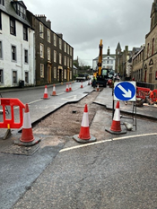  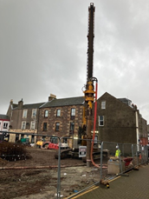  The excavations in Burnside Square are complete as is the secant piling. This is where overlapping [secant] piles are used to form structural or cut off walls which achieve the necessary level of water tightness. See pic below  The actual flood attenuation tank installation began on Wednesday of this week and should be finished by Sunday. | Road schemes  All capital work for this year on Bute is now complete with crews concentrating on revenue maintenance work such as pothole patching, sign maintenance, culvert cleaning etc.  We continue with capital footway improvement works on Ardenslate Road and A815 Alexandra Parade which are to be completed by the end of March.  Junction sign replacement  Work is ongoing to replace major junction signs with bi-lingual signs on A815 between Toward and Strachur and A886 from Strachur to Colintraive.  Ardbeg sea wall  Our Infrastructure Design team is progressing with studies and surveys to support the permanent design solution. The next survey is a ground investigation which is scheduled for the third week in March  A full condition survey of the whole sea wall in the area [over 1km] is being commissioned to assess its overall condition to see if any works in these areas need to be included in the same design package.  Following these surveys we will assemble an outline design solution and costings which will form the basis of a tender package which we will then go to the market with. | Environment, Development and Infrastructure [EDI] Committee  The EDI Committee meets next week and will consider a number of reports from Roads and Infrastructure.  These include:  - Roads Reconstruction Capital Programme [to follow]  - Annual Status and Options Report  - Route Optimisation Update  - Rest and Be Thankful Update  - Cemetery Asset Report – Update  - Cardross Crematorium Inspection  - Playpark Funding – Update Report  You can view the full agenda here.

