

Please find below a brief update on various key areas of work.
Roads and Infrastructure
Weekly member briefing
Edition 85: 17th February
Please let us know if you find these briefings useful and if there is any specific information you would like or alterations to the format.
The updates are designed as a resource for you to be able to answer constituent queries.
You can find details of notable service disruptions on key service areas like bin collections and street lighting on the Council website here.
As well as the updates on notable roads and footway schemes in the table below, the whole roads and footway capital programmes are available online – you can access the full list of schemes here.
You can view all member briefings on the website

Oban, Lorn and the Isles | Helensburgh and Lomond | Mid-Argyll, Kintyre and the Islands | Bute and Cowal | All areas
Road schemes  The resurfacing scheme on the A816 at Kilninver has now concluded, on time and on budget.  Tiree recycling collections  We have recently made some improvements to the recycling shed at Gott Bay on Tiree which will now allow us to provide a better service for island residents.  Currently, each house as a blue bin and has three separate bags in which they put different recycling materials, then they put the three bags in the bin and put the bin out for collection on the scheduled day.  This is to allow the material to be hand sorted at Gott Bay.  As a result of the recent improvements which include new bays/walls for loading and unloading, these materials no longer need to be sorted on the island and can be co-mingled and taken away in a single,, mixed load for onwards machine sorting at our off-takers which is Enva based in Linwood.  What this means for residents is that they no longer need to use the separate recycling bag – they can now put all of their plastic [bottles, tubs, pots, trays], cans, paper and card directly into their blue bin.  Ultimately this should make it much easier for people on the island to use the service and to recycle, and brings the service here up to a par with the vast majority of the rest of Argyll and Bute  We will follow up with a comprehensive communications exercise for customers when we have a confirmed ‘go live’ date for the improved service  Lady of Lismore ferry  Following the drydocking for servicing and repairs, the Lady of Lismore should be back in service next week, at which point we will stand down the relief vessel.  Fionnphort recycling facilities  We are aware of a recent correspondence to Members from the local community about recycling facilities in the village.  There was a bring site here previously but it was removed because of constant fly tipping, which at times included dead animal carcasses, washing machines etc.  We are looking at options for public recycling for the summer months which could include 240litre bins being placed at certain key points. | Road schemes  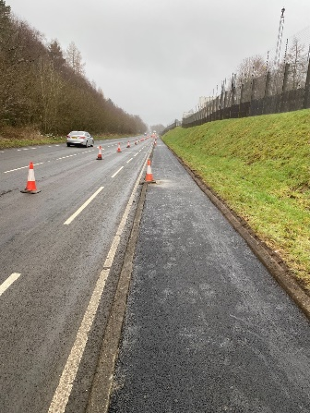  The capital footway scheme at Faslane is making good progress – some images are below.  Public transport infrastructure  We advised last week of works across the rest of Argyll and Bute which the Council is responsible for. In Helensburgh and Lomond the model is slightly different as it falls under the Strathclyde Partnership for Transport [SPT] area. This year we have been able to access over £100,000 of funding through SPT’s capital funding programme which has allowed us to progress with nine new shelters in Helensburgh and seven in Cardross.  We have secured over £100,000 each year since 2018 and Members will have seen a number of improvements to the network over the years.  The bus shelters installed through these upgrades are fully accessible, having both space to accommodate a wheelchair user and colour contrast seating for those with sight issues.  The specification of powder coating rather than paint on new shelters makes for a more durable finish which reduces ongoing maintenance costs.  These shelters also come with pre-installed wiring so that should we look to fit real time information tablets, cameras or electronic displays this should be straightforward. | Campbeltown Flood Scheme – Dell Road parking restrictions  There has been some correspondence relating to parking restrictions and works specifically on Dell Road.  There is a temporary traffic regulation order in place which restricts waiting [this means no parking] when indicated by signs  This order is effective from 0001 hours on the 20th of February 2023 to 2359 hours on the 30th of April 2023. This does not mean parking will be restricted for the whole time, rather it’s a blanket order which allows flexibility to restrict parking at points within that overall timescale.  At the moment the contractor is planning to undertake their works in mid-March.  Those works will include:  - Excavating a drainage track and installing new drainage and gullies  - Temporarily reinstating the road surface while the works progress  - Resurfacing works once all drainage is completed.  When the contractor is undertaking the works they intend to do this in sections of around 20metres at a time, which should help to minimise disruption and maximise the availability of parking spaces.  A letter will shortly go to local residents confirming these details  Ping Go bus service  The Ping Go service in Kintyre continues to be well used. This was a new service introduced to replace the previous Dial a Bus in this. The new service provides an increased range and frequency. .  We’ve been working with our colleagues at West Coast Motors who run the service to introduce further improvements, which will be coming in shortly. These include a new online booking system which allows advanced bookings to be made for specific times [as opposed to the current system where people can book half hour windows]. There will also be a dedicated call centre to handle enquiries and telephone bookings, which is an upgrade on the current system where customers phone bus depots directly. | Strachur landslip works  The groundwork for the vehicle restraint system [safety barriers] is progressing.  This week reinforced slabs have been poured on which the safety barriers are secured.  Below are some photos of the steel meshes being fabricated.  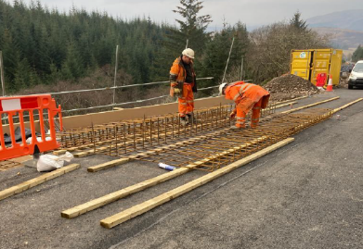  This is known as rebar (short for reinforcing bar), which is a steel bar or in this case a mesh which is used as to add tensile strength to concrete.  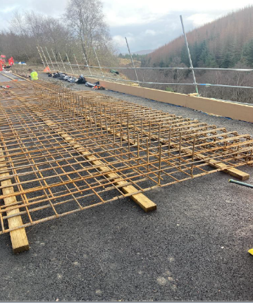  Ping Go bus service  The same enhancements to the Kintyre Ping Go service will also be coming online for the Cowal service shortly.  Capital footway works  The £13,000 footway capital scheme on Bute at the B844 High Road and Marine Road in Port Bannatyne is now complete  In Cowal our teams are progressing two footway jobs – a £35,000 scheme at Ardenslate Road in Dunoon and a £15,000 scheme on the A815 Bullwood Road.  The other footway schemes [Rothesay – Blain Terrace, Ladeside Road, St Brides Road; Innellan – Shore Road] involve lighting elements – we are doing column replacements and taking the opportunity to improve the footways at the same time, thus providing an economy of scale and stretching our budgets as far as possible. These are more complex schemes to arrange logistically, with the result that they are planned to go ahead at the start of the next financial year. | New parking meters  We are continuing to modernise our parking meters with a new order placed for another 33 meters.  These new meters will allow for card/contactless as well as cash payments. Customers also have the opportunity to pay by phone. You can find out more about car parking here.  Salt stocks  The road salt we use for winter maintenance is produced in Northern Ireland from natural rock salt which is excavated then crushed to create the finer material that we spread from our gritting vehicles.  The salt comes over in bulk by sea and is delivered to various ports in Argyll then distributed to our various depots.  This week we received a delivery of 2,000 tonnes through Ardrishaig Pier. Timber was then loaded on to the boat to take a ‘back load’ to wood processing plants.  The images below show the vessel, its route from Northern Ireland to Ardrishaig, and the salt covered and stored at one of our depots in Lochgilphead.    