

Please find below a brief update on various key areas of work.
Roads and Infrastructure
Weekly member briefing
Edition 82: 27th January
Please let us know if you find these briefings useful and if there is any specific information you would like or alterations to the format.
The updates are designed as a resource for you to be able to answer constituent queries.
You can find details of notable service disruptions on key service areas like bin collections and street lighting on the Council website here.
As well as the updates on notable roads and footway schemes in the table below, the whole roads capital programme is available online – you can access the full list of schemes here.
You can view all member briefings on the website

Oban, Lorn and the Isles | Helensburgh and Lomond | Mid-Argyll, Kintyre and the Islands | Bute and Cowal | All areas
Road schemes  We have secured an additional £100,000 from the Timber Transport Scheme which is allowing us to carry out resurfacing work of 1.5km on the previously improved section of the A816 at Kilninver, north of the B844 junction  This job will commence on Monday 30th January and is expected to last for around three weeks.  Craignure electricity upgrades  Following on from the previous update on these works, the power company are in liaison with the local community ahead of the key date Sunday 5th February where the power will be off in the village as the new transformer is installed.  The transformer is arriving on the island today ahead of the install next weekend. These works will upgrade the power supply for the whole village and are a key part of the future pier project.  Lady of Lismore  Lady of Lismore remains out of service to allow investigation into mechanical issues to be concluded. This is part of its dry dock regular maintenance cycle.  The opportunity to make some improvements is being taken at the same time. We hope to have the vessel back in service next week.  A relief vessel is continuing on this route for the time being. | Road schemes  We are progressing with drainage improvement works in the Glen Douglas area, and we expect to begin footway capital works in this area on Monday.  Kilcreggan Ferry infrastructure consultation  After some final adjustments to the web based content the consultation is now ready to commence on Monday 30th January and will run for six weeks.  The online consultation will be backed up by hard copy booklets, feedback forms as well as a QR coded poster on the ferry itself.  We are encouraging as many users of the service to take part as possible.  Glen Mallan  Colleagues at the MoD have once again requested we promote an Order which will allow for a road closure on the A814 at Glen Mallan to allow for the safe loading and unloading of items from the jetty.  The road will therefore be closed at points between Monday 6th and Friday 10th February.  The last time we had this in place the MoD liaised closely with the local community to ensure access and minimise disruption.  In total they closed the road for 12hrs and 55mins out of a theoretical total closure time of 60hours.  We expect this instance to be along the same lines as the previous closure. | Road schemes  Our colleagues in Development and Economic Growth have secured funding for a cycle scheme in Campbeltown – our local roads squad is delivering the scheme, effectively working as a contractor.  This ensures that money is kept within the organisation/ in the local area and that we can achieve best value for the funding secured.  Campbeltown Flood Scheme  A further project mailshot will be going out on Monday to update on progress on the scheme.  The main headline is that the works to create the flood attenuation tank in Burnside Square will begin on Monday, following excavations since the turn of the year. | Road schemes  On Bute we are working through footway improvements on the A844 while also working through a programme of culvert clearing.  In Cowal work continues on the U12 Succoth Road, which is a scheme jointly funded by a forestry harvester. We are also undertaking a programme of culvert cleaning.  Kirn Brae streetlights  Scottish and Southern Energy [the power supplier for this area] are scheduled to commence work today for the required re-cabling works on Kirn Brae. Work is expected to complete at the end of next week.  A disruption has been placed on the website to advise local residents of minor access issues during working hours. | Bin collections  There have been a number of disruptions to the bin collections this week due to an unusually high number of vehicle issues across all areas.  Disruptions have been placed on our website and a Keep In The Loop message issued to those that have signed up. This is another useful tool we use to keep customers informed of any service issues. This has been proven to work well over the years – there is a direct link between good, positive, clear, concise information being sent to customers on service issues and a reduction in customer contacts  New gully machines  We’ve included below some images of the new gully machines which arrived last week.  These are provided on something called a QCB which stands for quick change body.  The vehicle is one chassis which can take different bodies. These have come with gully and gritter bodies and also have the capability to take other bodies.  The vehicles are primarily for gully emptying which will minimise any flooding/drainage issues but they also add resilience and versatility to our wider fleet because of the different body options.  Increasingly we are looking to move towards these type of vehicles, which can be of particular use to our island operations, negating the need to ferry across specialist vehicles.  At the moment we are going through a training and familiarisation process for staff with the new equipment.

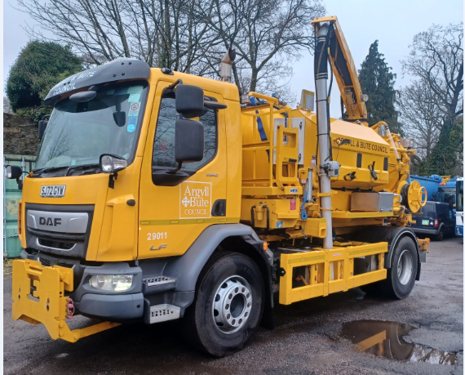

Images of one of our two new gully machines – this one was delivered to the Dunoon depot last week.

