
Please find below a brief update on various key areas of work.
Roads and Infrastructure
Weekly member briefing
Edition 77: 2nd December
Please let us know if you find these briefings useful and if there is any specific information you would like or alterations to the format.
The updates are designed as a resource for you to be able to answer constituent queries.
You can find details of notable service disruptions on key service areas like bin collections and street lighting on the Council website here
As well as the updates on notable roads schemes in the table below, the whole roads capital programme is available online – you can access the full list of schemes here.
All member briefings can be accessed on the website here

Oban, Lorn and the Isles | Helensburgh and Lomond | Mid-Argyll, Kintyre and the Islands | Bute and Cowal | All areas
Roads updates  The scheme at Blaran has been delayed slightly – the works are substantially complete with some tidying up to completed next week.  Traffic management will remain in place  Oban North Pier  The CEG Cosmos visited Oban North Pier again this week delivering 600MT of road salt and 300MT of logs  The vessel will return on 15th December to load a log cargo for Euroforest.  Lining work  White lining works are programmed to be carried out in the OLI area this Monday coming. | Roads updates  General maintenance is ongoing with scrub cutting being undertaken along the A817 this week and next  Lining work  One of our approved lining contractors will be in attendance next week (weather permitting) to carry out their outstanding allocated work.  Streetlighting  We have external contractors assisting with required civils work. They will be in attendance towards the end of next week and beginning of the following week.  This is mainly excavation work that is required for our engineers to access/replace cabling.  Welcome to Helensburgh signs  We have received a number of enquiries regarding the removal of the Welcome to Helensburgh signs.  Helensburgh Community Council have confirmed they have removed these in preparation for new ones being installed shortly | Roads updates  Work continues on the additional STTS scheme B8024 at Inverneil, with minimal disruption to road users.  On Islay we are working on revenue and capital works on Ballimony Road, with revenue repair works at the western end and a joint Council and Forestry capital road and junction improvement at the eastern end to facilitate timber extraction.  Lining work  White lining works are programmed to be carried out in Mid Argyll area this Monday coming.  Works in Kintyre are programmed to start the following Monday, with Islay to follow thereafter.  Campbeltown Flood Scheme  Work will finish for the festive break on 21st December.  When the contractors return on 5th January, works will be commencing within Burnside Square and the area will be closed to all parking from that date until the end of May 2023.  Between now and the festive break the contractor is forecasting the following works:  The Meadows SuDS  Pond 1B excavation  Drainage installation Meadowburn place and Witchburn Road  Burnside SuDS  Trial Digs to locate services ongoing  Dalaruan Street  Trial Digs to locate services ongoing  There is comprehensive information including letters and project updates on the scheme available on the Council website here. | Roads updates  General housekeeping including ditch and offlet cleaning on the A815 heading north from the Coylet Inn.  Our gully cleaning programme is ongoing along with scrub cutting and sign replacements.  The team are expected to begin footway improvement work on Marine Road and High Road in Port Bannatyne before Christmas.  The footway and lighting improvement works at Blain Terrace, Ladeside Road, Ladeside Place and St Brides Road will commence some time in February with the street lighting team being in attendance first carrying out cable and column replacement work and the roads team following on with resurfacing  Lining work  We have secured commitment from two contractors to complete a large quantity of outstanding work before Christmas, weather permitting.  Work will be prioritised with road safety markings attended to first, these include key junctions, unlit roads, warning signs e.g. SLOW, sharp corner and directional signs. | Bridge replacement schemes  Ground investigation work is complete at Oude and Pennyghael with Glenegedale scheduled to be undertaken next week.  The information sourced from these investigations will feed back to our design team to assist them in progressing with the bridge replacements.  EDI committee  The Environment, Development and Infrastructure Committee met yesterday and considered various reports on different projects and areas of work.  The papers and the webcast of the meeting can be accessed here.

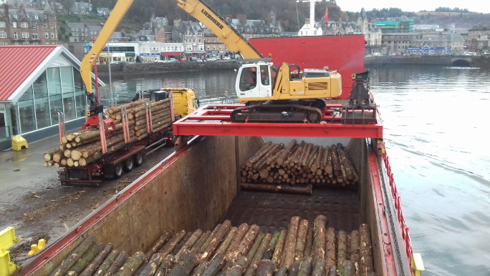
Timber loading on North Pier, Oban

