
Please find below a brief update on various key areas of work.
Roads and Infrastructure
Weekly member briefing
Edition 75: 18th November
Please let us know if you find these briefings useful and if there is any specific information you would like or alterations to the format.
The updates are designed as a resource for you to be able to answer constituent queries.
You can find details of notable service disruptions on key service areas like bin collections and street lighting on the Council website here
As well as the updates on notable roads schemes in the table below, the whole roads capital programme is available online – you can access the full list of schemes here.
All member briefings can be accessed on the website here

Oban, Lorn and the Isles | Helensburgh and Lomond | Mid-Argyll, Kintyre and the Islands | Bute and Cowal | All areas
Roads updates  We will complete this year’s capital works on Monday 22nd with a scheme at Middle Brae, Tobermory.  Preparation works at A816 Blaran are now complete with the 500m of carriageway now ready for surfacing  Oude Bridge  Our infrastructure design team were onsite this week to oversee the ground investigation work at Oude Bridge which is part of the £5.5million of bridge works funded from the Scottish Government’s local bridge maintenance fund.  Oban Winter Festival  An application was received this midweek for the use of the Corran Halls carpark for a fairground  Due to the lack of time allowed by the applicant for us to contact relevant partners and the lack of information e.g. safety certificates, risk assessments, site plan, fee agreement and time the application was refused.  The fairground have since occupied the carpark without permission. They have submitted extra paperwork that is currently being reviewed / considered.  Timber loading  Timber loading at the North Pier in Oban went very well this week.  There was excellent coordination between hauliers, our roads team and harbour staff with no more than two trucks on the quay at any one time.  In total there were 40 lorries unloaded and 1000 tonnes of timber safely loaded.  Due to the success of the operation this is something we would look to facilitate again in the future as a new avenue of generating business / income at the North Pier and reducing traffic on our road network | Roads updates  The local team have been in attendance with a vactor unit at Ceaderwood court and the surrounding area in Cardross to clear pipes that have been backing up and flooding the A814.  A vactor unit is a specialist piece of equipment that is designed to clean the most inaccessible areas of a drainage system  School Road, Kilcreggan  We are investigating if any further work is required to improve the drainage system and prevent any further flooding following the recent incident. | Roads updates  After receiving additional forestry funding the crews are returning to the B8024 at Inverneil next week for some additional surfacing and drainage work.  There will be no road closure however traffic management will be in place and road users should allow for additional travel time  Work is expected to be complete by Christmas  Dropped kerbs Ardrishaig  The dropped kerbs were due to be started by our internal team however the additional funding noted above stipulated that work should be completed prior to the Christmas break.  As this has delayed the construction again we’ve arranged for a local contactor to carry out these works instead.  The works are now programmed to start at the end of this month. | Roads updates  Continuing with general housekeeping works including: drainage works, offlet cutting, ditch cleaning, culvert checks and safety inspection defect repairs targeting problem sections on our priority routes first.  Scrub cutting for sight lines and road sign visibility is also beginning on our priority routes.  A886 landslip  The retaining wall is now fully installed with the road surfacing work also complete. The contractor is currently in the process of designing the vehicle restraint system (VRS) barrier and foundations with work expected to commence on this next week | Festive parking  All off-street parking charges will be suspended across Argyll and Bute for the two-week period prior to Christmas Day.  This is to encourage residents to support local shops in the lead-up to Christmas.  This will be in place from 9th to 24th December inclusive.
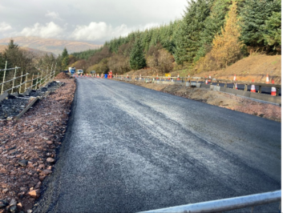

Completed resurfacing work on the A886, Strachur

Photo showing the safe loading of Timber at North Pier, Oban
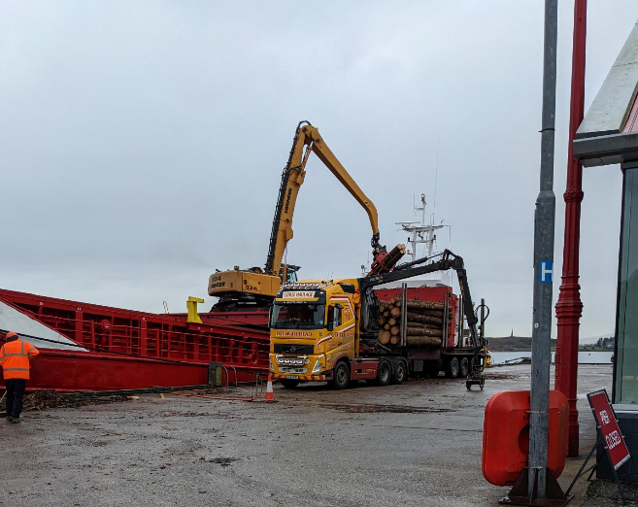

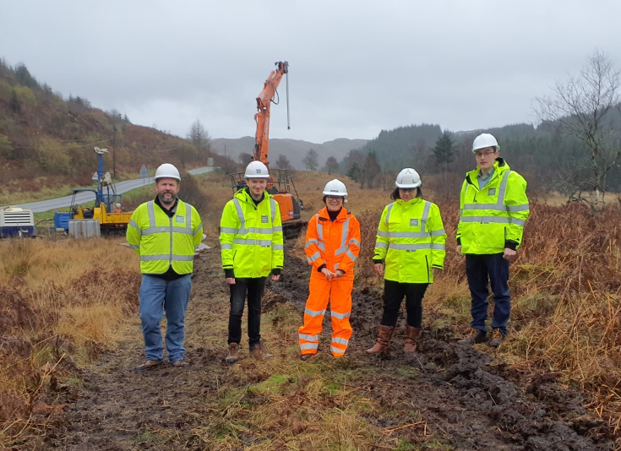

The design team onsite for ground investigation work at Oude bridge

