
Please find below a brief update on various key areas of work. These briefings are also available for reference as part of the various information resources available on the new Member Zone system
Roads and Infrastructure
Weekly member briefing
Edition 71: 21st October
Please let us know if you find these briefings useful and if there is any specific information you would like or alterations to the format.
The updates are designed as a resource for you to be able to answer constituent queries.
You can find details of notable service disruptions on key service areas like bin collections and street lighting on the Council website here
As well as the updates on notable roads schemes in the table below, the whole roads capital programme is available online – you can access the full list of schemes here.

Oban, Lorn and the Isles | Helensburgh and Lomond | Mid-Argyll, Kintyre and the Islands | Bute and Cowal | All areas
Notable road schemes  Capital surfacing works on Kerrera commenced this week and is scheduled for completion…  Capital footway surfacing at Bunessan on Mull is now complete  The significant capital works are still ongoing on the A816 Blaran & A819 Claddich sites  Salt delivery  Due to adverse weather conditions in other areas the salt delivery has been further delayed and is now scheduled for delivery the first week of November.  An alternative vessel was able to deliver salt to Mull on Tuesday 18th and we are currently looking at additional options for delivery by road for Oban mainland. Salt stocks are high and we will enter the winter period with good reserves.  Oban buses  A reminder that the revised timetables will come into effect on Monday 24th October with links to the new timetables below  Service 1/401 - Dunollie - Oban - Soroba (argyll-bute.gov.uk)  Service 5/405 Oban - Dunbeg - Benderloch - Barcaldine - Appin (argyll-bute.gov.uk)  Service 416 Oban - Longsdale Crescent - Mossfield Avenue - Hospital - Nant Drive (argyll-bute.gov.uk)  Mull bus services  Revised bus timetables to coincide with the Calmac winter timetable will come into effect on Monday 24th. Details of the new timetables can be found here Timetables & maps - West Coast Motors  LED Upgrade Scheme  Work is expected to recommence on the LED project on Monday 24th October. A total of 1100 luminaires will be replaced with more cost and energy efficient LED bulbs. The contractor has advised an expected 4-6 week lead time for completion.  Craignure Pier  A positive meeting has taken place this week with the Craignure community group regarding the development of a new pier for the Oban – Mull ferry. The Policy Lead and Officers met the group and discussed the next steps to developing the replacement pier.  Routine repair short term works are also underway at Craignure pier and this week surveys have been undertaken below the pier to facilitate cabling works to provide shore side power which will enable the existing generator to be replaced. | Notable roads schemes  Capital resurfacing work on the U149 at Ardmore is now complete  General maintenance such as potholing, ditching, gully cleaning etc… also being carried out across the area  Vacancies  The Team Leader post has now closed. We will now proceed with reviewing the applications and interviews expected to commence week beg 14th November.  The Assistant Team Leader vacancy closes on 3rd November | Notable roads schemes  Work continues on the B8024 with drainage works at the Inverneil side nearing completion.  General maintenance such as potholing, patching, gully cleaning etc… also being carried out across the area  Islay streetlighting faults  The street lighting engineer has been in attendance on Islay this week. All logged faults were attended and repaired where possible. The engineer did a full drive around the island to locate any further faults that may not have been logged.  Further work, with the assistance of civil contractors, is required where new columns / cabling etc is required.  A list is being complied of these outstanding works and will be issued to local members separately. All customers will be updated of the progress of their enquiry.  Waste disruptions  Due to a vehicle issue there has been some small disruption to the waste collections on Islay and Jura this week. Collections were delayed for all waste by a couple of days and should now be complete  Commercial glass collections in Campbeltown were also missed on Sunday however the crew managed to attend and catch up on Monday. | Notable roads schemes  The B8042 Victoria Rd resurfacing work is now complete (see image below) Work was delayed by 1 day due to a vehicle breakdown.  The jetpatcher has been delivering some revenue maintenance work potholing, patching etc on Bute this week and will return to Cowal next week  Inellan Primary School playground has also been resurfaced this week. This work was completed on behalf of our property services colleagues.  Lining work  We are placing pressure on the lining contractor for a committed start date to carry out both machine and hand applied lining work that is outstanding in the area  A886 Strachur landslip  The contractors have begun the Installation of the retaining wall and work continues on schedule | Train Strikes  Our public transport team are currently liaising with local bus companies in areas that may be affected by the planned rail strikes to ensure suitable school transport is provided for our school children.  The cost of providing this alternative school transport is deducted from the costs paid to National Rail

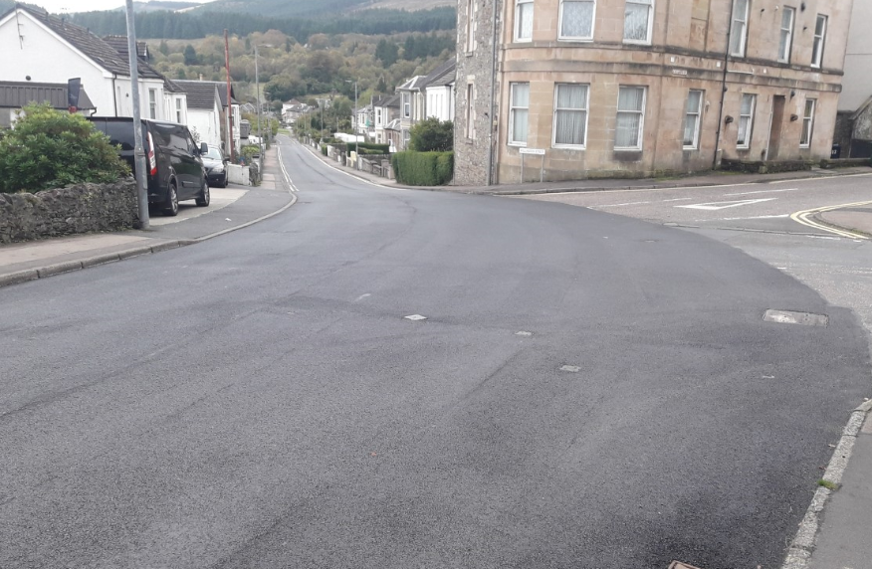
Recent resurfacing work on Victoria road in Cowal

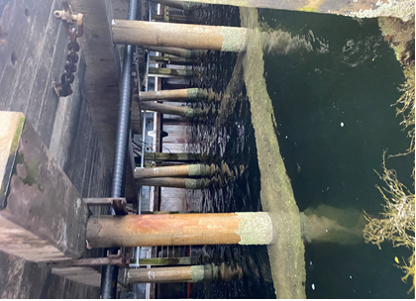
The pictures below provide a view of Craignure pier only available from the water.

