
Please find below a brief update on various key areas of work. These briefings are also available for reference as part of the various information resources available on the new Member Zone system
Roads and Infrastructure
Weekly member briefing
Edition 68: 30 September
Please let us know if you find these briefings useful and if there is any specific information you would like or alterations to the format.
The updates are designed as a resource for you to be able to answer constituent queries.
You can find details of notable service disruptions on key service areas like bin collections and street lighting on the Council website here
As well as the updates on notable roads schemes in the table below, the whole roads capital programme is available online – you can access the full list of schemes here.

Oban, Lorn and the Isles | Helensburgh and Lomond | Mid-Argyll, Kintyre and the Islands | Bute and Cowal | All areas
Weather issues  Tree down on Glenshellach Road, Oban which our local team has attended to.  Tree also down at Fishnish on Mull – operatives enroute at the time of writing to attend to this.  Notable road schemes  Footway works at Bunessan on Mull are ongoing.  The second phase of the scheme at Blaran on the A816 is also ongoing, and we have started works on the A819 Claddich Junction works, a £60,000 scheme of edge widening and overlay.  Overlay is where additional bituminous surfacing layer is laid over an existing surface to add strength.  Oban North Pier  We have included below a photo of small cruise ships stopping at Oban for changeover. This photo shows the versatility of the North Pier and the additional tourism traffic which is now able to come into Oban.  . | Weather issues  None reported  Notable roads schemes  The £80,000 capital scheme at Rockville on the B833 is ongoing, and works are expected to get underway on the U149 at Ardmore next week.  Operations team vacancies  As noted last week, we have key vacancies within this team. We hope to start a new Asst Team Leader around the middle of October and have received a number of applications for the Team Leader post which we are working through. | Weather issues  None reported  Notable roads schemes  Included below are photos of the ongoing works at Inverneil. These works are part funded through the Strategic Timber Transport Scheme, which finances projects that facilitate the sustainable transport of timber in rural areas of Scotland and deliver benefits for local communities and the environment.  The shots showing the geotextile material laid out on the surfacing and ready to receive the top coat showcase some of the innovative approaches we carry out to improve and strengthen our road network whilst ensuring value for money.  These works are ongoing – we aim to finish the surfacing around the middle of next week then will move on to verging works.  Campbeltown Flood Scheme  We are just finalising the arrangements for the Burnside Square consultation which we aim to put out on Monday and run for two weeks. There will also be letter drops around the local area and we are making arrangements with colleagues in Education to promote it via schools and also possibly have a sessions or sessions in at least the Grammar School.  In terms of works, these are continuing with drainage works to begin on Smith Drive on Monday.  To make sure these works can go ahead safely, there will be a requirement to install temporary traffic management on Smith Drive. There will also be parking restrictions on Smith Drive as the drainage is installed from the west corner of Smith Drive to Ralston Road.  Investigation works in Big Kiln Street and Burnside Street will also begin on Monday. To allow these works to go ahead safely they will require a road closure on Burnside Street and temporary traffic management on Big Kiln Street.  We have issued letters in both areas to those who will be immediately affected by the works and those same letters are hosted on the project webpage. Road closures and works are notified locally with signage and are also uploaded to the Scottish Roadworks Register which can be accessed here. | Weather issues  The Watergate, Rothesay was closed earlier as a result of debris falling from a building but is now open again, but the adjacent Store Lane is closed and likely to remain so over the weekend before we reassess alongside colleagues from Building Control.  On the A815 Sandbank there is carriageway flooding at the bottom of Ferguslee Street – this location can suffer from tidal/coastal flooding but in this case the cause appears to be different – operatives are enroute to investigate.  There are also some issues being caused by flooding at the Cothouse Caravan Park but it is the caravan park itself which is affected as opposed to the main road.  Notable roads schemes  The capital resurfacing works on Bute at U56 Wallace Avenue, U17 Bush Road, U16 Bush Avenue are all complete.  The footway capital scheme at Victoria Street is underway and will be ongoing next week.  In Cowal the A8003 improvements are continuing, with the remainder of the surfacing works set for next week,  Rothesay pontoons  The new pontoons at Rothesay were used last weekend to take tender boats from the visiting cruise ship. This worked well and we were able to bring an estimated 400 passengers ashore to enjoy the town.  The ship was called the Seabourn Ovation and it arrived from Belfast and was travelling onwards to Oban.  We have included some photos of the pontoons in action below. | Poor weather preparations  Across all areas our teams have been checking gullies/drains and culverts in known hotspots and ensuring that they are clear and ready to collect water.  Out of hours issues  Councils in the West of Scotland all use a system called RALF [Roads and Lighting Faults] for out-of-hours emergency calls.  These calls go to a call centre in Glasgow and are then passed on to the relevant Council’s stand-by manager to action as required.  The type of out-of-hours calls we might expect during stormy weather would be for things like fallen trees blocking roads.  The RALF number is 0800 37 3635  Ferries  The forecast poor weather appears to be less bad than first thought and at the time of writing our ferries are operating as normal, but they are liable to short-notice disruptions. We use a text service to update customers as well as the service disruption email function on the Council website [a link to which is in the above intro]

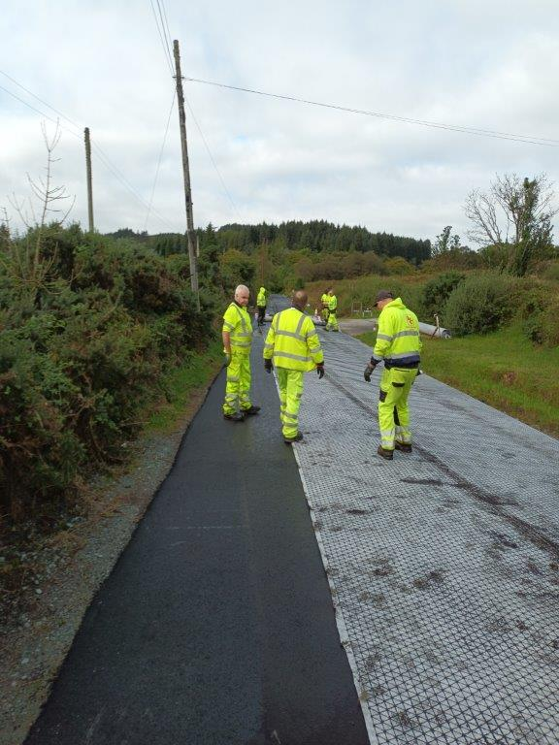
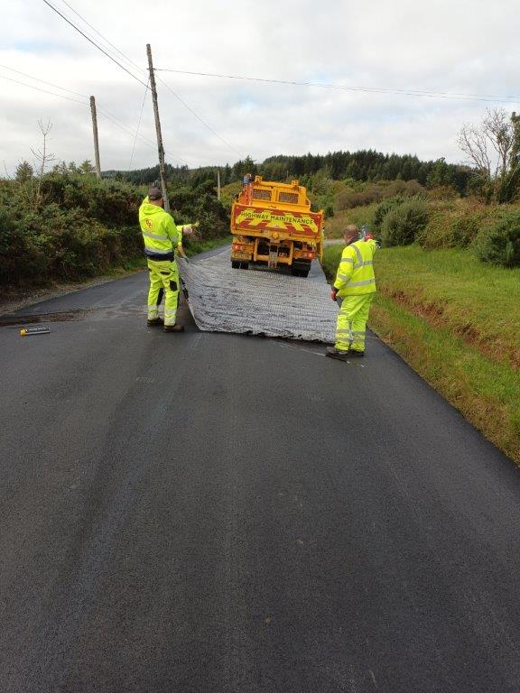

These two photos show the geotextile material being laid along the B8024 at Inverneil.

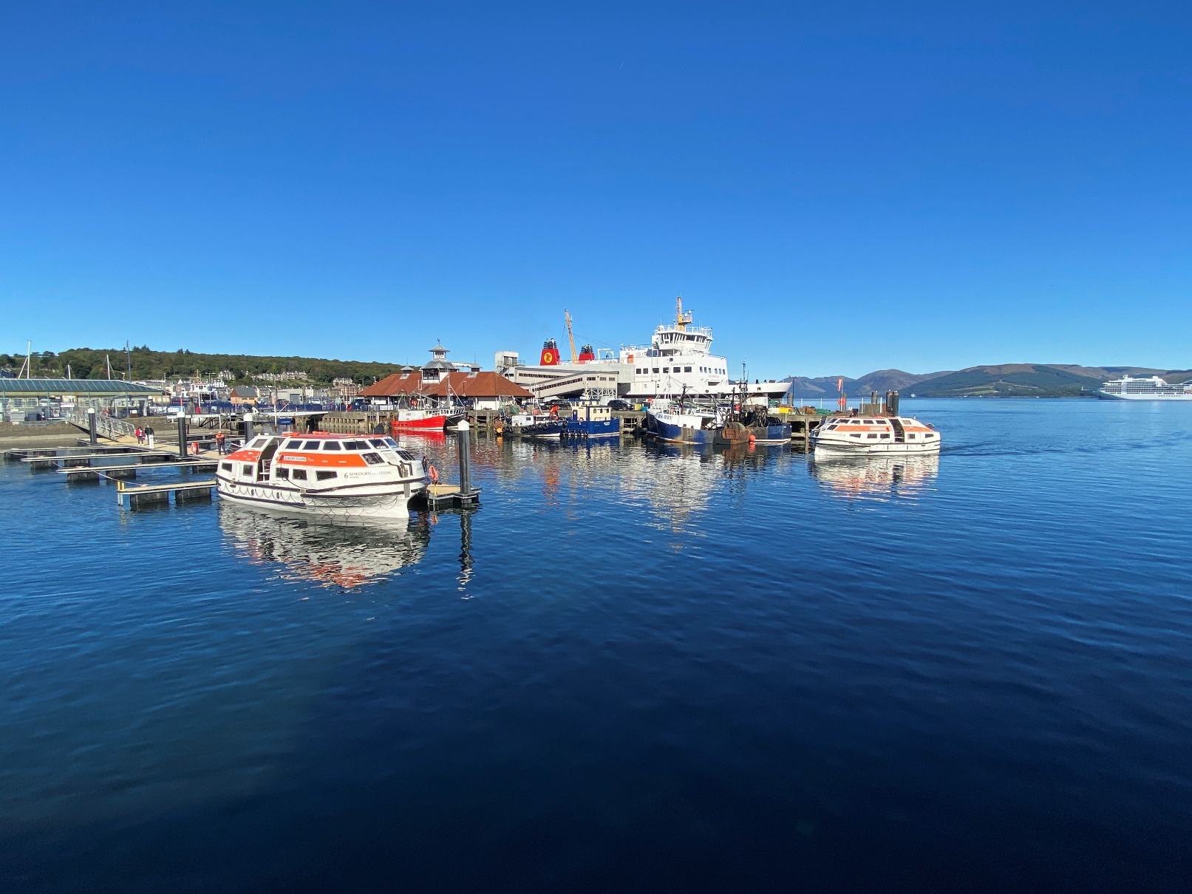
This photo shows the cruise ship tenders using the new pontoons in Rothesay
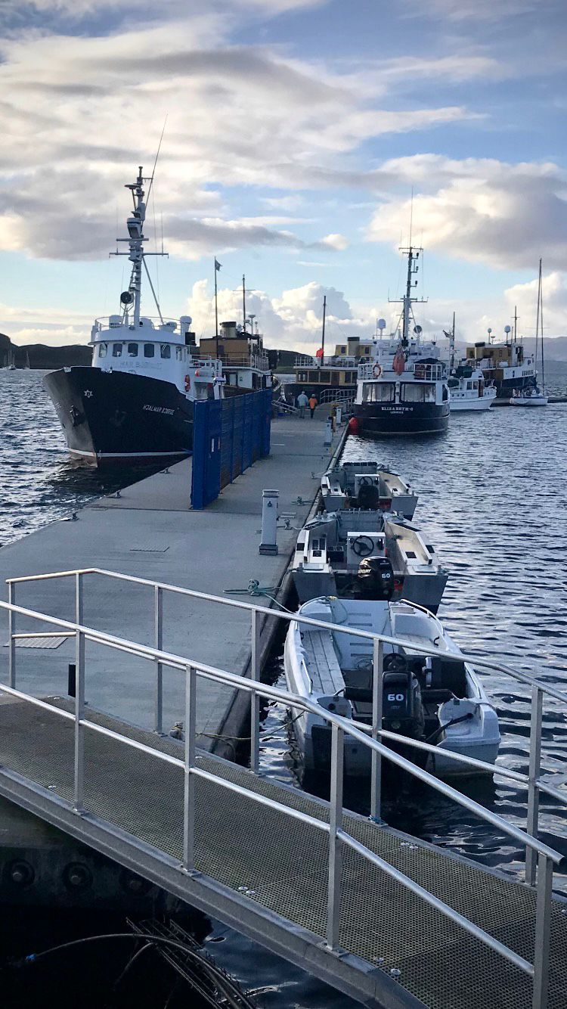

This final photo shows the cruise ship changeover in Oban

