
Please find below a brief update on various key areas of work. These briefings are also available for reference as part of the various information resources available on the new Member Zone system
Roads and Infrastructure
Weekly member briefing
Edition 63 – 19th August
Please let us know if you find these briefings useful and if there is any specific information you would like or alterations to the format.
The updates are designed as a resource for you to be able to answer constituent queries.
You can find details of notable service disruptions on key service areas like bin collections and street lighting on the Council website here: Service Status (argyll-bute.gov.uk)
As well as the updates on notable roads schemes in the table below, the whole roads capital programme is available online – you can access the full list of schemes here: https://www.argyll-bute.gov.uk/roads-capital-programme-0

Oban, Lorn and the Isles | Helensburgh and Lomond | Mid-Argyll, Kintyre and the Islands | Bute and Cowal | All areas
Notable road schemes  The final capital schemes on Mull reported in last week’s briefing are now drawing to a conclusion which will represent an end to the capital works on the island this year. Despite some ferry disruption and supply chain challenges these works have been completed largely to schedule thanks to the hard work and careful planning of the local roads team.  Surfacing work in Connel Village is scheduled to begin next week before the crew moves on to works through the centre of Oban. The work in Oban will be carried out with nightshift to minimise disruption  Mossfield car park  The Council’s surface dressing contractor has now finished using the car park at Mossfield for their temporary site compound, so it is now open and available as normal.  Final stage of streetlighting LED replacement Project  A successful bidder will be awarded the contract for the last stage of the LED project this week. The contractor will have an approximate Six week lead in time to commence works. There are around 1106 LEDs to be installed and we expect this to take in the region of seven weeks once the contractor gets underway.  Fly tipping of cardboard at Tesco  An incident of fly tipping was reported at the recycling point at Tesco carpark in Oban.  .  We arranged for this to be attended to by our contractor Renewi, who are responsible for the collection of cardboard from this area to attend as a matter of urgency and our crews assisted in the clear up.  Even when it is next to a public recycling point, this is still fly tipping and remains is a criminal offence which is set out in the 1990 Environmental Protection Act.  If anyone arrives at a public recycling point and it is full they should take their items home with them.  Border Force visit to Oban North Pier [see photo below]  Border Force are patrolling the west coast of Scotland and are currently using Oban as their base. They also carry out passport control for any cruise passengers with overseas visitors. These passport and security checks are often carried out by our Harbour team who are trained and suitably qualified for this process.  Network rail strikes  Oban High School pupils in and around Dalmally who normally get the train to school were transported via alternative bus transport because of the rail strikes earlier in the week  Bus services  Some tweaks have been made to the bus services in and around Oban to meet the new demands of the Dunbeg development and to continue to match services to areas of highest demand. This means that some services have been reduced where there was clear evidence of little or no use.  We understand there has been some correspondence regarding these changes and would ask that any specific issues [e.g. specific routes and specific times/services] could be highlighted through the Member Zone and we will look at these and provide detailed feedback.  Oban Bay  The initial informal consultation is underway for the Municipal Harbour Authority for Oban. We have reached out to over 1000 contacts with details of the consultation, which is available on the Council web site.  Officers have had a positive meeting with officials from Transport Scotland this week in Oban regarding the drafting of the Harbour Revision Order and the port generally. This meeting provided an opportunity for Transport Scotland officials to visually inspect the full bay including the limits as currently detailed in the consultation. | Notable roads schemes  Due to staff absence we haven’t been able to progress with any capital schemes in Lomond this week; we have only been able to deliver cyclic maintenance works e.g. potholing.  The works programme will be adjusted accordingly and we’ll follow up next week with an update on the remaining capital works.  A814 Ardmay rockfall  Works have started by a specialist contractor under the supervision of the Structures Team to remedy/make safe an area of recent rockfall/land slippage on the A814 at Ardmay.  These works will initially consist of removing/scaling back of on-site vegetation, and further assessment/surveying/ investigatory works to determine overall extent of works required to make the landslip area safe.  The actual rockfall itself was not overly significant and neither that nor these ongoing works need a road closure.  Helensburgh Waterfront EV chargers  The chargers have now been moved to their new location in the newly opened car park by the Waterfront contractor and are available and ready to use.  Luss Traffic Order  Just a short reminder that the public hearing for the Proposed Order is to be held at 10am on Tuesday 23 August, at the Loch Lomond Arms Hotel, Luss.  All the documentation on the proposed Order, along with information on all Traffic Orders, is available on the Council website here.  A814 Glen Mallan  A request has been made by the MoD for the option of closing the A814 at Glen Mallan at various points during a five day period in September, exact date to be confirmed.  This request is to facilitate the safe loading and unloading of munitions to and from an aircraft carrier.  Members may recall a similar optional closure in March this year. At that point we were approached at short notice. In this case we have a longer lead in and will be able to better notify those likely to be affected.  In March the closure option existing for 60hours and the MoD worked hard to keep disruption to a minimum and maintain local access, with the total closure time being just under 13 hours.  We will follow up with more information when a date is confirmed, and will publicise this through the Council’s various publicity channels.  Network rail strikes  Hermitage Academy pupils in and around Cardross who normally get the train to school were transported via alternative bus transport because of the rail strikes earlier in the week | Notable roads schemes  The second phase of upgrade works to the B8024 (south) at Glenralloch [following works last financial year] are into their third week. This phase of works, valued over £300,000, is co-funded through the Strategic Timber Transport Scheme, more information on which is available here.  There is a full road closure in place at this site to enable the works to progress safely. Alternative access is available via the C23 Glenakil Road  On the north end of the B8024 at Inverneil we are in phase one of road strengthening works, which have been progressing this week and will run into next week.  This site has a partial closure from 9.30-12.00 and 12.30-15.15 on weekdays.  For both schemes the local roads team is working hard to keep disruption to a minimum and ensuring local access is maintained as far as reasonably practical.  Jura Ferry  On Wednesday this week we conducted interviews for the vacant skipper position on the Jura Ferry.  These were positive and we are confident that the vacant position can be filled in early course.  The successful candidate will need a period of induction, orientation and familiarisation which will be carried out as far as possible ‘on the job’ and with full compliance to MCA guidance and regulations. With a new appointment we would hope to get back to providing a full service soon.  Campbeltown flood scheme  We are in the final stages of confirming arrangements for a member session and a separate community engagement event for the scheme at the end of August, with more information to follow early next week via the Council’s normal publicity channels.  These events will provide background information to the scheme, as well as the phasing plan/works programme at a high level, with a focus on the overall benefits and what the contractor will be doing locally to manage disruption and ensure good community relations. | Notable roads schemes  The £58,000 project on the C1 Bruchag Road got underway this week and will finish next week.  Rothesay pontoons  The pontoons are now in place and we are now awaiting the final parts of this project – commissioning of fresh water and electrical services. We look forward to opening these new facilities very soon.  Rothesay Harbour lift/passenger access system  The Council’s priority remains the safety of passengers and we are providing vehicular assistance for those passengers who require it to board the ferry service e.g. nobody has not been able to get the ferry because of the ongoing problems with the lift.  We have identified issues most likely caused by the failure of a torsion spring which caused damage to the cladding, roller shutter and shutter guides.  The operation of the lift is not possible without these associated safety limits engaged.  The mechanical engineering company who will be completing the repairs are now awaiting the necessary parts to be delivered so that works can progress.  We will hopefully soon be able to provide a timescale for this.  Rothesay Victoriana toilets – mess/vandalism  Unfortunately thesetoilets have suffered from inconsiderate use over the past weekend. We will be monitoring the facility closely – hopefully this is just an isolated incident.  A886 Leanach landslip  Following our recent updates on the appointment of a contractor, we are now expecting them to mobilise to site next week. | Burial and cremation service  Not something which we normally cover in these briefings, this is a key statutory function that we provide across 131 cemeteries throughout the Council area, as well as one crematorium  Our burial service has eight interments scheduled for next week, and our crematorium has 11 bookings.  As part of the wider spread of resources available in member zone we will shortly be uploading information sheets on this service area.

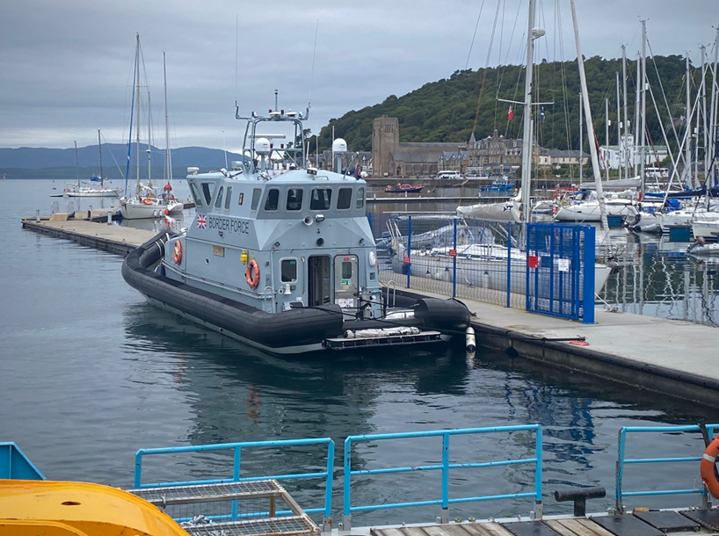
Border Force boat visiting Oban at the Council’s North Pier

