
Welcome back to all Members following the summer recess.
Please find below a brief update on various key areas of work. These briefings are available for reference on the new Member Zone system, and will shortly be joined by more specific information sheets and key policies documents.
Roads and Infrastructure
Weekly member briefing
Edition 61
Please let us know if you find these briefings useful and if there is any specific information you would like or alterations to the format.
The updates are designed as a resource for you to be able to answer constituent queries.
You can find details of notable service disruptions on key service areas like bin collections and street lighting on the Council website here: Service Status (argyll-bute.gov.uk)
As well as the updates on notable roads schemes in the table below, the whole roads capital programme is available online – you can access the full list of schemes here: https://www.argyll-bute.gov.uk/roads-capital-programme-0

Oban, Lorn and the Isles | Helensburgh and Lomond | Mid-Argyll, Kintyre and the Islands | Bute and Cowal | All areas
Notable road schemes  Lorn - Surfaced sections of Ulva Road, Morven Hill and Longsdale Road. Surface dressing works in South Shian and C29 Inverinan to Kilchrenan.  A816 Kilninver road widening scheme.  Mull - Capital surfacing works ongoing, all schemes for the south of the island complete.  Surface dressing works on Mull complete.  Oban Consultation  The wider pre-application continues and the web page is being updated regularly. We have already received some responses.  The summer Navigational Risk Assessment has been completed, the information gathered will be used to inform the proposed limits and Traffic Management requirements.  The project remains on track and an update report was presented to the Harbour Board meeting held 4 August 2022.  The 4 August Harbour Board meeting also gave approval for officers to progress a business case to lengthen the North Pier Oban. This is being progressed due to the increasing demand for commercial berthing at North pier. | Notable roads schemes  School Road in Kilcreggan, Luss Road and the A814 dual carriageway were all resurfaced in July.  Roads that were surface dressed were Aros Road, Smugglers Way, Ardencaple Drive, Loch Drive, Castle Avenue, Cairndhu Avenue  Heritage Park has once again been awarded the Green flag award.  All verge grass cutting is complete  The new carpark and public realm will open on Monday 8th August with the Leisure Centre opening on the 3rd September.  The EV Charger points located at the existing Helensburgh Swimming Pool require relocating to the new Helensburgh Leisure Centre Carpark therefore there will be no access to the Electric Vehicle Chargers at Helensburgh swimming pool for two weeks | Notable roads schemes  A816 Cairnbaan Corner,  Clachan Village Loop  A846 Bridgend  Colonsay  B842 Saddell  B842Peninver  A842 Southend  Campbeltown Flood Protection Scheme  Contractor, Dawson WAM are progressing with Programme development and currently expect to mobilise to site at start of September 2022.  Following mobilisation by the contractor an ‘open day’ will be arranged (date to be confirmed, likely mid-September for elected Members to attend both a presentation and site tour).  Contractor is aware of requirement to sensitively plan Burnside Square works and shall be engaging directly with stakeholders and the community regarding this.  Designers, AECOM and ABC Estates section are continuing to progress with landowner access around Mill Knowe.  we have prepared a dedicated webpage for the project which is set out in FAQ format: https://www.argyll-bute.gov.uk/campbeltown-flood-protection-scheme  The webpage provides the option for anyone interested to sign up to regular project update email alerts, and these updates will also be hosted on the page itself.  Campbeltown Esplanade Reventment  All urgent/emergency repairs have now been completed – Argyll and Bute Council’s Bridge Squad were on site for around 4 weeks.  Other, less urgent/lower priority areas of pitching repairs, parapet repairs and valve installations shall be scheduled in around other higher-priority works – this is currently programmed for late 2022, however is subject to reprogramming around higher priority works.  Jura Ferry  Since the new recruitment push we have had a positive response for the position of Boat Master.  The crew continue to assist with maintaining the service with as little disruption as possible in the meantime  No early or late bookable service throughout August due to staff commitments. The core timetable will still run as normal.  Islay’s Gartbreck landfill site cell extension is nearing completion. This will provide landfill capacity to the start of the Biodegradable Municipal Waste (BMW) landfill ban together with capacity for none BMW material beyond the ban. | Notable roads schemes  A815 Whistlefield to Invernoaden and North of Strachur - Surface Dressing  UC19 Coustoun Road  B839 Pole Farm to Inveronich  UC22 Mill Cottage to Lower Camquart  B828 Glen Mor  Rothesay Pontoons  The Principal Contractor, Teignmouth Maritime Services, restarted site works on 22 June 2022 and has installed the pontoon system, piles and access gangway. A specialist subcontractor, Gael Force Engineering is due on site week commencing 1st August 2022 to install utilities for the berthing facility and the secure access fencing. Following this the Principal Contractor will then oversee the testing and commissioning of the facility in preparation for handover to the Council.  Rothesay Harbour lift  Our framework engineers have appointed a new subcontractor for the mechanical repairs. They are at present sourcing the materials required for the repair and will also work with us on any additional modifications which may be implemented to ensure we have confidence in the longer term operability of the equipment.  The intention is to have the repair executed as soon as practicable.  A886 Strachur (Leanoch) Landslip  Contractor, Taziker, have progressed designs for retaining wall and now ready to progress to site works  In advance of slip repair works, temporary diversion shall be formed – Our Legal Services are assisting Taziker with landowner engagement to secure access,  Site works shall start following formation of temporary diversion – currently programmed for mid-August. This shall be contingent upon access being secured to land.  Works currently expected to take 2 months  Purchase of Glen Loin Carpark  Design Services are progressing with the proposed tender requirements to enable a tender process to be issued for the purchase of Glen Loin Carpark | Play Park Funding  The recent tender process failed to generate any bids. We requested feedback as to why there were no applications and we were advised that the timescales for completion of work were too short. A request for more time to complete was made and this is currently being assessed by our procurement team. A further re-tender process will be looked at this month  2022-23 Roads Capital Programme  Staff continue to deliver our capital programme, the above updated link gives the most recent work completed and underway.  We have been successful in bidding for STTS (Timber Transport) funding of £958,445. This in effect supports our Capital programme with funding from roads which are used by timber transport vehicles. There is strict criteria around this which must be adhered to

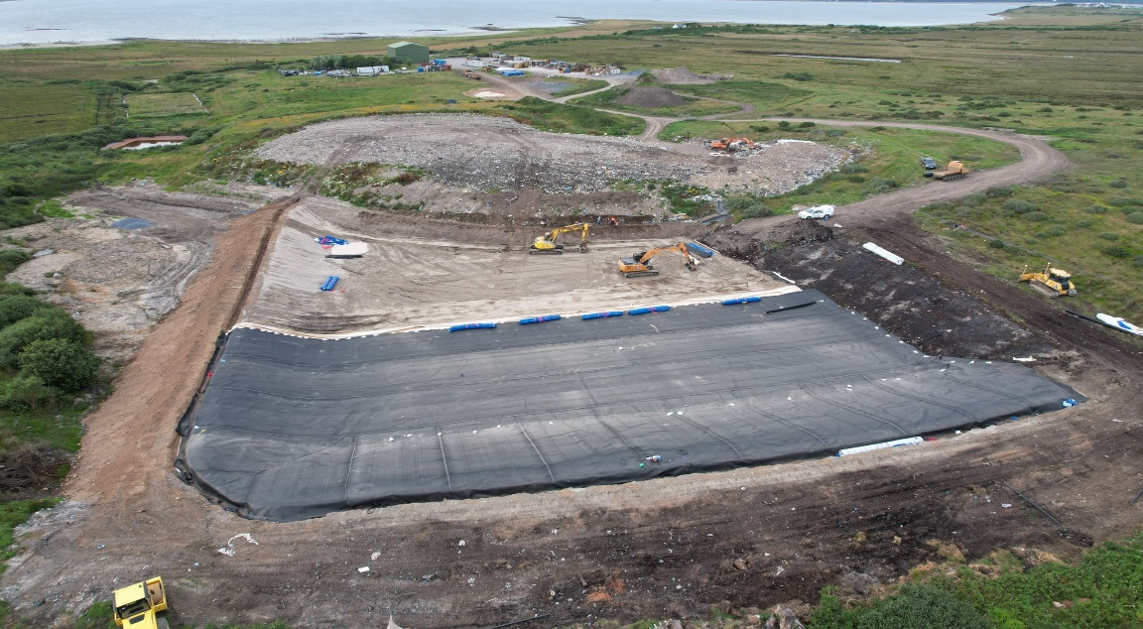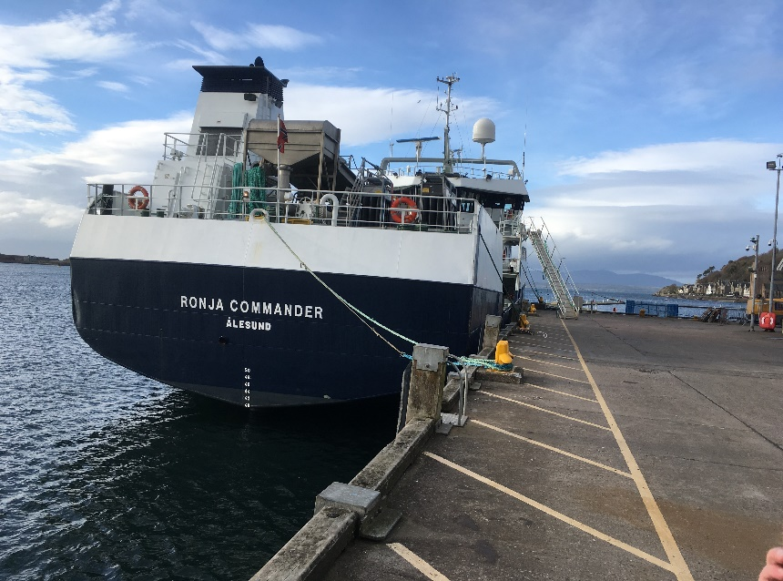
Photo on the left – new landfill cell on Islay with the recycling transfer shed in the far distance and leachate lagoon and reed bed filtration system to the centre to top left of the photo. Photo on the right is the berthing face of North Pier Oban, the Harbour Board at its meeting on 4 August gave approval for a Business Case to be progress for the extension of the pier. This is in response to increased commercial traffic at the pier

