
Please find below a brief update on various key areas of work. Going forward these briefings will be available for reference on the new Member Zone system, as well as specific information sheets.
Roads and Infrastructure
Weekly member briefing
Edition 57
Please let us know if you find these briefings useful, and if there is any specific information you would like or alterations to the format.
The updates are designed for you to be able to easily answer any constituent queries.
You can find details of notable service disruptions on key service areas like bin collections and street lighting on the Council website here: Service Status (argyll-bute.gov.uk)
COVID absence
Unfortunately, we are experiencing a sharp rise in COVID absence across our front line teams. This is causing some delays in works such as grass cutting etc as staff are redeployed to ensure that statutory services like burials and bin collections are prioritised. We are also bringing in some external labour to help plug the gaps in our teams. This is a dynamic situation that we are managing on a daily basis.

Oban, Lorn and the Isles | Helensburgh and Lomond | Mid-Argyll, Kintyre and the Islands | Bute and Cowal | All areas
Staycation Warden  We have now recruited into this post and expect the successful candidate to start in July  Notable road schemes  The £30,000 inlay [removal and replacement of surface over entire width, where levels fixed by kerbs etc.] on the U15 Duncraggin Road has been completed  Various schemes in Tiree will begin next week, with a total value of just under £100,000. These works will focus on regulating which is where an additional layer of bituminous surfacing is applied to the road surface to smooth out ruts and potholes, prior to new surface layer. This will be followed by overlay which is where an additional bituminous surfacing layer is laid over the existing to add strength. This treatment method is usually used rural (lower traffic) roads  Oban pontoons  The North Pier pontoons have once again been busy with marine visitors to Oban, which continues to bring money into the local economy and support local jobs, businesses etc. | Notable roads schemes  Pre surface dressing works completed in and around Garelochhead.  Another pre surface dressing scheme has started in James Street in Helensburgh, which will continue into next week.  We expect our surface dressing contractor to begin work w/b 20th June [weather dependent].  Luss/Duck Bay  We have warden cover in place for this tourist hotspot over the weekend, and the public litter bin will be emptied to the scheduled collection frequency [which is already enhanced through the summer months]  Luss TRO  A new dedicated webpage for the Luss TRO has been created and will be regularly updated with progress:  https://www.argyll-bute.gov.uk/draft-luss-traffic-management-order | Jura Ferry  Our Marine Team have set up a regular meeting with the Jura Community Council to liaise with them regarding developments with the Jura Ferry. These meetings take place every Monday afternoon  Work continues to seek additional crew to work on the ferry to help ensure we can deliver the timetable. The local community are working with officers to assist with the recruitment process. The community have been busy taking some excellent drone footage which we’ll use to encourage prospective colleagues to come and join us, and an image we’ll use to help promote the post.  £15million Campbeltown Flood Scheme  Contract award clarifications with procurement are now complete.  Start-up meeting planned for next week followed by confirmation of a programme and the contractor accessing the site.  Officers are working with the contractor in terms of a works scheduling etc.  We will shortly issue a programme of works that will include timings of the various key elements as well as contact details and general information about these significant works.  Notable roads schemes  The £30,000 overlay scheme at Tangy is now complete. | Rothesay Fountain  We have asked our colleagues in the Property team to progress with repairs to the fountain. Once it is in working order, we are looking to progress a partnership with the local BID group to manage it.  Notable roads schemes  In this area we are completing pre-surface dressing works in advance of the contractor starting surface dressing operations w/b 20th June [weather dependent]  Rothesay Harbour Lift  A further site visit is planned for Wednesday with the lift engineers to agree a repair and modification plan for the lift. | Bin replacement programme  Following the £100,000 allocation in this year’s budget, we have inventoried our public litter bins and are looking to place a bulk order for new bins over the next week or so.  The bin programme will focus on bin  replacements and where possible combining multiple bins to improve the street scape.  Where possible the replacement bins will be  240L wheel bins contained in a ‘street cabinet’  These are better bins which increase capacity for some of the older bins and ease loading.  The funding is split evenly across the four administrative areas and current estimates are that the £100,000 should provide for nearly 160bins.  Grass cutting  Following a few queries from members on the subject we thought it would be helpful to explain that after grass cutting we do not pick up the trimmings/cuttings.  A number of years ago the Council agreed not to pick up grass cuttings as a policy saving. This remains the Council’s policy.  We do however ask our staff to be vigilant and to ensure standards e.g. ensuring grass cuttings are not scattered on footways etc.

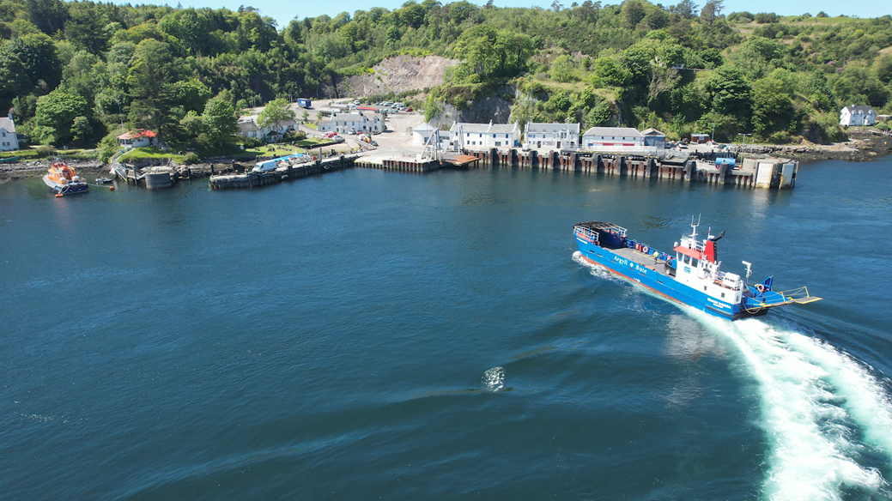
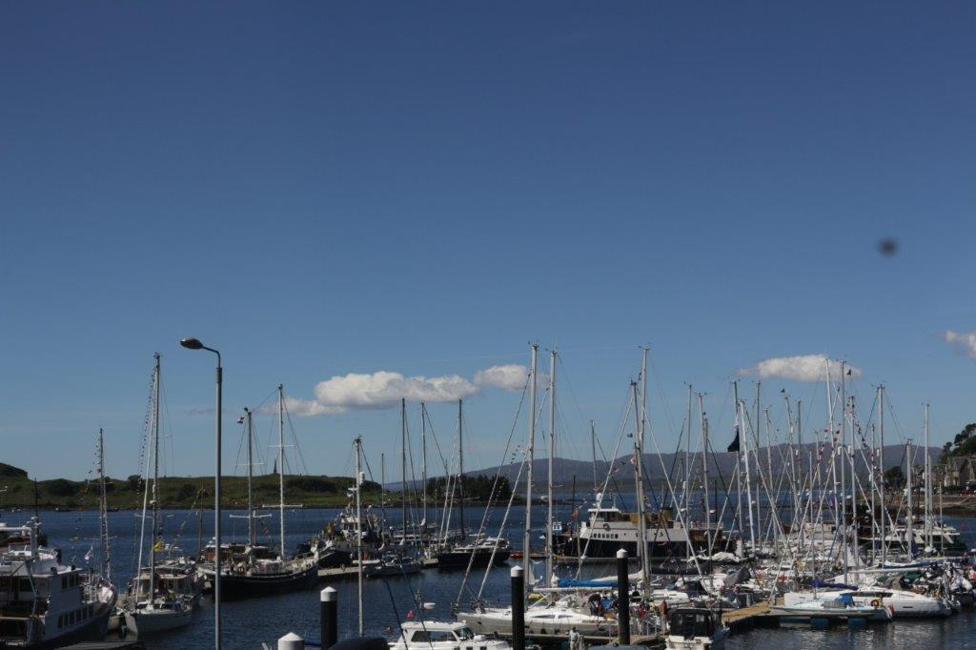
Busy Oban Pontoons
Promotional drone shot of the Jura Ferry

