
Please find below brief update on various key areas of work. These briefings are also available for reference on the new Member Zone system, as well as specific information sheets.
Roads and Infrastructure
Weekly member briefing
Edition 56
Please let us know if you find these briefings useful, and if there is any specific information you would like or alterations to the format.
The updates are designed for you to be able to easily answer any constituent queries.
You can find details of notable service disruptions on key service areas like bin collections and street lighting on the Council website here.

Oban, Lorn and the Isles | Helensburgh and Lomond | Mid-Argyll, Kintyre and the Islands | Bute and Cowal | All areas
Holiday weekend warden cover  Following no take up from ongoing recruitment exercises we are looking to put out a further recruitment process with more flexibility around working hours. It may be that we need to change the working hours to Mon- Fri to try and secure the right candidate  LED streetlighting project  We are entering the third week of tender process. After the award process is complete we expect the project to commence late July / early August  Oban – Craignure vessel  The ‘new’ vessel arrived yesterday. It replaces the It will undertake linkspan interface trials and crew familiarisation.  Notable road schemes  Airds Bay, B845 Taynuilt & Balindore surfacing work complete  Next week the team will be at Duncraggan road before Tiree works begin week beg 13th June  North Pier  We continue to be busy at North Pier, since 1st April we have had 234 vessels in at the pier and 785 at the pontoons | Monaebrook Place  Resurfacing works scheduled over the next couple of weeks once Scottish Water confirm the area can be re-filled  Lining contractors expected to return next week to complete backlog of work from previous financial year  Notable road schemes  Pre surface dressing works continue in Garelochhead, the team will be working on Station road next Mon & Tues | Notable road schemes  Preparation works at Peninver to be completed today with the works at Drumlemble to be complete on Monday 6th June  Capital inlay work to completed at Tangy on Tuesday 7th June with work beginning at Calton on Wednesday  Campbeltown Flood Mitigation Scheme – total scheme costs £15M  The contract has now been formally awarded and the contractor will commence pulling together their detailed delivery programme which will include details of community liaison.  Through these briefing notes we’ll issue a programme of works which will include timings of the various key elements as well as contact details and general information about these significant works. | Rothesay Harbour lift  An independent specialist / hydraulics expert completed an assessment to identify fault with the lift equipment. Our team will now also carry out additional inspections to ensure that a comprehensive repair plan can be put in place.  Rothesay Pontoons  Contractors due on site this month to commence work to reinstall the pontoons  Notable road road schemes  Pres surface dressing along with scrub cutting and drainage work will continue on the A815 Whistlefield to Invernoaden, A815 Adrnagowan to Ardchyline & A886 Shalunt Cottage North, Bute  Roadside verge cutting due to begin next week on Bute. | Wardens cover will be provided over the holiday weekend other than on Friday where there will be limited cover available.  The main duties of the staycation wardens include:  - Engaging with the visiting public and locals in a positive manner,  - promoting the area and advising on local info (waste – general and chemical, caravan/camping site, bring sites, main recycle sites, public conveniences,  - Promoting responsible behaviour, outdoor access code etc.  - Checking bring sites for excess waste/fly tipping - remove if possible, report if not.  - Litter pick/cleanse problematic areas, have a presence in rural communities and associated network.  - Check PC’s for cleanliness and stock level (carry some basic stock, report cleanliness issues).  - Joint patrols with Police Scotland where policing priorities and oveall resources allow.  Summer bedding displays  The summer bedding plants have been delivered and work will be ongoing over the next couple of weeks to plant these into bedding displays.

The Recent addition to the CalMac Fleet – Loch Frisa alongside Craignure Pier during trials ahead of the vessel coming into service between Craignure and Oban

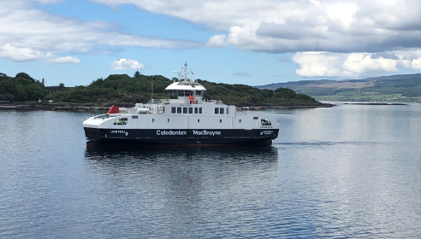

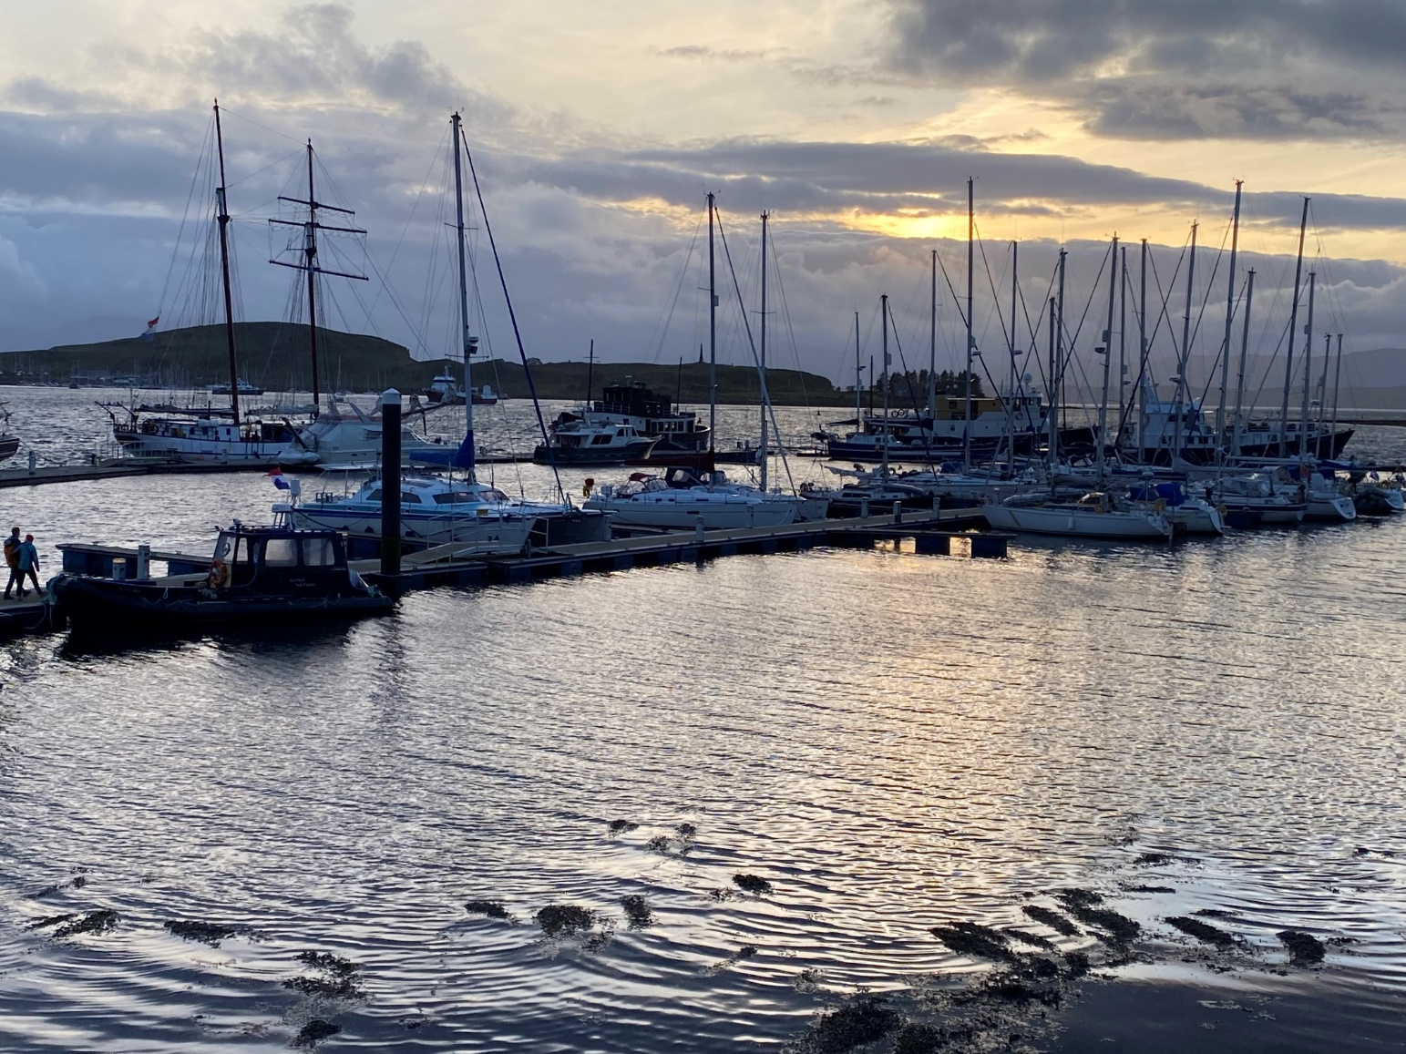

Photo showing the delivery of our bedding plants

Photo of the Oban pontoons taken at last Friday at sunset

