
Please find below brief update on various key areas of work. Going forward these briefings will be available for reference on the new Member Zone system, as well as specific information sheets.
Roads and Infrastructure
Weekly member briefing
Edition 55
Please let us know if you find these briefings useful, and if there is any specific information you would like or alterations to the format.
The updates are designed for you to be able to easily answer any constituent queries.
You can find details of notable service disruptions on key service areas like bin collections and street lighting on the Council website here.
The Environment, Development and Infrastructure Committee meets next week. There are three significant reports on the agenda from RIS – roads reconstruction programme; RIS council funded projects; RIS externally funded projects, as well as a report from our colleagues in the Development and Economic Growth team on staycation, aspects of which cut across both service areas.
The full agenda pack is available here.

Oban, Lorn and the Isles | Helensburgh and Lomond | Mid-Argyll, Kintyre and the Islands | Bute and Cowal | All areas
Staycation warden  We had to re-advertise this role – the advert closed yesterday and we are in the process of reviewing the applications.  Oban North Pier Pontoons  The pontoons have been extremely busy over the past couple of weeks – great news for the town as they continue to bring in visitors who go on to spend their money in local shops, restaurants etc.  Continuing the marine visitor theme, the Waverly is booked into Oban on Monday 6th June.  Completing the LED streetlighting project  The final 1,000 old style luminaires will be replaced over the course of the summer with modern, energy efficient LEDs. This will complete the LED replacement project across Argyll and Bute, the final stage of which had to be paused as a result of COVID/lockdown.  We are going through the tender process and assessment at the moment and expect to appoint a contractor soon, with a view to them starting late July.  Notable road schemes  Surface dressing preparations completed at Airds Bay and ongoing on the B845 | Staycation warden  The staycation warden has been in post in this area since 5th May.  Working as part of our wider team of environmental and parking wardens, cover will be in place for the Luss area this weekend as this is a known tourist hotspot.  We are continuing to work with the national park, community, police and local businesses to help mitigate any negative experiences resulting from increased visitor numbers.  Notable road schemes  Completion this week of surface dressing preparatory works at Ardencaple Drive, Loch Drive and Aros Road. Starting the same work on U roads in and around Garelochhead next week. | Staycation warden  The staycation warden for this area is due to start with us on 2nd June  Campbeltown flood protection scheme  We are in the process of completing the requirements for the licences/consents for the project, and completing the process of awarding a works contract. We would expect to be able to announce the contract award in the next couple of weeks.  Notable road schemes  We have completed the pre surface dressing works in the Inveraray housing schemes, Clachan Loop and Southend, so these surfaces are now ready to be dressed.  Next week we will start to prepare Peninver and Drumlemble. | Staycation warden  The staycation warden has been in post in this area since 5th May.  Rothesay Harbour lift  An assessment has been arranged on site with staff from our Marine Team and specialist engineers for Tuesday coming. We hope to provide a positive update on an agreed way forward in next week’s briefing.  Notable road schemes  Pre-surface dressing work is underway on the A815 south of St Catherines  We are also undertaken ditching, scrub cutting and tidy up along that same stretch of road, but north of St Catherines  W/b 6th June we will be starting a scheme of road widening on the A8003 at Glen Calladh. | Consultation on electric vehicle charger plans  Our consultation on electric vehicle charger plans has been launched. It runs from now until 30th June.  There are currently 28 EVC sites situated across Argyll and Bute and we are consulting members of the public on a draft list of possible new sites as part of a medium to long-term future strategy for EVC infrastructure in the area.  Any help in promoting the consultation would be much appreciated as we want to reach as wide an audience as possible.  The consultation is available here.  There are various local maps which are easier to read contained in the consultation itself. We have overall maps of the proposed and existing sites below.  Summer bedding displays  The plants for the floral bedding displays throughout Argyll and Bute are expected to start to arrive early next week. You will start to see the beds being planted out soon after.  Fleet replacement  We continue to replace older vehicles with low emission/hybrid/ electric vehicles. The focus at the moment is on new school transport vehicles – we have just placed an order for another six new greener, cleaner mini-buses.
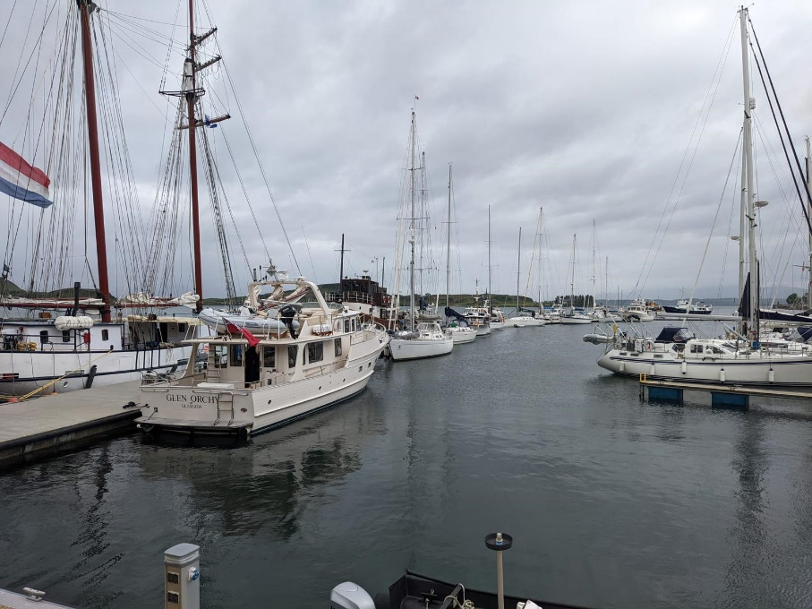
Busy Oban pontoons
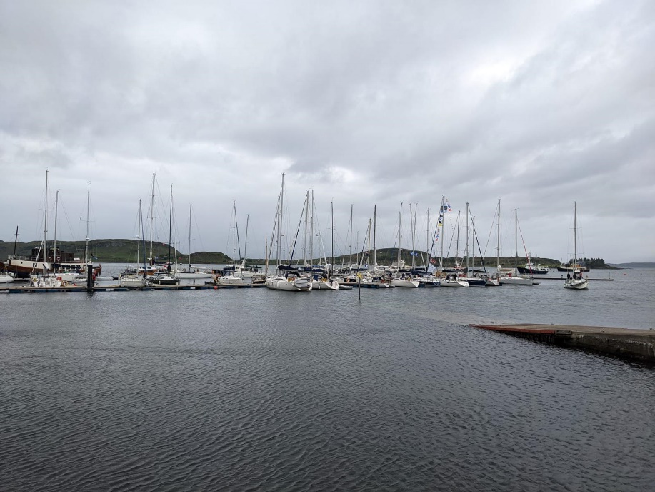
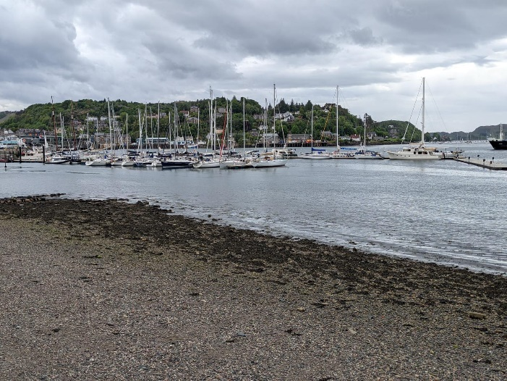

EVC consultation Argyll and Bute-wide maps
