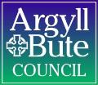

Member Zone: Highlight Briefing March 2023

- SERVICE REQUEST PORTAL - ACTIVITY
The table below shows the number of requests logged by members since the launch of Member Zone in June 2022 and their status:
 | RIS Requests | Other Services | Total
Total Requests Made | 744 (80%) | 191 (20%) | 935
Requests in Action* | 147 | 18 | 165
Requests Actioned by Services | 597 | 173 | 770
Requests Closed by Members | 357 | 121 | 478
Open with Members | 237 | 52 | 289
*Includes those awaiting response, escalated and where work is scheduled by Services.
Of the 165 responses in action as at 03/03/23, 96 are with the Service for response, 40 have work scheduled for completion, 22 have had an initial response and the Member has asked for further information/clarification and 7 have been escalated. Of the 96 requests with the Service for response, 19 exceed their SLA response time by two weeks or more.
- SERVICE REQUEST PORTAL – MEMBER ENGAGEMENT
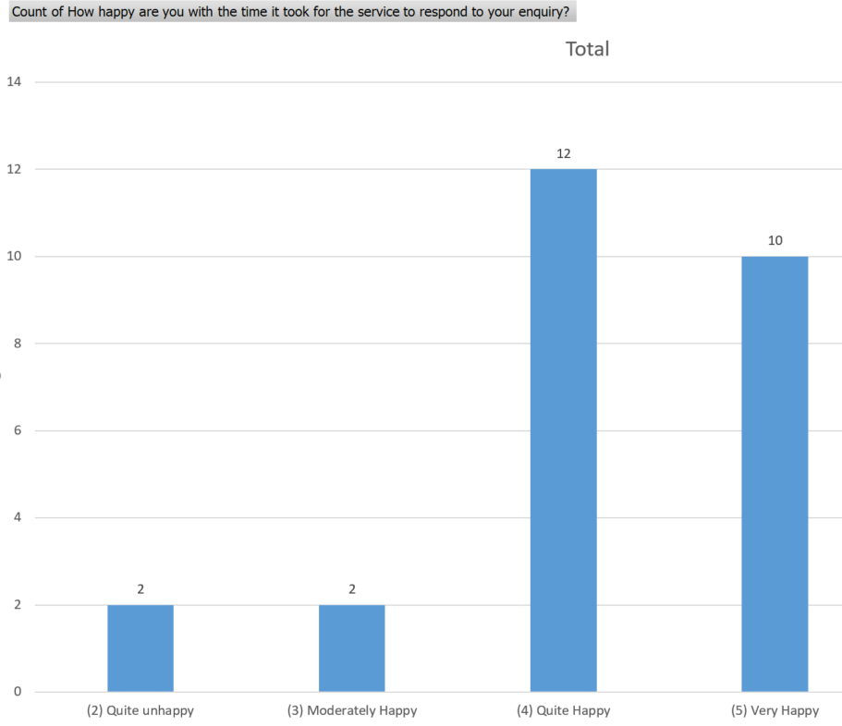
  - Member Feedback On Member Zone Request Portal
In order to monitor timeliness and quality of responses over time from a Member perspective new functionality was introduced in November 2022 to enable Members to complete a short feed back survey on each response after they had marked it closed. This is voluntary and outcomes up to end of February are shown in the following charts. In summary 22 out of 26 respondents said they were quite or very happy with the speed of response and 29 out of 32 respondents were satisfied with the quality of response; 27 marking them good or excellent:
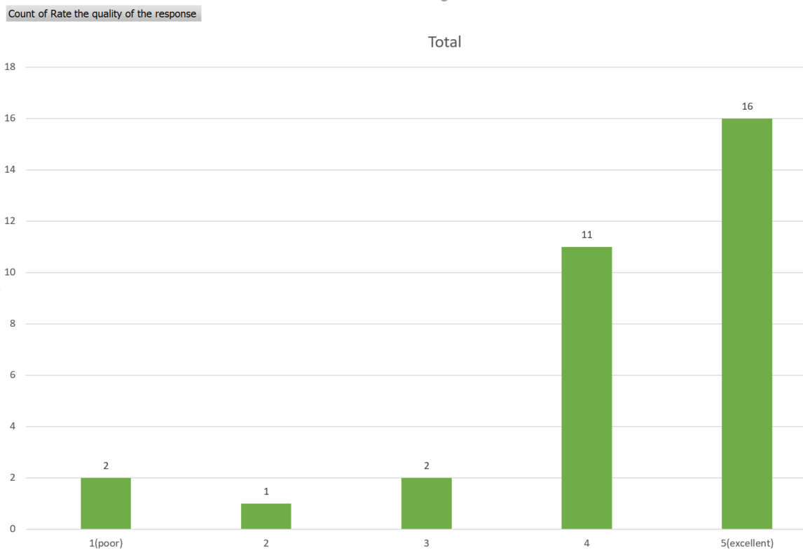
There were many positive comments including:
- Excellent service, problem solved very quickly. Customer delighted. Thank you
- Exceptionally rapid response would also please the local Community Council.
- Comprehensive updates provided.
- This took a few goes but the officer went above and beyond to find a solution for my constituent.
Some less favourable feedback included:
- I thought that the response was very bland
- The incident was not updated. I observed the filled pothole and closed the incident myself.
- Response was delayed, but ended up with a satisfactory result.
RIS also have their own internal quality checking approach and feedback on requests relevant to them are reviewed as part of that to inform continual improvement.
  - Member usage of Member Zone Request Portal
It is important that the maximum number of member requests possible are routed to Services via the MZ portal as this allows Services to deal with them in a structured, efficient way and avoids perception of a two tier service to Members. It also helps members control their caseloads. The table below shows the number of requests per member since go live:
Banding of Number of Requests Made | Number of Members in this Banding
Zero – 10 requests made | 11 members
11 – 30 requests made | 13 members
31 – 50 requests made | 6 members
50+ requests made | 6 members
It is clear that there is a significant minority of members who are not using the Member Zone Portal to log their informational or service requests.
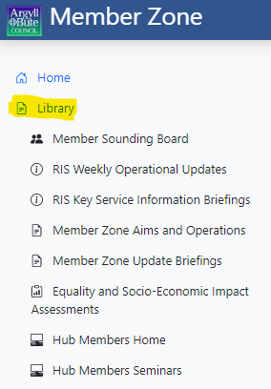
- MEMBER ZONE INFORMATION RESOURCES
One key difference between Member Zone and its forerunner the Councillor Casebook is that MZ is more than just a service request portal, but also a useful information hub for Members. The MZ support team has therefore created a Library function in MZ with a range of operational and technical support briefings, links to relevant web pages and the Sounding Board documentation. Many have been added at the specific request of members and the team are happy to fulfil other member information resource requests going forward.

- SOUNDING BOARD AND ONGOING IMPROVEMENTS TO MZ
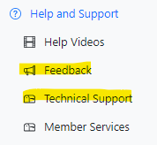
Member Zone was designed around the needs of Members and was always intended to evolve with their ongoing input; informally through the feedback or technical support buttons in MZ Help and Support section and formally through the Member Sounding Board; whose documents are held in the MZ library. Sounding Board Membership is open to any member and the third Board Meeting will be in early April.

A key role of the Sounding Board is to propose and prioritise enhancements to Member Zone, which the Digital Service Team then build and implement. So far there have been four releases of enhancements and each is accompanied by an MZ Update Briefing and a video tutorial. The Briefings are in the MZ Library and the videos in the Help and Support Section. The most recent release just before Christmas included:
1. A new layout for the web based MZ interface with collapsible menus to make navigation simpler and look and feel less cluttered.
2. New fortnightly scheduled reports for members in excel format detailing their open and closed requests with the last activity on them. We can turn off the reports for those councillors who did not want to receive them.
3. New functionality that separated open and closed cases into two separate caseload lists for ease of management over time
4. New filter and search options within the caseload for example to allow alphabetical or date based filtering and search by constituent name. Again, this should make caseload management easier.
5. A template email response from within a specific request that auto fills the case details and standard text, to allow the member to email colleagues or constituents about the case. This also acts as a de facto share in ward function.
6. A new print function so that individual cases can be printed off e.g. to be posted to constituents who struggle with digital.
7. New Planning / Building Standards service request form with a few dedicated planning/building standards fields as agreed with Planning.

Forthcoming developments in the fifth technical release include:
- Two factor authentication for logging on; to add extra security in line with new online security standards
- A staged system of auto closing completed responses from Services that have not been actioned by members; two reminders before closure
- Red, Amber Green visual request status in member’s open caseloads to allow them to readily identify those past their SLA
- An Urgent or Fastrack indicator functionality for priority service requests.

Members wishing to join the Sounding Board should notify Helen MacLeod at Member Services.
----------------------------------------------------
If you require further information or need any clarifications on the content of this Briefing, please do not hesitate to contact:
Bob Miller
Customer Engagement Manager
March 2023

