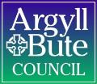

Member Zone: Member Update Briefing 4 (December 2022)

INTRODUCTION
Since the launch of Member Zone in May 2022, a total of 750 requests have been logged: 580 (77%) of those were for Roads and Infrastructure Services with 170 for other Services. As the development of Member Zone continues, the following new features / updates will be made live on Tuesday 20th December:
- New: menu layout (point 2 below)
- New: open and closed enquiries now separated (point 3 below)
- New: improved enquiry search options (point 4 below)
- New: option to email details of enquiry (point 5 below)
- New: option to print enquiry (point 6 below)
- New: automated fortnightly recent activity report (point 7 below)
The purpose of this briefing is to advise Members of these new features that will be made live on Tuesday 20th December and to outline a number of other developments in progress which can be found at the end of this briefing (point 9 below). Training videos showing how these features can be accessed will be added to the section found within the Help and Support grouped menu heading.

NEW: Menu Layout
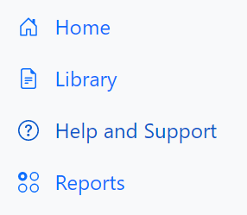
As more features and information resources have been added to Member Zone, the menu on the left hand side of the screen had become too cluttered. Now similar options/resources have been grouped together and can be accessed by clicking on the relevant grouped menu heading:

- All documents and resources can be found under Library
- All things related to Help and Support are found under this heading
- Reports contains access to the just introduced Open and Closed incidents reports.

Clicking on a relevant grouped menu heading will reveal the contents for that group, and clicking on the grouped menu heading again will hide them:
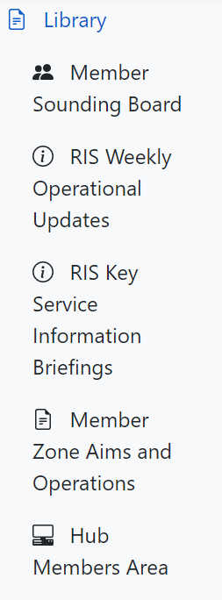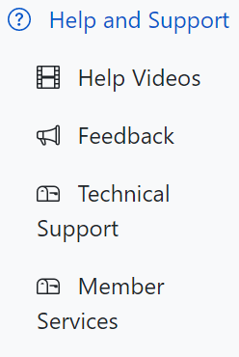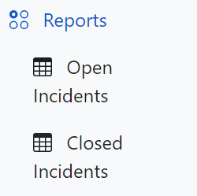

NEW: Open Incidents and Closed Incidents Reports
Under the grouped menu heading Reports, there are two reports for Open Incidents and Closed Incidents. As the number of enquiries that Members have logged in Member Zone will continue to grow over time, at the request of Members on the sounding board enquiries have been split in to those that are open and closed.

Clicking on either report will display all open or closed incidents:

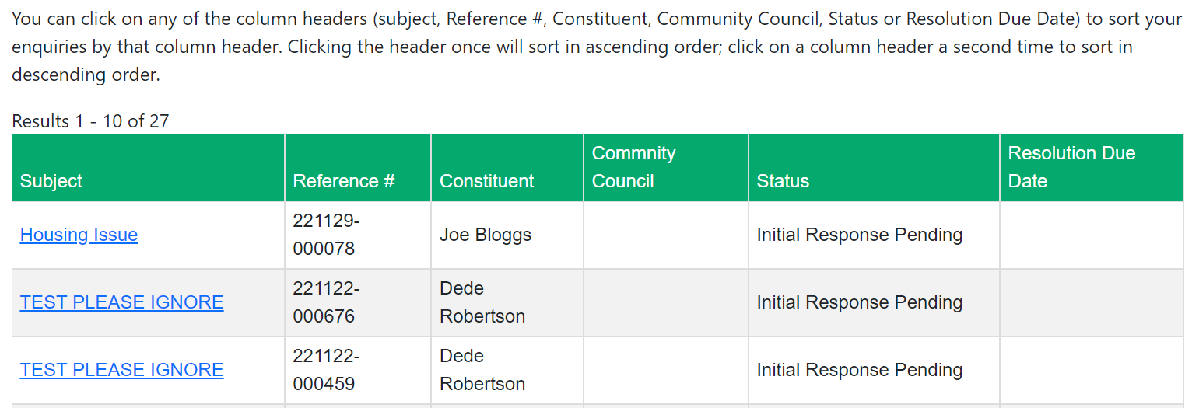

NEW: Improved Enquiry Search Options
When viewing either Open Incidents or Closed Incidents reports, as detailed above new columns have been added for Constituent and Community Council.
Above the report, there are now new options for searching to look for individual incidents and/or grouped incidents:
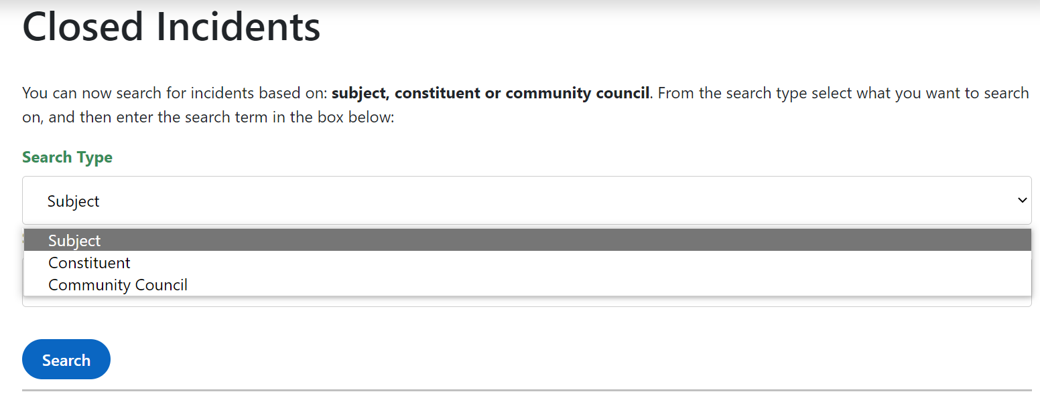
The Search Type dropdown menu lets you select whether you want to search based on Subject, Constituent or Community Council. Once this has been set, enter the search criteria in the Search by Keyword box and click the Search button:

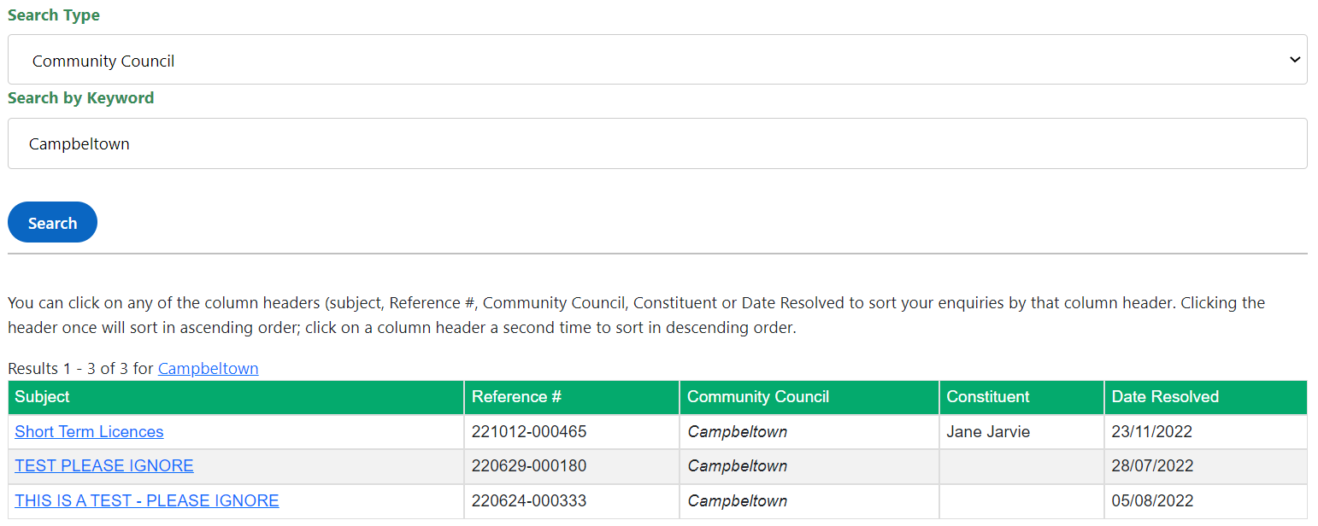
In the above example, the Search Type selected was Community Council and the search criteria entered was Campbeltown. The results displayed are all the enquiries where the Community Council is set to Campbeltown.

NEW: Option to Email Enquiry
When viewing the details of an enquiry within Member Zone, an option to send an email from Member Zone has been introduced:
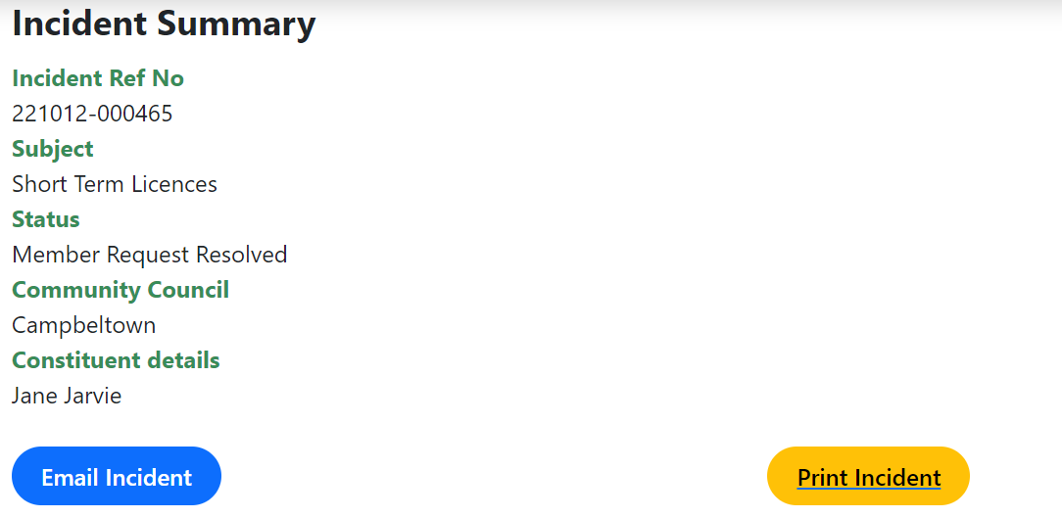
Click on Email Incident button and an email will be created and populated with details of the enquiry:
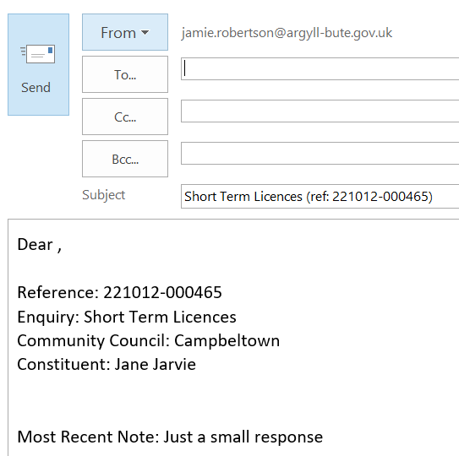
The email subject will contain the subject of the enquiry and the reference number from Member Zone.

The body of the email will contain:
- Enquiry reference number
- Subject of enquiry
- Community Council (if present)
- Constituent (if present)
- The most recent note added to the enquiry in Member Zone
Members can tailor the content of the email and send to constituents, community councils or anyone else that has an authorised interest in the enquiry.

As a formal option to share enquiries with other Members in your ward has yet to be introduced, this option can be used to advise other members in your ward that you have raised an enquiry.
NOTE: Sharing enquiries with other members in your ward can only be done when the constituent that has raised their enquiry with you has given their explicit consent for the enquiry to be shared with other members in your ward.

NEW: Option to Print Enquiry
When viewing the details of an enquiry within Member Zone, there is also now the option to Print Incident. Clicking this button will display the enquiry in a new tab. All the pertinent information about the enquiry is displayed, along with the five most recent notes:
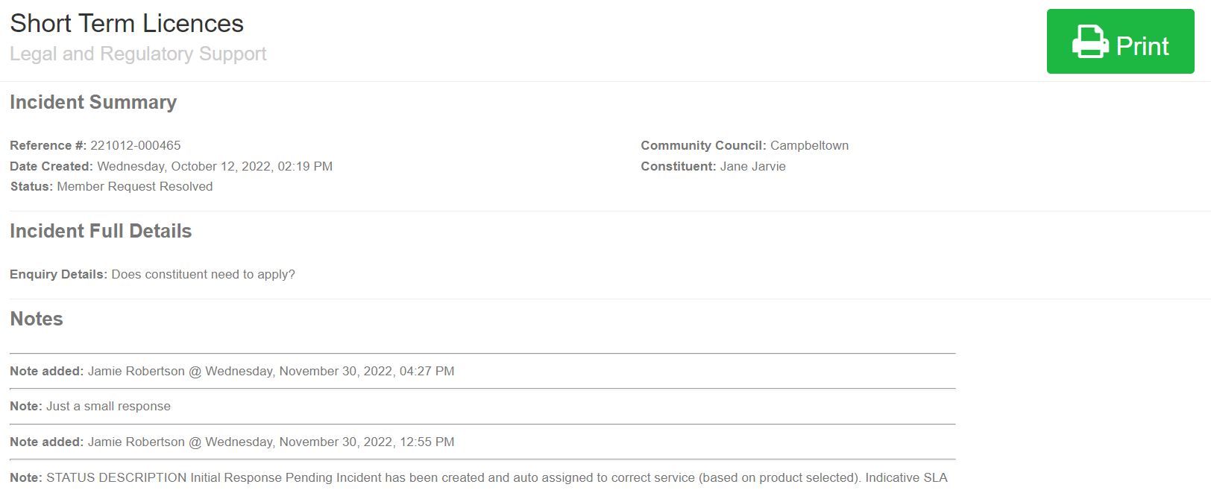
Click the Print button and the following window will be displayed, where a Member can choose to print the enquiry or save it as a PDF document:
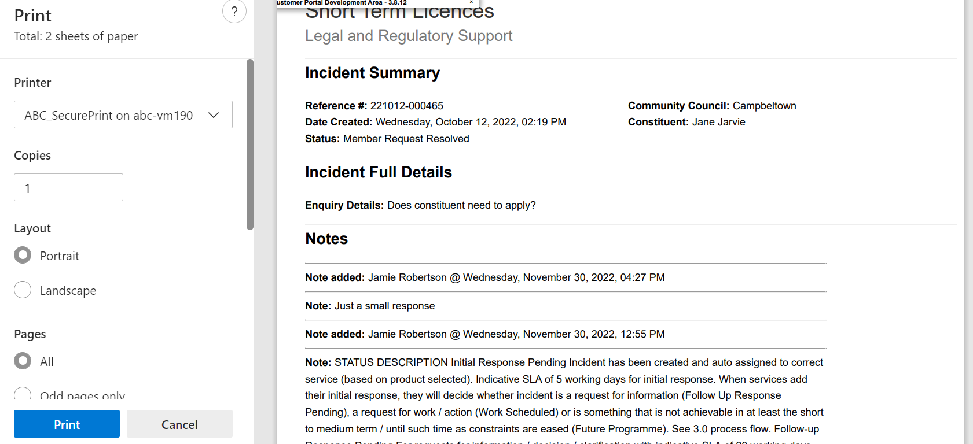

PRINTING:
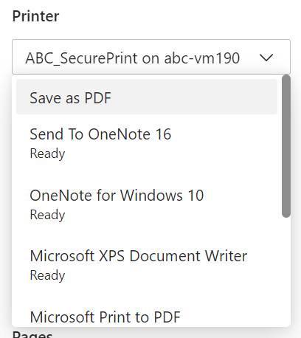
From the printer dropdown menu, select the relevant available printer that is connected to the device that you are logged in to Member Zone on and click the Print button.
SAVING AS PDF:
If you wish to save the enquiry as a PDF document, from the printer dropdown menu select the option Save as PDF and the blue button in the bottom left hand corner of the window will change to a Save button. Click the Save button and then navigate to the relevant folder where you want to save the PDF file.

NEW: Fortnightly Recent Activity Report
To help Members manage and track progress of enquiries, the option to receive a fortnightly report by email has been introduced. An email will be issued fortnightly and it will include a spreadsheet as an attachment with the following three reports:
- Member Zone Summary: This report is an overall summary detailing how many enquiries logged by the Member broken down by each status within Member Zone.
- Member Zone OPEN Incidents: This report will detail all notes added to open enquiries within the previous fortnight.
- Member Zone CLOSED Incidents: This report will detail all notes added to closed enquiries within the previous fortnight.
An anonymised example of the layout and content of this fortnightly report has been sent alongside this update briefing. If any Member wishes to receive their own fortnightly recent activity report please email jamie.robertson@argyll-bute.gov.uk to request this.
Once this has been set up for a Member, if they no longer wish to receive the fortnightly recent activity report this can be easily cancelled at any time.

Member Zone – Member Sounding Board
The second meeting of the Member Sounding Board took place on Friday 2nd December and minutes of this meeting can be found in Member Zone under the Library grouped menu heading.
The next meeting will take place in March 2023 and membership of the Board is open to any member by letting Helen MacLeod in Member Services know of your wish to join.

Future Developments
In line with planned developments and in addition to the enhancements identified by the Member Sounding Board, the next developments will be:

Share Enquiries with other Members in Same Ward
The option to share enquiries with other Members within the same ward was rarely used in the previous application for Member enquiries, however, it is clear from individual feedback from Members and from the sounding board that this functionality should be available in Member Zone.

Two Factor Authentication
To provide additional security when members log into Member Zone. This provides security for both the council network and for customer information held within Member Zone.
----------------------------------------------------

If you require any further information or need any clarifications on the content of this Briefing, please do not hesitate to contact Member Services (memberservicesteam@argyll-bute.gov.uk, 01546 60 4305) or Jamie Robertson (01586 55 5202, jamie.robertson@argyll-bute.gov.uk).

Bob Miller Helen MacLeod
Customer Engagement Manager Member Services Officer
December 2022 December 2022

