

Member Zone: Member Update Briefing 1

- OVERVIEW
The new Member Zone went live week commencing Monday 16th May. The project to create Member Zone hasn’t stopped and there will continue to be new features added to Member Zone (and any issues addressed) over the coming weeks and months. This briefing is to advise of the first round of new features added to Member Zone.
- NEW FEATURES
The green section on Member Zone will be used to update Members about new features or any issues that have been resolved in Member Zone:
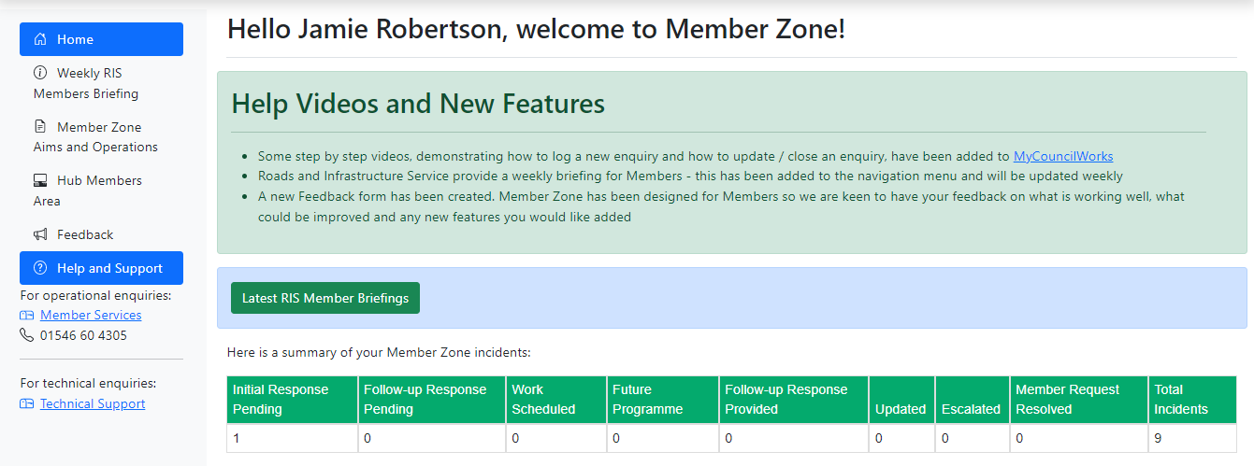
  - New Help Videos Added
Some new ‘how to’ videos have been added online to help Members navigate Member Zone. The first two that have been added are:
- How to log a new enquiry
- How to review and update existing incidents
More videos will be added over the coming weeks.

  - Weekly Roads and Infrastructure Member Briefing Added to Navigation
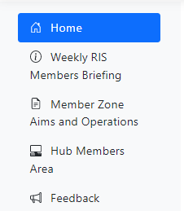
Each week, Roads and Infrastructure Service produce a briefing for Members containing information about various key areas of work (an example briefing can be viewed at Appendix A: Roads and Infrastructure Services Weekly Member Briefing)
These briefings are designed for Members to help you easily answer any constituent queries.
This menu option will take you to the Council website where all Weekly RIS Members Briefing are stored.

  - New Feedback Form Added
Member Zone is a brand new bespoke web portal that has been created for Members. If you have any feedback about Member Zone (be it negative, positive or requests for extra features) please click on the Feedback option and complete the feedback form.
The project team is keen to hear from Members about what is working well, what could be improved, and if there are any issues.
This form can also be used if you have any suggestions about new features you believe would be beneficial for all Members to be included in Member Zone.
- Further information
If you require any further information or need some clarifications please do not hesitate to contact Member Services (memberservicesteam@argyll-bute.gov.uk, 01546) or Jamie Robertson (01586 555 202, jamie.robertson@argyll-bute.gov.uk).

Bob Miller Helen MacLeod
Customer Engagement and Transformation Manager Member Services Officer
May 2022 May 2022

Appendix A: Roads and Infrastructure Services Weekly Member Briefing
Roads and Infrastructure
Weekly member briefing
Edition 54

Please find below brief update on various key areas of work. Some of the updates pick up on specific queries from the Roads and Infrastructure Services Member Induction Session in Oban on Tuesday of this week.
Going forward these briefings will be available for reference on the new Member Zone system, as well as specific information sheets.
Please let us know if you find these briefings useful, and if there is any specific information you would like or alterations to the format.
The updates are designed for you to be able to easily answer any constituent queries.
Contacting the Service
We have a central team which tracks and monitors correspondence via the Member Zone system and/or our central mailbox, so if you have any queries please don’t hesitate to either respond to the email address or log a query on the system. This is picked up by the central team and they consult with the relevant local/technical staff and aim to put information together for you which is clear, helpful and in Plain English. Feedback on the responses to your queries is also welcomed so that we can make sure we are meeting your needs and providing a good information service to you and your constituents.
You can find details of notable service disruptions on key service areas like bin collections and street lighting on the Council website here: Service Status (argyll-bute.gov.uk)

Oban, Lorn and the Isles | Helensburgh and Lomond | Mid-Argyll, Kintyre and the Islands | Bute and Cowal | All areas
Roads reconstruction programme  Good progress is being made with the roads reconstruction programme.  North Pier  Good numbers of visiting yachts at North Pier and medium sized cruise ships have visited Oban using the North pier to bring their guests to land | Food waste collections  There have been delays to the collection of food waste bins this week in Lomond.  This has been due to an issue with the food waste vehicle [we use a specific, specialist bin lorry for food waste collections].  Normal service is scheduled to resume next week on the normal weekly collection cycle.  An update has been placed on the website and this is automatically emailed out to customers who have signed up for disruption notifications.  Weekend warden cover Luss  Weekend warden cover is in place for Luss – warden cover is targeted at known hot spots. However, the weather forecast is not good which may reduce the number of visitors and possible issues.  The council continues to work with the national park, community, police and local businesses to help mitigate any negative experiences resulting from individuals visiting the area. | Islay-Jura ferry  Following some disruption to service normal service will resume on Saturday however we have had to cancel the extra bookable sailing on Friday evening due to the replacement vessel needing to return to its home port earlier than anticipated.  Roads capital scheme Muasdale  This scheme was completed this week  Inveraray housing schemes capital works  These are planned to begin next week.  Fuel tanker overturned Islay  A fuel tanker overturned between Port Askaig and Bridgend on Islay.  Council teams attended and assisted Police Scotland to make safe – the road is currently operating under traffic control while we assess the damage and organise repairs to the verge. A specialists team is due to visit site to check for environmental compliance and to remove any residual contamination | Rothesay Pontoons  Final verification checks for the design for the improvement work to the Rothesay Pontoons are expected to be completed very soon. These checks are being done independently to ensure confidence that the designs will fulfil all requirements  All permissions and consents to enable work on the e seabed are in place and the contractor will be remobilising the works soon to complete this pontoon enhancement  Passenger lift Rothesay Harbour  We have had to take the passenger lift at Rothesay Harbour out of service following a break down last week. Specialist engineers are investigating the source of the problem and we will endeavour to have the lift working safely again as soon as possible.  Unfortunately this will bring some inconvenience for passengers, however, safety is paramount and we must ensure that the lift is fully repaired prior to being put back into use.  Sea wall Ardbeg  Good progress is being made with the detailed design process is for a permanent repair to the damaged sea wall on in Rothesay. We are performing a number of surveys at the moment which will inform the design work.  Various permissions and consents are also being obtained to carry out the permanent repairs.  These permissions were not needed for the temporary emergency repairs that were carried out to save the road, utility services and land beyond the road corridor.  The temporary works continue to work well and are being regularly monitored.  It is too early to say what the timescales for the permanent works will be.  Capital footway works carried forward  The remaining capital footway works which had been carried forward from last year due to high numbers of COVID absences in the local team have now been completed. | Roads reconstruction programme  A significant £8M capital programme was approved by the Environment, Development and Infrastructure (ED&I) Committee in March. This programme is being delivered however many of the schemes are having to be adjusted due to the significant increases to bitumen costs experienced in recent weeks. Details of the adjustments to the programme will be reported to the June ED&I Committees  When finalised it will be available on the website here  Surface dressing preparatory works  Pre-surface dressing works are ongoing across the area to get road surfaces ready for surface dressing treatments.  Note Surface Dressing is a surfacing method which is used across our road network. The treatment consists of a specialist bituminous ‘glue’ which is used to adhere stone chipping to form a new running surface. This treatment not only seals the road form the ingress of water but also provides a friction course to provide grip for road users.  A detailed briefing note will be issued to Members explaining the use and benefits of surface dressing  Staycation traffic  Whilst there are a noticeable number of visiting campervans and motorhomes in the area there seems to be very few issues being reported. This may be due to the fact that campsites have largely reopened and taking many of the visitors.

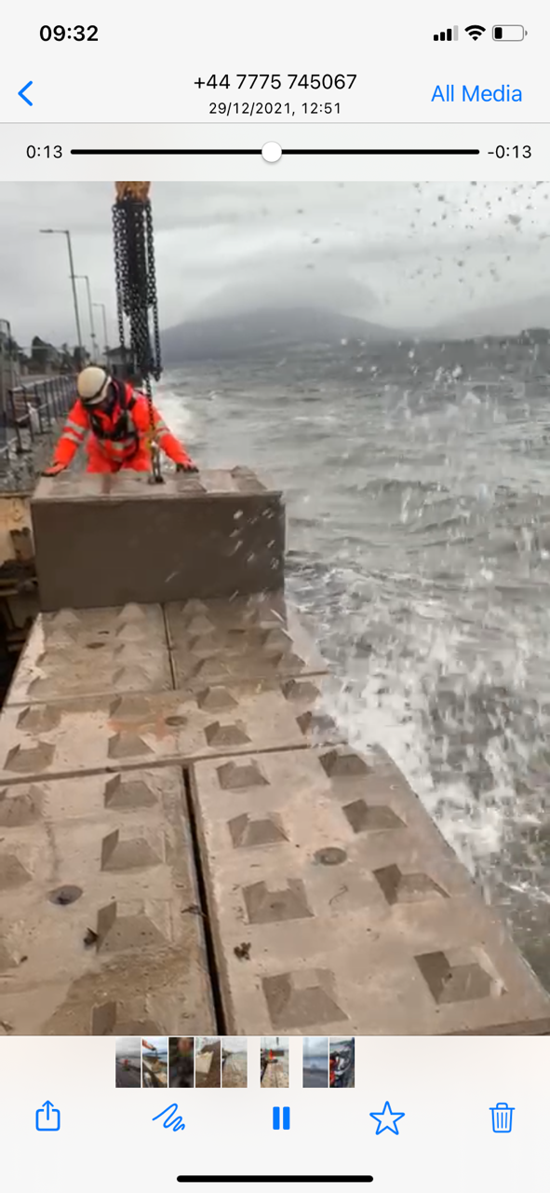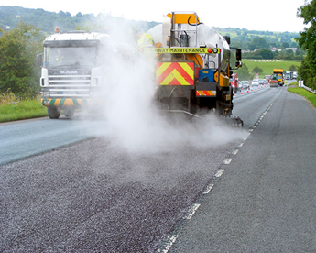
Temporary repairs to the Bute Sea Wall Typical surface dressing works

